WELLBEING GRID 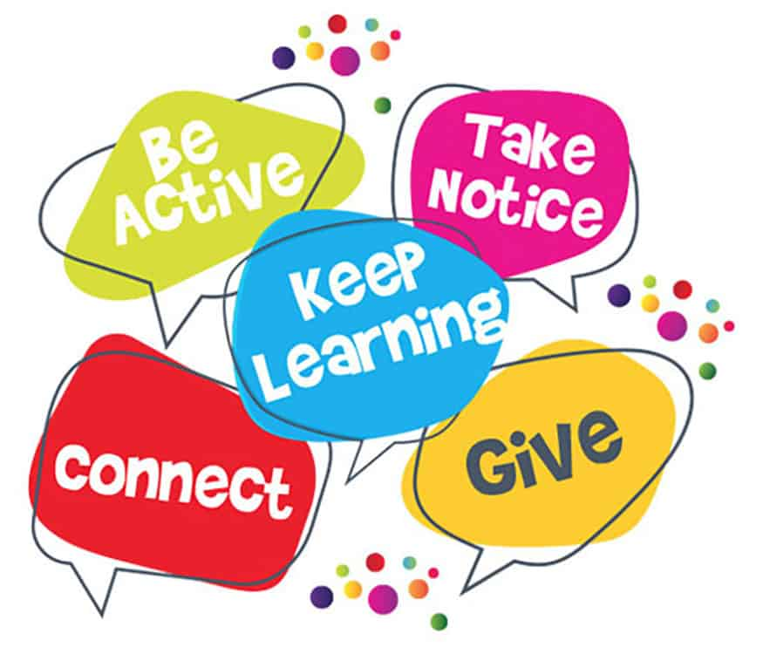
- Here is a menu of various activities that you can choose from during Wellbeing Monday and Wellbeing Tuesday.
- We are encouraging parents and teachers to join in also!
- Remember to be calm, be grateful, and be kind to yourself and others!
Creative Activities | Meditation &Breathing | Calming Activities | Spreading Kindness | Mindful Movement –Yoga& Dance | Keep Learning!
Create your own self–portrait and write down all the positive things about yourself –things you enjoy doing, skills that you have and things that you are passionate about!  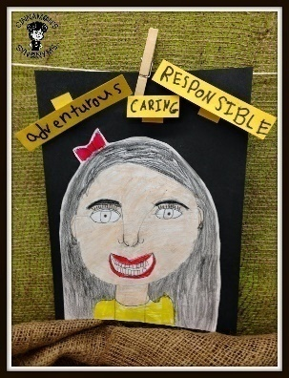  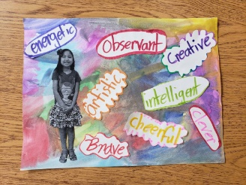 | Click on the link to listen to a guided meditation clip.  https://soundcloud.com/user-547419318/woodland-walk-visualisation-for-children-guided-by-nuala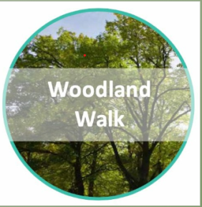  Try out this breathing exercise. Trace around the star with your finger while breathing.  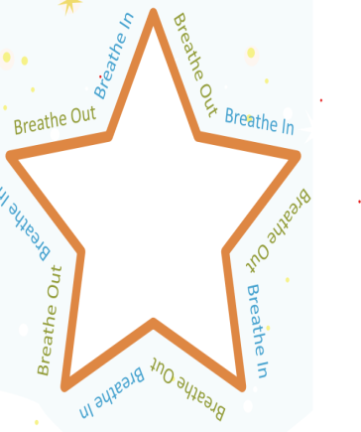 | Do some mindful colouring while listening to some quiet music.  https://www.teachingideas.co.uk/2d-art/mindfulness-colouring-images-animals    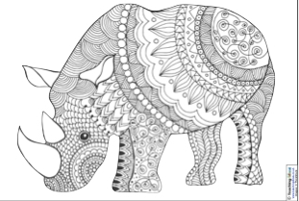 | Give the gift of your time – spend some time with a friend or family member or someone who needs cheering up.  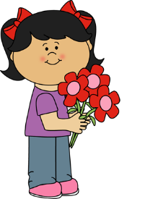  Do something helpful around the house. Helping is a great way to make us and other people feel good.  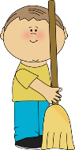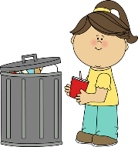 | Try a yoga pose.  https://www.youtube.com/watch?v=ho9uttOZdOQ  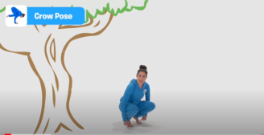  Go outside for a walk or a run!  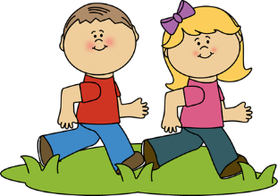 | Set a challenge you will enjoy achieving. Learning new things will make you more confident as well as being fun!  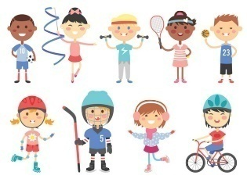  Try and learn a new recipe!  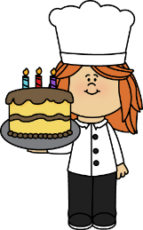
Create a collage “All about me!”  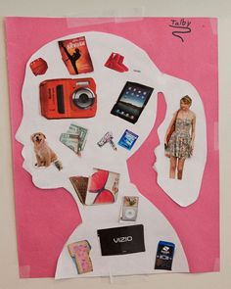 | Another meditation clip.  https://soundcloud.com/user-547419318/a-day-at-the-beach-visualisation-for-children-guided-by-gerard-1 | Watch the video about mindful drawing  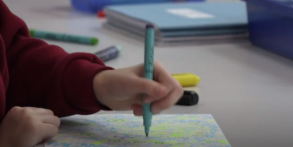  https://www.youtube.com/watch?v=Eyrj1P26yNg | Do a random act of kindness for someone at home.  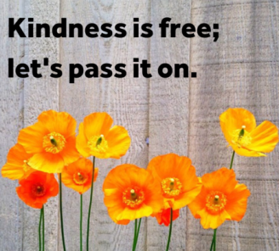 | Try a yoga session on Cosmic Kids yoga.  https://youtu.be/LhYtcadR9nw   | Play a new game or learn a new skill like origami or chess or something you will enjoy.  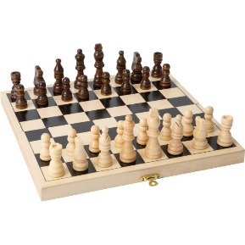
Decorate a wellbeing rock.  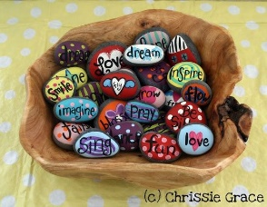 | Try out the Snake Breath. Sit in a comfortable position. Inhale through your nose and exhale through your mouth, making a long ‘Sssssss’ sound, like a snake. Try to make the exhalation last as long as you can before you inhale again.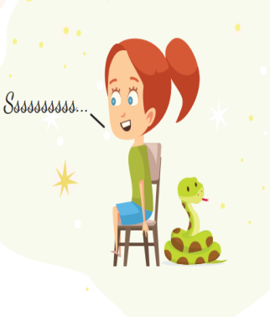 | Go on a calming nature walk and afterwards draw what you saw. Look for living and non-living things.  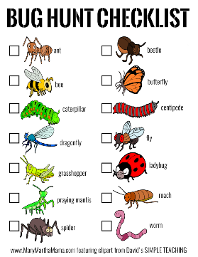  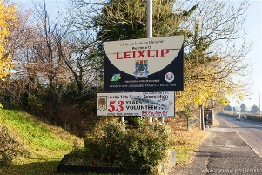 | Make a special effort to use your manners today –greeting people when you see them, smiling and saying thank you.   | https://www.youtube.com/watch?v=23VdtT0vQUY   | https://www.youtube.com/watch?v=cZdO2e8K29o  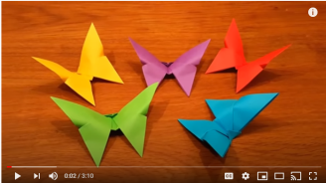

Make your own personal bookmark.  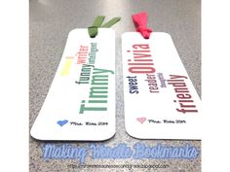  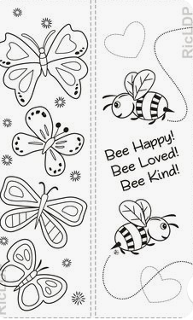 | Try out the Bee Breath method, follow the link below.  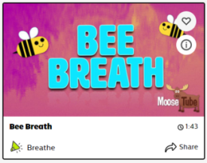  https://app.gonoodle.com/activities/bee-breath?s=category&t=Breathe&sid=40  Listen to the sound clip:  https://soundcloud.com/user-547419318/the-hot-air-balloon-deirdre-lavelle-1 | Make a calm jar!  https://www.youtube.com/watch?v=KcygQajnBmo  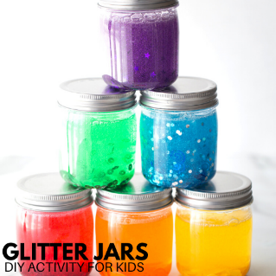 | Think of 3 things you are grateful for today and do this exercise often. Some people write these down in a journal.    1.What is the best thing that happened today?  2.Name something that makes you happy.  3.What is your favourite outdoor activity?  4.Name something that you are grateful to have.  5.Name someone that makes you smile.  6. Who makes you feel loved and why? | Try a Go Noodle activity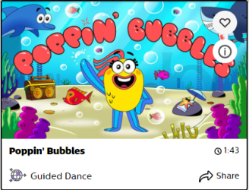  https://app.gonoodle.com/activities/poppin-bubbles?s=category&t=Guided%20Dance&sid=38 | Do something to make yourself or your friends feel good.  https://app.gonoodle.com/activities/help-others?s=Search&t=kindness  
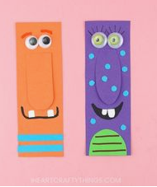 | https://soundcloud.com/user-547419318/the-sleepy-train-visualisation-for-children-guided-by-ciara   | Listen to a mindful story.  https://www.youtube.com/watch?v=bYKKPfTPG5g  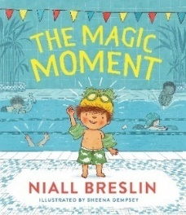 | 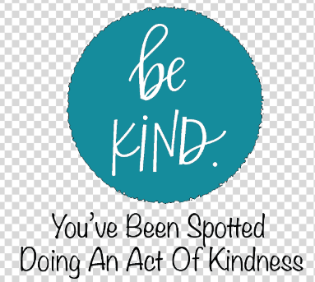 | Dance, dance, dance!  https://app.gonoodle.com/activities/dance-dance-dance?s=Search&t=dance   | Think of other ways you can keep learning and feel good.  

