Wednesday May 6th 2020
3rd Class Ms Hughes
English (My Read at Home and Get Set are available online see webpage)
- My Spelling Workbook pg 58 Unit 15
Today’s spellings: crept-kept (LCWC) Write spelling 3 times.
Write 4 sentences with each spelling word.
Answer Q1+2 pg 58 My Spelling Workbook
- Writing- Look at A and read the letter Cian wrote to his cousin Jane. Answer the questions orally.
Answer Q B Write a letter to a relative telling them about a special place you visited, or write a letter to a relative or friend telling them what you’ve been doing at home since COVID 19 happened. (Post the letter if possible with permission)
- My Read at home- Read the next page and answer questions orally.
- Library Book- Read your library book or listen to a story on www.storylineonline.net/library/ or Elevenses with David Walliams

Maths
- Mental Maths Book- Week 30 pg 84 complete Monday
- Tables Champion- Week 29 pg 38 complete Monday
- Warm Up-Word Problem
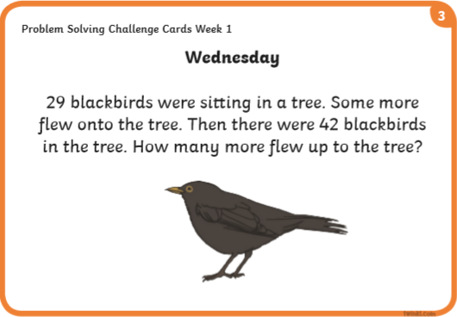
- What is area? Click on this link to find out more.
https://youtu.be/_uKKl8R1xBM
- Planet Maths- Topic 23:Area pg 138
Estimate, compare and measure the area of regular and irregular shapes
Answer QA-D pg 138
Answer QA+B pg 139

Gaeilge
- Seanfhocail: Ní neart go cur le chéile (There is strength in unity)
- Téama: An Aimsir (The Weather) Continued
- Litriú: An t-Earrach (Spring) + An Samhradh (summer). Write 3 times in copy like spellings.
- Log into Folens online and find Scéal 16. Éist agus léigh.

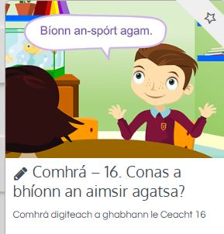
- Answer Ceist F lch 133 Is breá liom…

Religion
- Log in to ‘Grow in Love’ https://www.growinlove.ie/en/ and access the 3rd class materials.
- Email: trial@growinlove.ie Password: growinlove
- Select Third Class. Click into Theme 8: The Church is a Community of Believers Lesson 3: Baptism
- Listen to the song The Spirit of God is upon us
- Read about belonging on page 70 and complete activity

Well-being
- Happy Memory Snapshots
- Talk about what the happiest times in your life are.
- Draw and write about these on pg 2 of the activity journal
- Choose a Well-being activity different from last time
https://padlet.com/thirdclassmshughes/7nelhuv6lglw4ti6

