Wednesday May 27th 2020
3rd Class Ms Hughes
For additional support see https://padlet.com/thirdclassmshughes/7nelhuv6lglw4ti6
English (My Read at Home and Get Set are available online see webpage)
- My Spelling Workbook pg 64 Unit 16
Today’s spellings: ward-swarm (LCWC) Write spelling 3 times.
Write 4 sentences with each spelling word.
Answer Q9 Word Search Any 16 Words pg 65 My Spelling Workbook
- Get Set –Review Famous Irish Landmarks pgs 236-239
- Answer QD 1-5 Orally. Answer QE pg 241 Write the questions
- My Read at home- Read the next page and answer questions orally.
- Library Book- Read your library book or listen to a story on www.storylineonline.net/library/ or Elevenses with David Walliams

Maths (Planet Maths available online see webpage)
- Mental Maths Book- Week 33 pg 87 complete Wednesday
- Tables Champion- Week 32 pg 41 complete Wednesday

- Warm Up- Word Problem
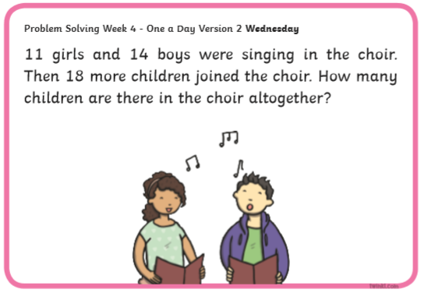

Planet Maths- Topic 26: Capacity pg 159 (Addition)
Solve and complete practical tasks and problems involving the addition of capacity (l, ml).
- Access Folens online and play the Capacity game https://content.folensonline.ie/programmes/PlanetMaths/PM3/resources/activities/pm_3c_159/capacity.html
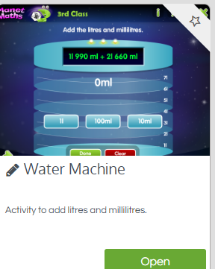
- Answer QB 1-9 Adding litres
- Optional answer QC
- Remember what to do if you need to regroup
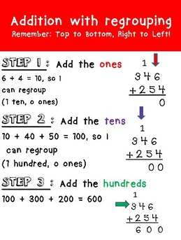

- Make sure your answer is in litres(l) and milliltres (ml)
- The answer for the example above would be 600ml
- If the answer was 1,600 you would write it like this 1 litre and 600 ml
Gaeilge
- Téama: Caitheamh Aimsire (Past Times)
- Litriú: pianó(piano) + trumpa(trumpet). Write 3 times in copy like spellings. Draw a picture of a pianó agus trumpa and label.
- Féach ar https://youtu.be/ICw5G9TAJfg. After watching try asking the ceist and answering it Cén caitheamh aimsire is fear leat?
- Draw the ceist in a speech bubble in your copy. Draw another speech bubble answering the ceist.
- Déan 10 as 10 https://rtejr.rte.ie/10at10/ as gaeilge

Religion
- Log in to ‘Grow in Love’ https://www.growinlove.ie/en/ and access the 3rd class materials.
- Email: trial@growinlove.ie Password: growinlove
- Select Third Class. Click into Theme 10: The Mass
Lesson 1: At Mass We Listen to the Word of God
- Read page 81 of the ebook and chat about it.
- In resource section do the interactive matching activity.
Science
- How does light travel from one place to another?
- Watch the following video about Light https://youtu.be/3kAbRFL42ok
- Watch again and stop to answer these questions
- What is light?
- How does light move?
- What can light pass through?
- What happens when light bends?
- Read Ch 18 Travelling Light pages 93-96 Science Windows on the World. Access the book on edco online if you don’t have it.
- If possible complete the Let’s Investigate and Find out More activities on page 94. Use template to record.
- Check out some light and dark activities https://www.sciencekids.co.nz/gamesactivities/lightdark.html
Optional Choiceboard
- Choose a different activity to do each day.

