Wednesday June 3rd 2020
3rd Class Ms Hughes
For additional support see https://padlet.com/thirdclassmshughes/7nelhuv6lglw4ti6
English (My Read at Home and Get Set are available online see webpage)
- My Spelling Workbook pg 66 Unit 17
Today’s spellings: explore-adore (LCWC) Write spelling 3 times.
Write 4 sentences with each spelling word.
Answer Q1 Changing Letters pg 66 My Spelling Workbook
- My Read at home- Read the next page and answers questions orally.
- Library Book- Read your library book or listen to a story on www.storylineonline.net/library/ or Elevenses with David Walliams
Maths
- Mental Maths Book- Week 34 pg 88 complete Monday & Tuesday
- Tables Champion- Week 33 pg 42 complete Monday & Tuesday
- Warm Up- Word Problem
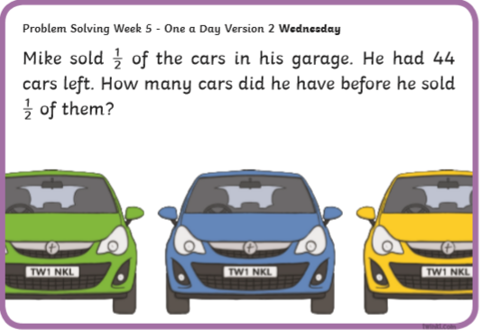
- Planet Maths
Page 150 Mental Maths 6 Answer QA1-10

Gaeilge
- Téama: Ócaidí Speisialta (Special Occasions)
- Litriú: bainis (wedding) + comhghairdeas (congratulations).
Write 3 times in copy like spellings.
- Déan 10 as 10 https://rtejr.rte.ie/10at10/ as gaeilge
- Féach ar lch 156+157
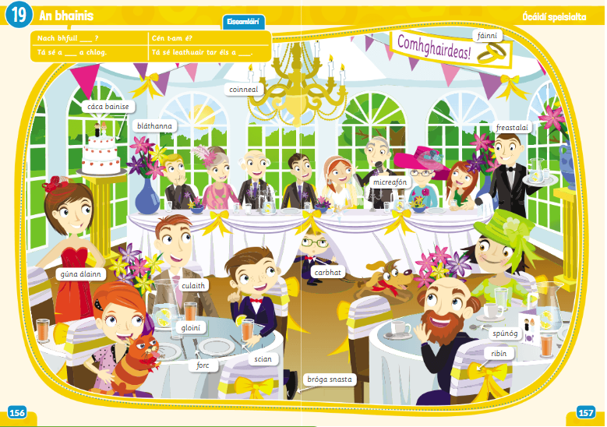
- See padlet- Foclóir video.
- Do the interactive activity online. Listen to the new vocabulary, try to say the words and match to correct picture.
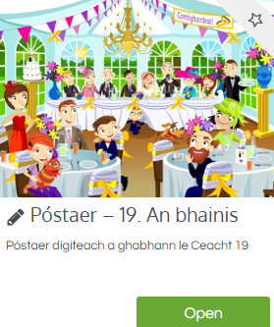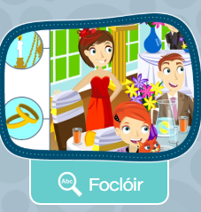

Religion
- Log in to ‘Grow in Love’ https://www.growinlove.ie/en/ and access the 3rd class materials.
- Email: trial@growinlove.ie Password: growinlove
- Select Third Class. Click into Theme 10: The Mass
Lesson 2: At Mass We Remember and Give Thanks
- In resource section, look at the poster and chat about it.
- Read page 82 of Grow in Love. Look at the pictures and answer the questions.

Well-being
- Challenge yourself to do three kind things for others each day, Complete the journal activity page.
- Choose a Well-being activity from padlet that you haven’t yet done

Geog/English (Intercultural Project)
These tasks can be used as a foundation for the project or as part of it.
- Look at the powerpoint Continents of the World and chat about it.
- On the world map, identify the continents. Colour each continent a different colour. All countries in each continent should be the same colour.

Intercultural Project
Intercultural Day was scheduled to be celebrated in school on June 5th. Students in Scoil Mhuire are being assigned a project based on a country of their choice. The whole idea is to research a country and culture that you might not know about, or have a connection with, but the choice is yours!
The project will run from June 3rd-12th. Siblings can work together. Projects can be in a format of choice, A4 report, poster, powerpoint etc. I will share some templates that might help.
Keep an eye on the website as Mrs. Dowling will be giving more details about it.
Have fun researching!

