Wednesday June 10th 2020
3rd Class Ms Hughes
For additional support see https://padlet.com/thirdclassmshughes/7nelhuv6lglw4ti6
English (My Read at Home and Get Set are available online see webpage)
- My Spelling Workbook pg 68 Unit 17
Today’s spellings: Italy-knife (LCWC) Write spelling 3 times.
Write 4 sentences with each spelling word.
Answer Q7 Word Ghost pg 68 My Spelling Workbook
Answer Q8 Compound Words pg 68 My Spelling Workbook
- Work on Intercultural project if not yet completed
- My Read at home- Read the next page & answer questions orally.
- Library Book- Read your library book or listen to a story on www.storylineonline.net/library/ or Elevenses with David Walliams
Maths (Planet Maths available online see webpage)
- Mental Maths Book- Week 35 pg 89 complete Wednesday
- Warm Up- Word Problem
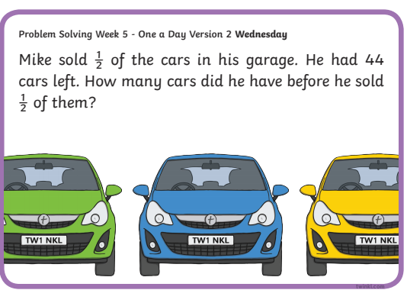

Planet Maths- Topic 27: Time 2 pg 164
Read dates from calendars and express weeks as days and vice versa.
- Access Folens online and try the activity to change minutes to
hours and minutes
https://content.folensonline.ie/programmes/PlanetMaths/PM3/resources/activities/pm_3c_163/index.html
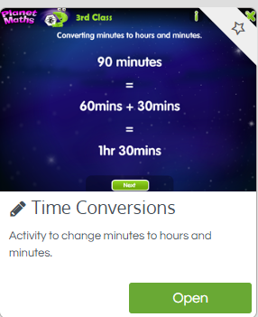
- Answer QA 1-9 pg 164
- Optional answer QA 10

Gaeilge
- Téama: Caitheamh Aimsire (Past Times)
- Déan 10 as 10 https://rtejr.rte.ie/10at10/ as gaeilge
- Féach ar na dathanna agus léigh. Look at the colours and read.
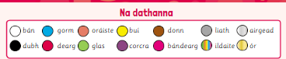
- Abair Liom D1-5 lch 160
Cad a bhí ar gach duine? What was everyone wearing?
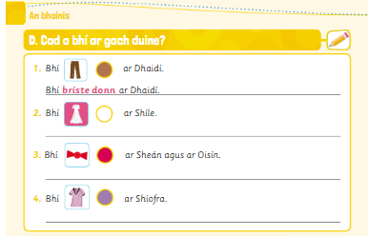

Religion
- Log in to ‘Grow in Love’ https://www.growinlove.ie/en/ and access the 3rd class materials.
- Email: trial@growinlove.ie Password: growinlove
- Select Third Class. Click into Seasonal/Additional Lessons
- Check back or look at an additional lesson of your choice
- Read the pages in your book and chat about it.

Well-being
- Get Creative. Use your imagination to invent new creatures. Complete the journal activity page 12.
- Choose a Well-being activity from padlet that you haven’t yet done

Intercultural Project
- Work on country project if not completed.

Optional Choiceboard
- Choose a different activity to do each day.

