Tuesday May 26th 2020
3rd Class Ms Hughes
For additional support see https://padlet.com/thirdclassmshughes/7nelhuv6lglw4ti6
English (My Read at Home and Get Set are available online see webpage)
- My Spelling Workbook pg 64 Unit 16
Today’s spellings: litre-warden (LCWC) Write spelling 3 times.
Write 4 sentences with each spelling word.
Answer Q7 Word Warrior pg 64 My Spelling Workbook
Answer Q8 Antonyms pg 64 My Spelling Workbook
- Get Set –Read pages pgs 238-239 Famous Irish Landmarks
- Answer QB 6-10. Answer QC orally.
- My Read at home- Read the next page and answer questions orally.
- Library Book- Read your library book or listen to a story on www.storylineonline.net/library/ or Elevenses with David Walliams

Maths (Planet Maths available online see webpage)
- Mental Maths Book- Week 33 pg 87 complete Tuesday
- Tables Champion- Week 32 pg 41 complete Tuesday

- Warm Up- Word Problem
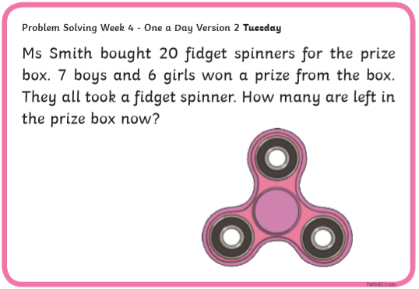
- Planet Maths- Topic 26: Capacity pg 158 (Estimating + Measuring)
Estimate, compare, measure and record the capacity of a wide variety of objects using appropriate metric units (l, ml).
- Watch https://youtu.be/QMpkm4dAB4w
- Answer QA+B pg 158

Gaeilge
- Téama: Caitheamh Aimsire (Past Times)
- Litriú: drummaí(drums) + bosca ceoil(music box). Write 3 times in copy like spellings.
- Draw a picture of a drummaí agus bosca ceoil and label.
- Féach ar https://youtu.be/ICw5G9TAJfg. After watching try saying
- Is maith/breá liom…..
- Ní maith/ Is Fuath liom…..

Religion
- Log in to ‘Grow in Love’ https://www.growinlove.ie/en/ and access the 3rd class materials.
- Email: trial@growinlove.ie Password: growinlove
- Select Third Class. Click into Theme 10: The Mass
Lesson 1: At Mass We Listen to the Word of God
- Read pages 80 of the ebook and chat about it.
- In resource section do the interactive sequencing activity.

PE
- Tuesday is normally our PE day. Do this work out with Joe Wicks instead https://youtu.be/Y2AkYD10d7Q
- Choose an activity you haven’t done in the PE or Well-being column on padlet.

