Tuesday May 12th 2020
3rd Class Ms Hughes
English (My Read at Home and Get Set are available online see webpage)
- My Spelling Workbook pg 60 Unit 15
Today’s spellings: swift-lift (LCWC) Write spelling 3 times.
Write 4 sentences with each spelling word.
Answer Q6 Proof Reading pg 60 My Spelling Workbook
- Get Set –Read pages pgs 216-220 Spy Dog
- Answer QD Quest and query 1-5.
- My Read at home- Read the next page and answer questions orally.
- Library Book- Read your library book or listen to a story on www.storylineonline.net/library/ or Elevenses with David Walliams
Maths (Planet Maths available online see webpage)
- Mental Maths Book- Week 31 pg 85 complete Tuesday
- Tables Champion- Week 30 pg 39 complete Tuesday
- Warm Up- Word Problem
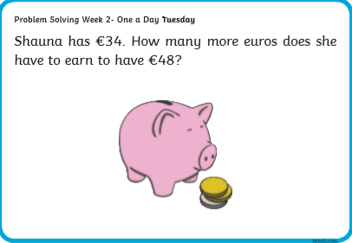
- Planet Maths- Topic 24:Division pg 144
Divide a two-digit number by a one-digit number without remainders
Answer QB 1-6 Orally
Watch https://youtu.be/trjepeOy2rc
Answer QA 1-15 on paper
Optional QB 7 and QC
Gaeilge
- Téama: Caitheamh Aimsire (Past Times)
- Litriú: rugbaí(rugby) + iománaíocht (hurling). Write 3 times in copy like spellings.
- Log in to Folens online and listen to the comhrá. Read along on lch143 agus déan ceist C1-5 Tá mé go maith…
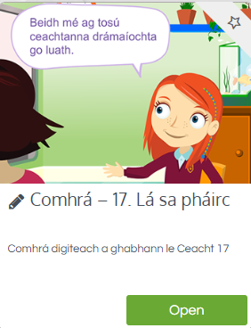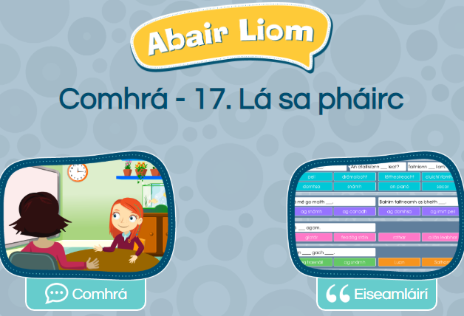
Religion
- Log in to ‘Grow in Love’ https://www.growinlove.ie/en/ and access the 3rd class materials. Email: trial@growinlove.ie Password: growinlove
- Select Third Class. Click into Theme 9: Celtic Christianity
Lesson 1: Early Christian Ireland
- In the resource section, watch the video about St. Kevin and the Blackbird.
PE
- Tuesday is normally our PE day. Do a work out with Joe and Rosie instead https://youtu.be/QvWzWqLk8iQ
- Choose an activity you haven’t done in the PE or Well-being column on padlet.

Optional Choiceboard
- Choose a different activity to do each day.

