Tuesday June 16th 2020
3rd Class Ms Hughes
For additional support see https://padlet.com/thirdclassmshughes/7nelhuv6lglw4ti6
English (My Read at Home and Get Set are available online see webpage)
- My Spelling Workbook pg 70 Unit 18
Today’s spellings: lighter-prawns (LCWC) Write spelling 3 times.
Write 4 sentences with each spelling word.
Answer Q3 Crossword pg 71 Across Clues My Spelling Workbook
- My Read at home- Read the next page & answer questions orally.
- Library Book- Read your library book or listen to a story on www.storylineonline.net/library/ or Elevenses with David Walliams
Maths (Planet Maths available online see webpage)
- Mental Maths Book- Week 36 pg 107-109 complete Tuesday
Complete Tuesday for the week that you are on. Some people are on different weeks.
- Warm Up- Word Problem
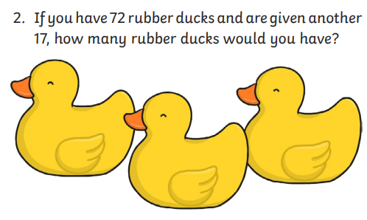
- Planet Maths- Revision pg 167 Rounding
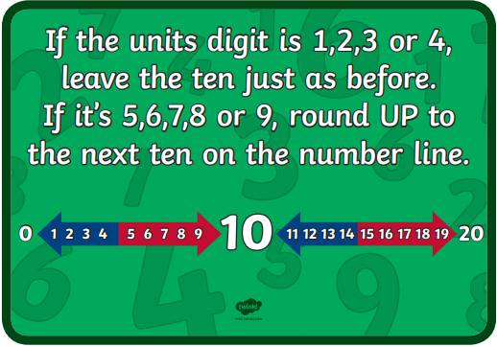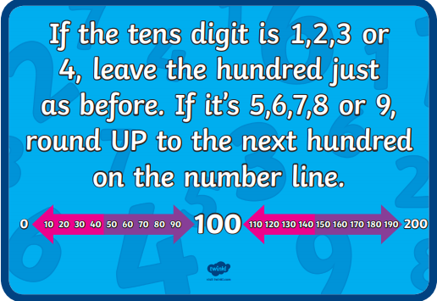

- Answer Q1+2 page 167
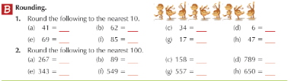
Gaeilge
- Téama: Ócáidí Speisialta (Special Occasions)
- Abair Liom lch 164
- Go on to folens online and listen to the scéal https://content.folensonline.ie/programmes/AbairLiom/3rd_class/resources/Passage/AL_3C_ACT_PAS_CH20_002/index.html
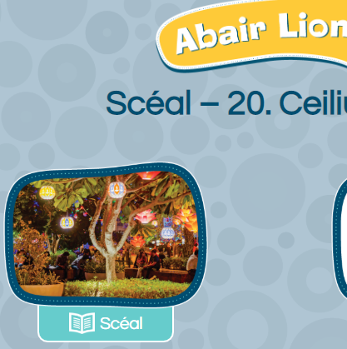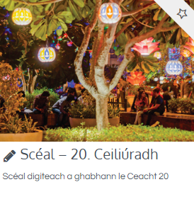
- Go to padlet and listen to the translation.
- Listen to the scéal on folens online again and follow along in your Abair Liom
- Try and read it yourself. Maith thú!

PE
- Tuesday is normally our PE day. Do this work out with Joe Wicks instead https://www.youtube.com/watch?v=v4ShRREe26w
- Spell your name out and do the activities
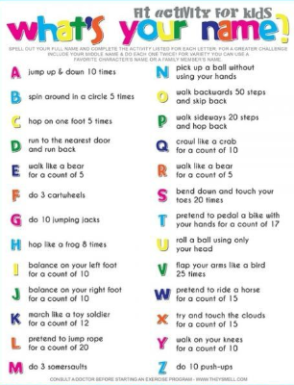
- Choose an activity you haven’t done in PE/Well-being on padlet.

