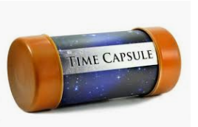

Time to create a time capsule.
You will need:
- An empty container e.g. small cardboard box, empty plastic container, small used cereal box.
- Paper
- Pencil/Pen
- Markers or colouring pencils

Instructions:
- Write a letter to your future selves. Tell them about yourself – what you like to eat / like to drink / what your hobbies are / what class you are in / what age you are / who your friends are / what you want to be when you grow up. Don’t forget to date your letter e.g. 23rd March 2020.
- Collect some food wrappers / labels of things you like.
- Draw a picture or your family or include a photograph.
- Trace around your hand so your future self can compare hand sizes with you.
- Ask your parents for today’s newspaper or write down the main headlines from RTE / Virgin Media news today.
- Put all of the above in your container or box (decorate the box if you wish).
- Ask a parent to help you to bury the box in your back garden or hide it in the attic of your house.
- Find the box and open it in ten years time!

