Thursday May 28th 2020
3rd Class Ms Hughes
For additional support see https://padlet.com/thirdclassmshughes/7nelhuv6lglw4ti6
English (My Read at Home and Get Set are available online see webpage)
- My Spelling Workbook pg 64 Unit 16 Suffixes –y words
Today’s spellings: wardrobe-second (LCWC) Write spelling 3 times.
Write 4 sentences with each spelling word.
Answer Q9 Word Search Remaining 16 Words pg 65 My Spelling Workbook
- Get Set –pg 236-239 Choose one of the Irish Landmarks and write a fact file about it. Use the template or on your own paper.
- My Read at home OR Library Book
Read your library book or listen to a story on www.storylineonline.net/library/ or Elevenses with David Walliams

Maths (Planet Maths available online see webpage)
- Mental Maths Book- Week 33 pg 87 complete Thursday
- Tables Champion- Week 32 pg 41 complete Thursday
- Warm Up- Word Problem
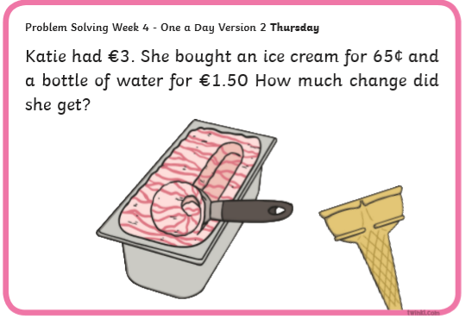
- Planet Maths- Topic 26: Capacity pg 160 (Add or subtract)
Solve and complete practical tasks and problems involving the addition of capacity (l, ml).
- Answer QA+B1-3 pg 160
- Remember what to do if you need to regroup
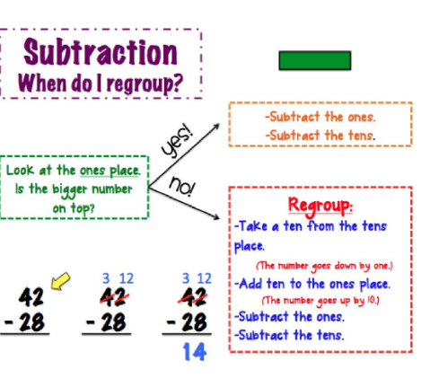

- Make sure your answer is in litres (l) and milliliters (ml).
- For the example above the answer would be 14 ml.
Gaeilge
- Téama: Caitheamh Aimsire (Past Times)
- Litriú: fidil(fiddle) + damhsa (dancing). Write 3 times in copy like spellings.
- Draw a picture of a fidil agus damhsa and label.
- Déan 10 as 10 https://rtejr.rte.ie/10at10/ as gaeilge
Religion
- Log in to ‘Grow in Love’ https://www.growinlove.ie/en/ and access the 3rd class materials.
- Email: trial@growinlove.ie Password: growinlove
- Select Third Class. Click into Theme 10: The Mass
Lesson 1: At Mass We Listen to the Word of God
- In resource section listen to some reflective music.
- Review pages 79-81 of the ebook and chat about it.

Art (linked to yesterday’s Science)
- Review light from yesterday-What can light pass through? What happens when light bends?
- Take a photo (with permission) showing light and dark and email it to me by Monday 31st if you can!
- Here are some ideas
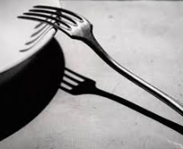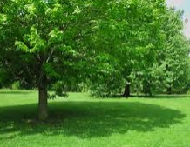

Optional Choiceboard
- Choose a different activity to do each day.

