Thursday May 21st 2020
3rd Class Ms Hughes
For additional support see https://padlet.com/thirdclassmshughes/7nelhuv6lglw4ti6
English (My Read at Home and Get Set are available online see webpage)
- My Spelling Workbook pg 62 Unit 16 Suffixes –y words
Today’s spellings: dried-carries (LCWC) Write spelling 3 times.
Write 4 sentences with each spelling word.
Answer Q4 Tenses pg 63 My Spelling Workbook
- Get Set –pg 235 Similes- Explain what a similie is in your own words and give an example. Complete QG 1-5 Watch your Ps and Qs.
- My Read at home OR Library Book
Read your library book or listen to a story on www.storylineonline.net/library/ or Elevenses with David Walliams

Maths (Planet Maths available online see webpage)
- Mental Maths Book- Week 32 pg 86 complete Thursday
- Tables Champion- Week 31 pg 40 complete Thursday
- Warm Up- Word Problem
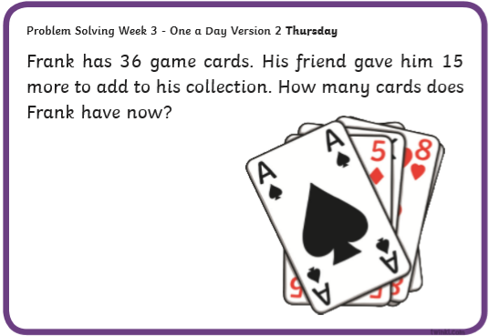
- Planet Maths- Topic 25: 3D Shapes pg 155
Explore, describe and compare properties of 3D shapes.
Solve and complete practical tasks and problems involving 2D and 3D shapes.
- Revise the properties of 3D shapes https://www.bbc.co.uk/bitesize/topics/zjv39j6/articles/zgqpk2p
- Answer QA+B pg 155

Gaeilge
- Téama: Caitheamh Aimsire (Past Times)
- Litriú: cluiche (match) + ceol (music). Write 3 times in copy like spellings.
- Scéal: Éist leis an scéal again.
- Answer QA Freagair na Ceisteanna lch 149
Geography
- Find out about the planets in our solar system. Watch this https://youtu.be/d8y8kc317EE .
- Read Ch 12 Our Planet in Space pages 72-77 Geography Windows on the World. Access the book on edco online if you don’t have it.
- Answer questions 1-9 orally on page 75.
- Read and colour the planets worksheet. (This will be needed for Art)

Optional Choiceboard
- Choose a different activity to do each day.

