Thursday May 14th 2020
3rd Class Ms Hughes
For additional support see https://padlet.com/thirdclassmshughes/7nelhuv6lglw4ti6
English (My Read at Home and Get Set are available online see webpage)
- My Spelling Workbook pg 60 Unit 15
Today’s spellings: soar-score (LCWC) Write spelling 3 times.
Write 4 sentences with each spelling word.
Answer Q8 Word Search pg 61 My Spelling Workbook
- Get Set –Verbs (past+ present). Explain what a verb is and give an example. Complete QG Watch your Ps and Qs.
- My Read at home OR Library Book
Read your library book or listen to a story on www.storylineonline.net/library/ or Elevenses with David Walliams

Maths (Planet Maths available online see webpage)
- Mental Maths Book- Week 31 pg 85 complete Thursday
- Tables Champion- Week 30 pg 39 complete Thursday
- Warm Up- Word Problem
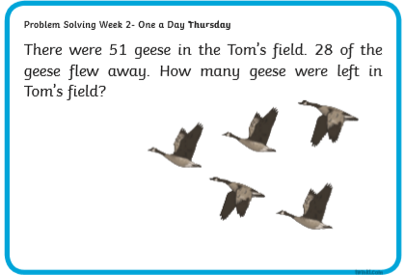
- Planet Maths- answer in Math copy if you have it or on any paper you have Topic 24:Division 3 pg 146
Divide a two-digit number by a one-digit number with remainder
Watch https://youtu.be/4CLEXtD5S7s
Answer QA 1-10 pg146
Optional QB and C
Gaeilge
- Téama: Caitheamh Aimsire (Past Times)
- Litriú: leadóg (tennis) + snámh (swimming). Write 3 times in copy like spellings.
- Déan Ceist F Briathra Aimsir Chaite (Past Tense Verbs)lch 145
Religion
- Log in to ‘Grow in Love’ https://www.growinlove.ie/en/ and access the 3rd class materials. Email: trial@growinlove.ie Password: growinlove
- Select Third Class. Click into Theme 9: Celtic Christianity
Lesson 1: Early Christian Ireland
- In the resource section, watch the video about St. Kevin and the Otter.

Science/Engineering Project (See Wednesday)
- Work on Spaghetti Tower Challenge
This project can be completed over a few days and other members of the family can help. You have a week to work on this. Email photo’s of finished towers (landscape photos are best) on or before Wednesday 18th May.
- Plan and Create
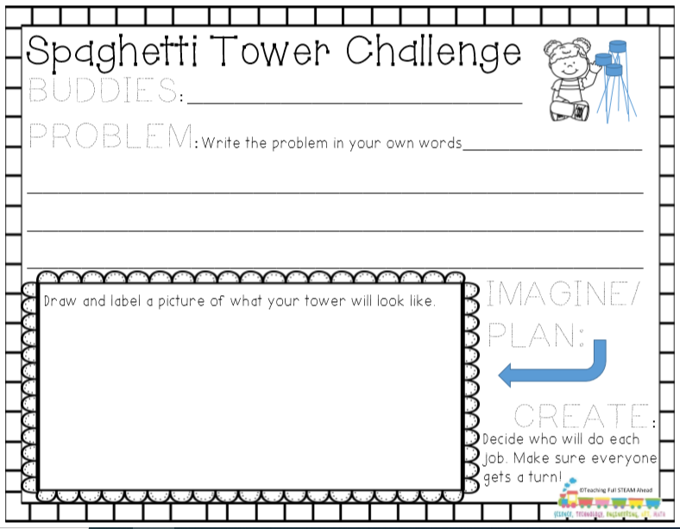

- Test and Improve
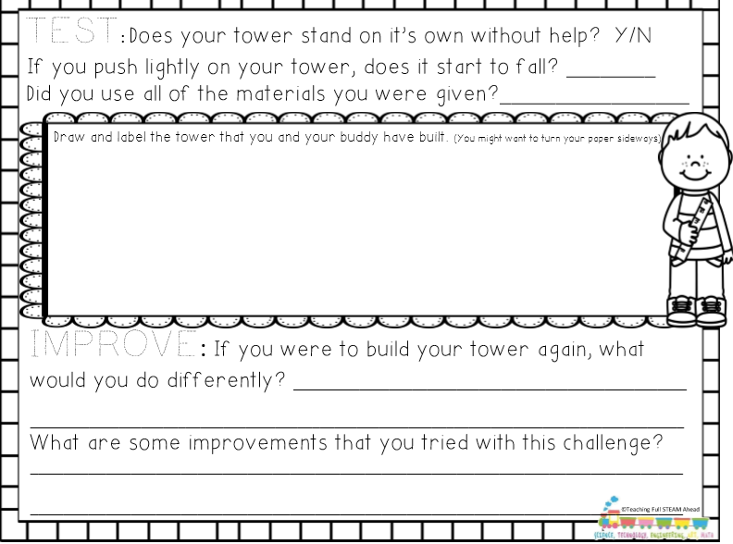

- Data Collection
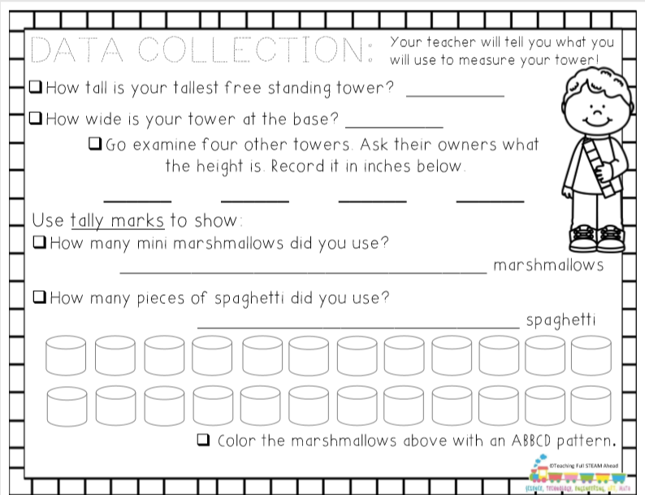

- Evaluate- What would you improve? What worked well? What didn’t work too well? What did you learn?

Optional Choiceboard
- Choose a different activity to do each day.

