Thursday June 4th 2020
3rd Class Ms Hughes
For additional support see https://padlet.com/thirdclassmshughes/7nelhuv6lglw4ti6
English (My Read at Home and Get Set are available online see webpage)
- My Spelling Workbook pg 66 Unit 17
Today’s spellings: shore-store (LCWC) Write spelling 3 times.
Write 4 sentences with each spelling word.
Answer Q2 Missing Letters pg 66 My Spelling Workbook
- My Read at home- Read the next page and answer questions orally.
- Library Book- Read your library book or listen to a story on www.storylineonline.net/library/ or Elevenses with David Walliams
Maths (Planet Maths available online see webpage)
- Mental Maths Book- Week 34 pg 88 complete Wednesday & Thursday
- Tables Champion- Week 33 pg 42 complete Wednesday
- Warm Up- Word Problem
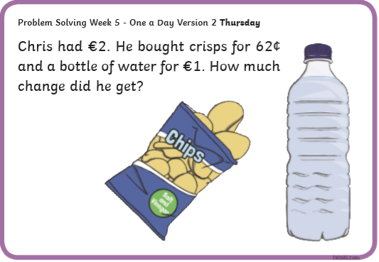
- Planet Maths
Page 150 Mental Maths 6 Answer QB1-10
Gaeilge
- Téama: Ócaidí Speisialta (Special Occasions)
- Litriú: culaith (suit) + gúna álainn (lovely dress).
Write 3 times in copy like spellings.
- Déan 10 as 10 https://rtejr.rte.ie/10at10/ as gaeilge
- See padlet- Scéal video
- Éist leis an scéal ar Folens online
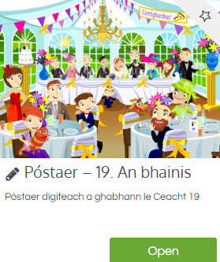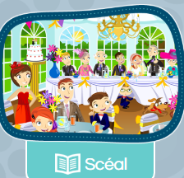
Religion
- Log in to ‘Grow in Love’ https://www.growinlove.ie/en/ and access the 3rd class materials.
- Email: trial@growinlove.ie Password: growinlove
- Select Third Class. Click into Theme 10: The Mass
Lesson 2: At Mass We Remember and Give Thanks
Read page 83 of the ebook and chat about it.
- In resource section do the interactive matching activity.

PE
- Do this Thursday work out with Joe Wicks https://youtu.be/g8X1pvW3Spg
- Choose an activity you haven’t done in the PE or Well-being column on padlet.

Geog/English (Intercultural Project)
These tasks can be used as a foundation for the project or as part of it.
- Look at the powerpoint Families around the World and chat about it.
- Alphabetical Countries Worksheet-Sort the countries into alphabetical order. You might need to look at an alphabet or draw one out to help. There are optional extra challenges but the main task is alphabetical order.

