Thursday June 18th 2020
3rd Class Ms Hughes
For additional support see https://padlet.com/thirdclassmshughes/7nelhuv6lglw4ti6
English (My Read at Home and Get Set are available online see webpage)
- My Spelling Workbook pg 70 Unit 18
Today’s spellings: honest-write (LCWC) Write spelling 3 times.
Write 4 sentences with each spelling word.
Answer Q4 Shape Sorter pg 71 My Spelling Workbook
- My Read at home- Read the next page and answer questions orally.
- Library Book- Read your library book or listen to a story on www.storylineonline.net/library/ or Elevenses with David Walliams
Maths (Planet Maths available online see webpage)
- Mental Maths Book- Week 36 pg 107-109 complete Thursday
Complete Thursday for the week that you are on. Some people are on different weeks.
- Warm Up- Word Problem
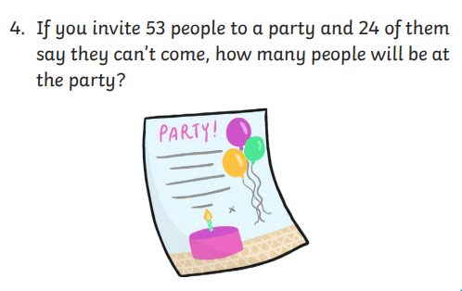

- Planet Maths- Revision: Time pg 168
- Access folens online and do the activity
https://content.folensonline.ie/programmes/PlanetMaths/PM3/resources/activities/pm_3c_020b/index.html
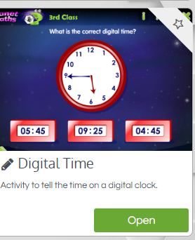

- Answer QA 1-4 pg 168

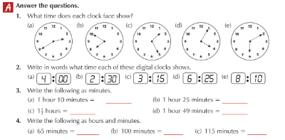

Gaeilge
- Téama: Ócáidí Speisialta (Special Occasions)
- Déan 10 as 10 https://rtejr.rte.ie/10at10/ as gaeilge
- Go on to folens online and listen to the scéal https://content.folensonline.ie/programmes/AbairLiom/3rd_class/resources/Passage/AL_3C_ACT_PAS_CH20_002/index.html
- Look at Abair Liom lch 165 Ceist B Ceangail
- Go to padlet and listen to the translation.

Geography
- Read Ch 14 My passport in Windows on the World.
We already did a lot of this work when we were doing the Intercultural project.
- See if you can find your passport, look at the information in and see if you have any stamps from different countries in it.
- Complete the passport worksheet.

Optional Choiceboard
- Choose a different activity to do each day.

