Work for Thursday 28th May
English :
- ‘What a Box’ Pg 37
- Free Writing : 15-20 minutes of free writing. If you don’t know how to spell a word try your best to Sound it out!.
- Wordbox 17A
- High Frequency Words 41 – 50
Gaeilge :
Bua na Cainte – Mé Féin 7.2
- Tá Teidí ____________ .
(ag léim, ag siúl, ag rith, ag súgradh, ag gol, ag gáire).
- Amhrán- Tá Teidí ag Rith: Play 2/3 times and join in.

Maths :
- Counting practise : count forwards and backwards to 20. Silent counting for every second number (1 out loud, 2 is silent, etc).
- Practise the shapes that we know : 2D – square, rectangle, triangle, circle, 3D – cube, cuboid, cylinder, sphere. Try to find some around the house.
- Continuing with money – Today we will be looking at adding different money – for example what is 2c + 1c + 1c. The children can use their fingers, or their number lines and coins if available. Or similarly use the cubes – 2c = 2 cubes or for 5c put 5 cubes.
- Small Planet Maths Book p.35
Religion :
Try some guided meditation for 10 mins- The link I have attached is a guided meditation so it will tell the children what to do.
https://www.youtube.com/watch?v=mV9BBR1RoGg

Art :
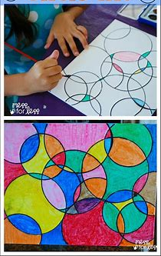
This week we are going to do some ‘Circle Art’. You draw loads of circles on a page, make sure they overlap in places – make them big and small and then you colour in the different spaces. Get an adult to draw the circles for you, or else use a glass (be careful) and trace around it.

