Sports Day Activities

It is possible to increase or decrease the level of challenge in any task using STTEP.
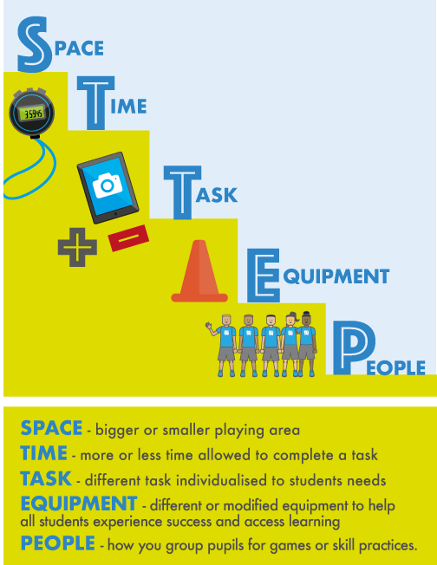

Equipment list
Equipment | Household Alternative
Ball | rolled up pair of socks
Bean bags | rolled up socks / socks filled with rice and securely closed
Cones | paper plates / cereal boxes / toy cars / books / water bottles
Sack | black bin bag
Skittles | used 2L Water bottles
Running

Activity 1 - Traffic Lights / Musical Statues
Description of Activity
Invite pupils to find a space in a large open playing area where they are not in
contact with anyone else. On a signal, pupils move around the playing area in
response to the following commands.
- The game leader holds up something red and the pupil must stop.
- The game leader holds up something orange and the pupil must walk.
- The game leader holds up something green and the pupil must run.
Variation:
This game could also be played with music instead of the colours and pupils must freeze when the music stops.

Activity 2 - Rock, Paper, Scissors Tag
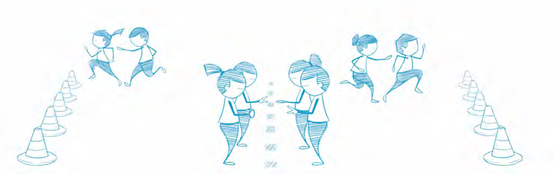
Description of Activity
Arrange pupils in pairs, standing one metre apart and facing each other. All pairs line up along a centre line with a safety line in place behind both sets of pupils. Each pair begins by performing a rock-paper-scissors routine. A rock is a closed fist, paper is a flat hand, and scissors are the index and middle fingers in a cutting position. Paper always covers rock, rock breaks scissors, and scissors cut paper. To determine a winner, pupils count to three and form a rock, paper, or scissors. The winning pupil then chases their partner toward their safety line, attempting to tag them before they are safe. Line up again and repeat the activity.

Throwing

Activity 3 - Knock ‘em Down Pinball
Description of Activity
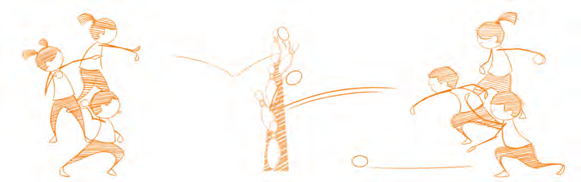
Pupils line up a distance apart, either side of a line of skittle targets (an alternative is to use water bottles) as shown. Groups take turns to roll a ball, trying to knock over a target in the middle. If a pupil successfully knocks over a skittle, they can claim this skittle and bring it over to their side. Continue playing until all of the skittles have been claimed.

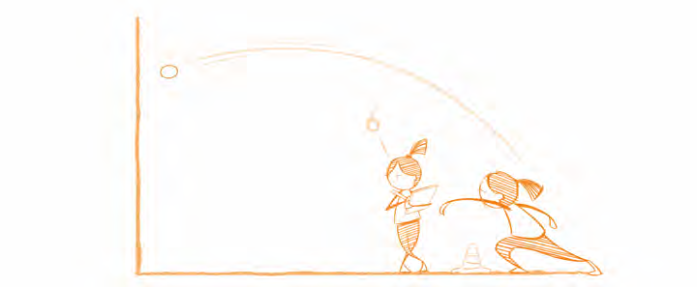
Activity 4 - Tennis Ball Challenge
Description of Activity
Pupils work in pairs, one throwing and the other counting. The aim is to throw the ball against the wall and catch it again as many times as possible in thirty seconds without it landing on the ground.

Activity 5 - Bowling
Description of Activity
Use cones to set up a bowling lane approximately five metres in length for each group. At the end of the bowling lane place five skittles as targets. Each bowler has three balls to knock over as many skittles as possible. All bowlers take a turn and then replace the knocked skittles. Keep your score. The pupil that knocks over the most skittles wins. Increase difficulty by increasing the distance between the thrower and the skittles or decreasing the width of the lane.
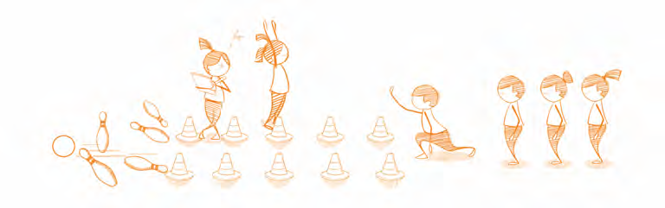

Kicking
Activity 6 - Through the Gate
Description of Activity
Arrange pupils in pairs with one ball per pair. Each pupil stands on a spot facing their partner who is also standing on a spot an appropriate distance away. Set up a gate between each pair using two cones. Pupil A attempts to kick the ball to pupil B through the gate. One point is awarded for each time the ball is successfully kicked through the gate.
Single pupils could play the game off a wall. Increase the distance to increase difficulty.

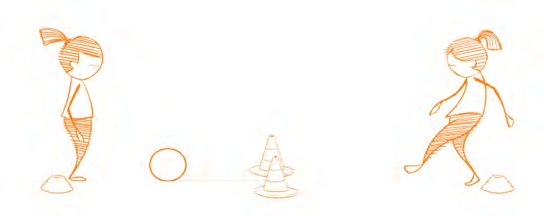

Activity 7 - Kick to Score
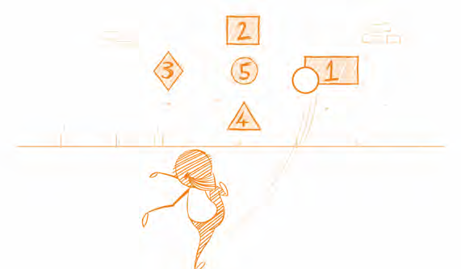
Description of Activity
Draw or stick target areas at various heights on a wall. Points should be placed in the centre of each target from one to five. Pupils are given a score to achieve, e.g. ten. Pupils must hit the targets on the wall to achieve that score. A variation of this could be to see who has the highest score after 2 minutes.

Activity 8 - Rebound Ball
Description of Activity
The pupil places a cone three to five metres from a wall within their designated playing area. This pupil then places their ball next to the skittle and kicks it, aiming to hit the skittle on the rebound (when the ball comes back off the wall if should hit the cone). If the cone is hit, the cone is then moved one metre further away from the wall.

Balancing
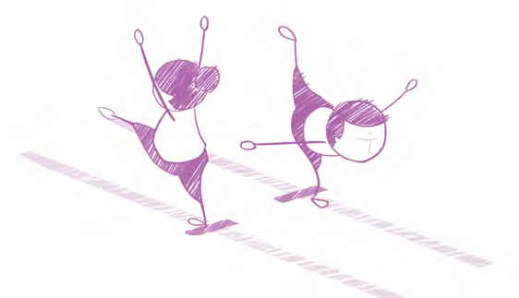
Activity 9 - Walk the Line
Description of Activity

Pupils walk along a line on the floor (this could be a line painted on the floor, a strip of tape or a line of spot markers). Invite pupils to:
- turn fully around in the middle without losing balance or toppling off the line
- complete the task with their eyes closed (in pairs with one pupil acting as a guide)
- hold a shape for a count of three as they balance on the line.

Traditional Sports Day

Activity 10 - Wheelbarrow Races

Description of Activity
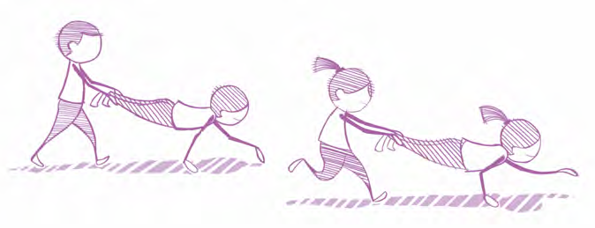
Arrange pupils in pairs. Set up two lines of cones, twenty metres apart and invite pupils to find some space along the line. One pupil adopts the high plank position and their partner lifts their legs below the knee. The pupil holding the high plank moves their hands to go forward, with their partner carrying their legs behind. Invite pupils to time themselves travelling from one cone to another.

Activity 11 - Obstacle Course
Description of Activity
Invite pupils to set up and run their own obstacle course. Use any equipment available - household or otherwise. Invite pupils to do the obstacle course, time themselves and try to beat their original time.

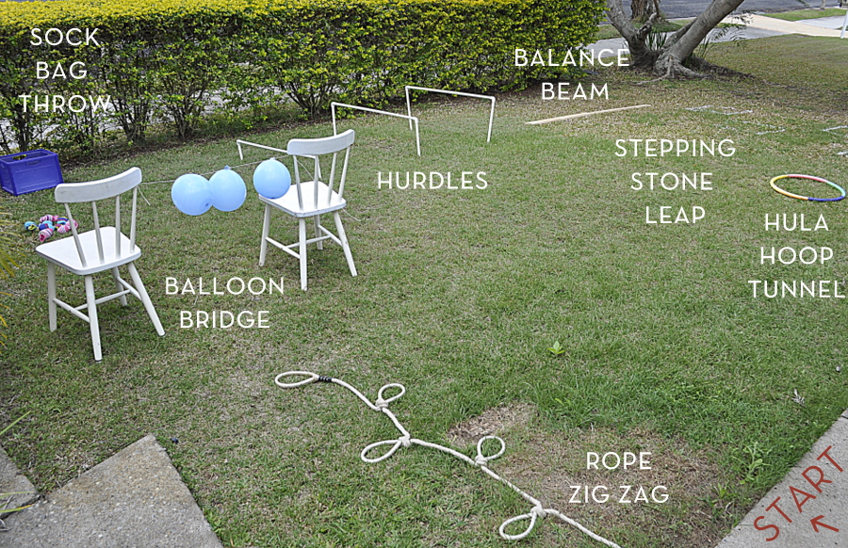

Activity 12 - Egg and Spoon Race
Description of Activity
Each pupil gets a spoon and an egg / potato. Each team must carry their egg on their spoon from the starting line to a turnaround point and back again. If the egg is dropped, the pupil must stop and retrieve it.

Activity 13 - Sack Race
Description of Activity
Each pupil puts both legs into sack and hops around a cone, or some marked point, and back. You could time the participants.

Activity 14 – Stations
Description of Activity
- Basketball shooting (Into a container if you don’t have a hoop)
- Football penalty shoot out
- Throwing bean bags at targets
- Bucket and sponge race… have an empty bucket / container a distance away from the starting point. At the starting point the pupil stands with a plastic top and beside them is a container full of water. The pupil fills the cup with water and races to the opposite bucket. They can time themselves completing the task or race against their siblings / parents. (A few holes could be inserted into the cups for older pupils!)

Activity 15 – Race to Solve the Jigsaw
Description of Activity
Place all the jigsaw pieces in a container a distance away from the starting point. Pupils race out to grab a single piece at a time and begin making their jigsaw back at the starting point. This activity can be timed or as a race against a sibling. It might be a good idea to make the jigsaw on a tray / flat surface at the starting point. You could also race out to grab some Lego and build something if you didn’t have a jigsaw.

Activity 16 - Cosmic Kids Yoga
Description of Activity
Choose an activity from the following website to complete. https://www.cosmickids.com/category/watch/

Activity 17 – Balloon Burst
Description of Activity
Pupils collect a balloon at the starting point and must run towards a chair positioned some distance away. Pupils sit on the balloon to burst them and race back to collect another balloon. This event can be timed or as a race against a sibling / parent.

Activity 18 – Novelty Races / Sprints
Description of Activity
- Three legged race
- Race with object balanced on head
- Race blindfolded with someone shouting directions
- Sprint – who can cross the line first?
- Create your own race!

