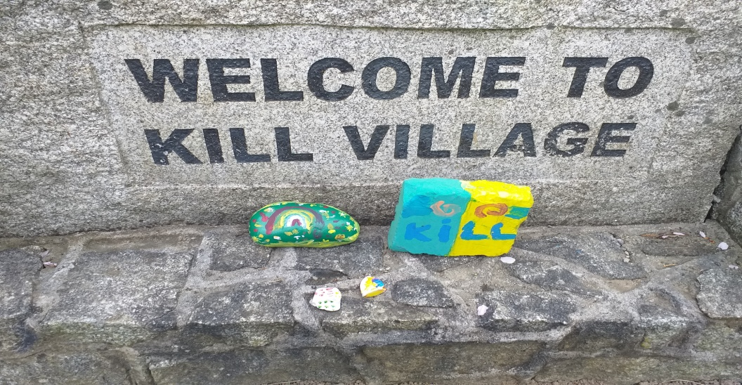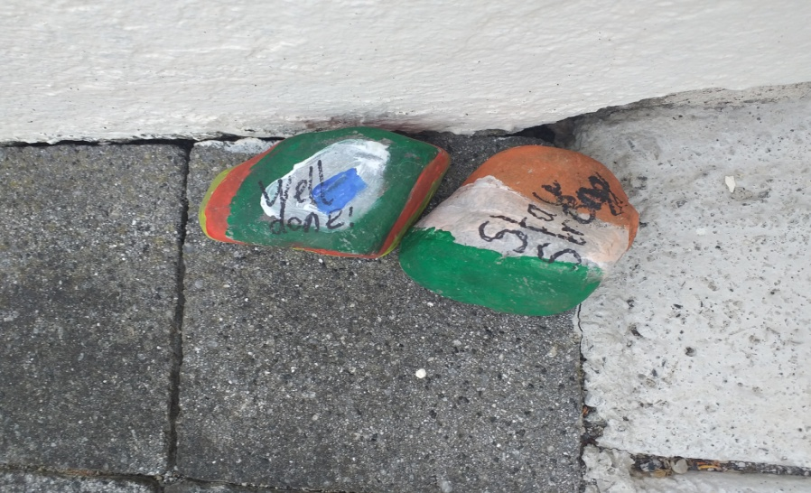

Have you seen painted stones around your town? People are leaving kind messages everywhere! We are going to make some to leave when we go on our walks, to cheer people up and make them smile!

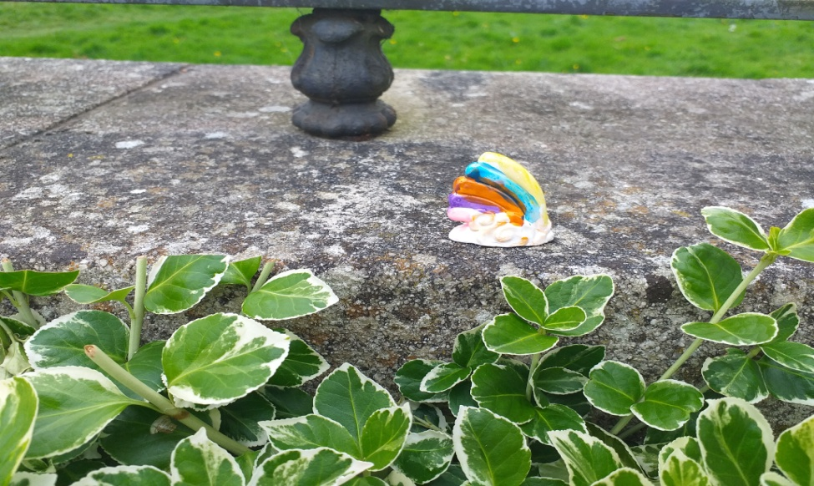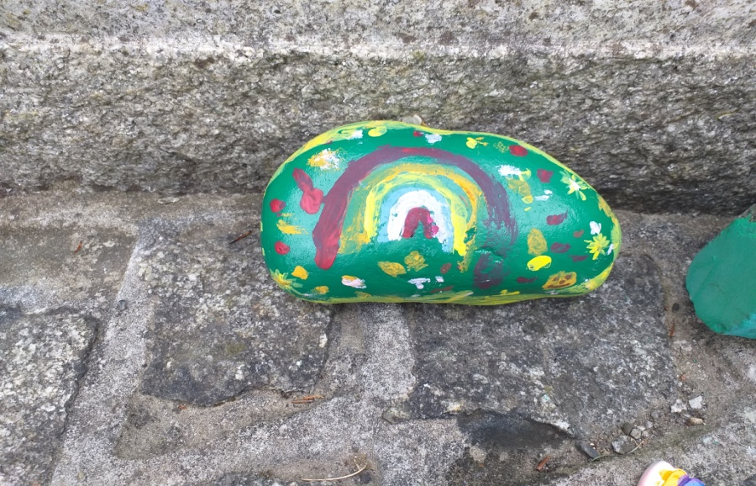
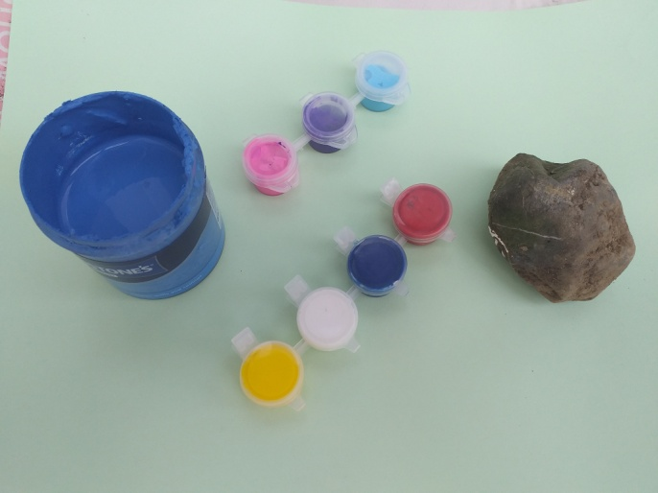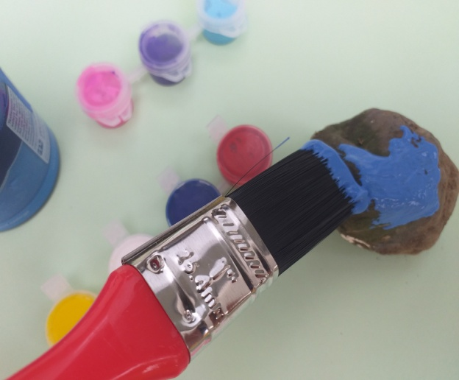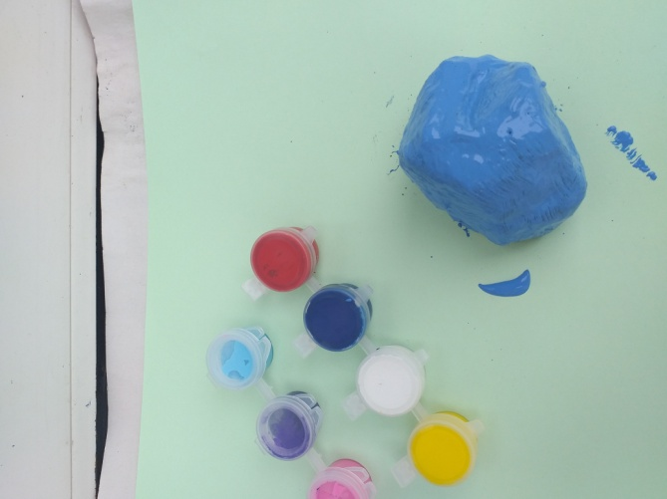

You will need these items Paint your stone a base colour Leave it to dry

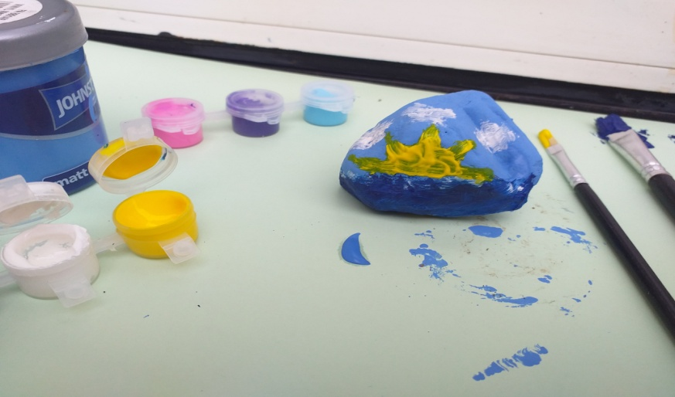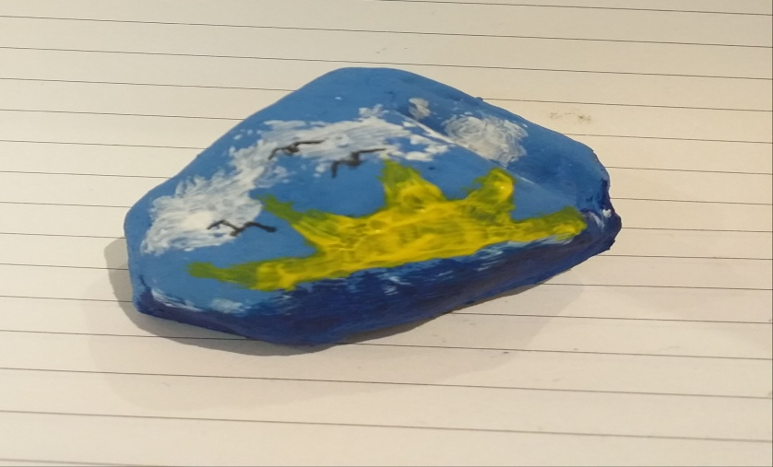
Add some new colours to your dry stone.... ....and some details with markers or pens.
Send us some pictures of your stones please! I am going to leave a thank you message for our bin men next!

