Old and New School Buildings
- Talk about the 2 pictures.
- What is the same? What is different? Which do you prefer?
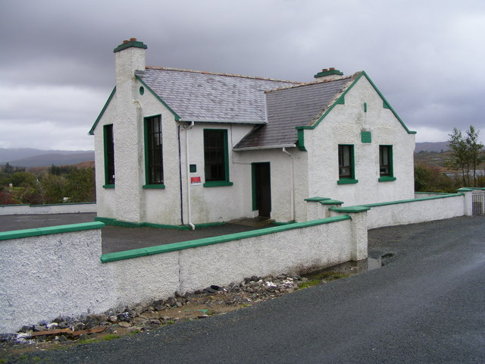Primary School Building – 1911

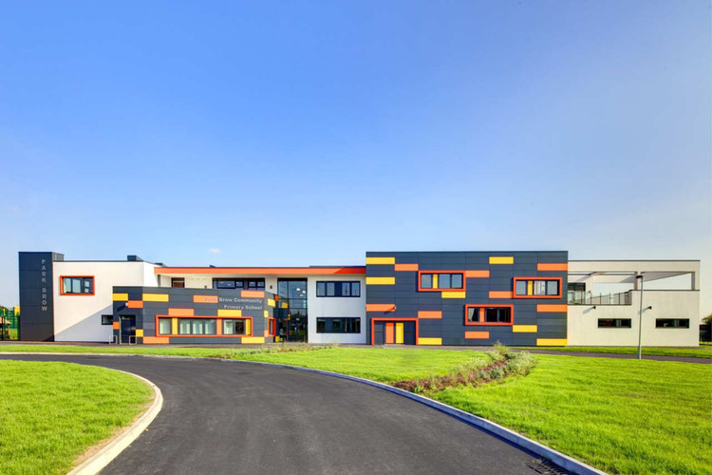
Primary School Building - 2020

