Hi all, we are continuing to celebrate Intercultural Week this week.
Happy Monday 8th June! : )
English
1. Write your news from the weekend and draw a picture.
2. Read P. 13-14 of Jasper Saves the day.
3. Spelling Workbook: Unit 9– exercise 1 and 2
4. Spelling list 30: put one word from the spelling list into a sentence

Maths
- Mental Maths: Week 34 Monday and the problem
- Tables: -11
- Planet Maths: p 130
Gaeilge: Bua naCainte –Siopadóireacht-
- Listen to the scéal – An Sionnach agus an Chircín Rua
SESE: Australian Animals
- Read through the PowerPoint on the class pager on Australian animals.
- Draw a kangaroo. Label each of the body parts and what that part is used for. Use the sheet below to help.
Religion Theme 10: Lesson 2
- Look at the video about the law of love. Discuss with your family how you follow the law of love.

P.E : Take part in 30 minutes of exercise

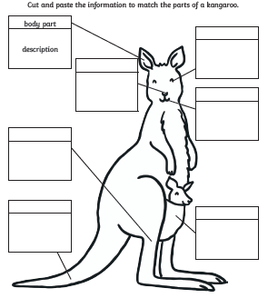
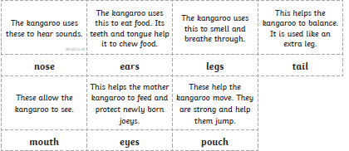
Tuesday 9th June
English
- Jasper Saves the Day: Read p.15, 16, 17
- Writing: look at the picture on page 15 of ‘Jasper Saves the Day’ and write one sentence to say what Jasper will do with each object.
- Spelling Workbook: Unit 9 exercise 3
- Spelling list 30: Put one word from today’s spellings into a sentence.
Maths
- Mental Maths: Week 34 Tuesday and the problem
- Tables: -11
- Complete following subtraction sums.

Gaeilge: Siopadoireacht-ceacht 4
- Listen to the scéal again – An Sionnach agus an Chircín Rua
- Complete P. 83
SESE: Australian Animals
- Using the Australian Animals PowerPoint from yesterday, draw a Koala and label the body parts and what they are used for. Use the sheet below to help.
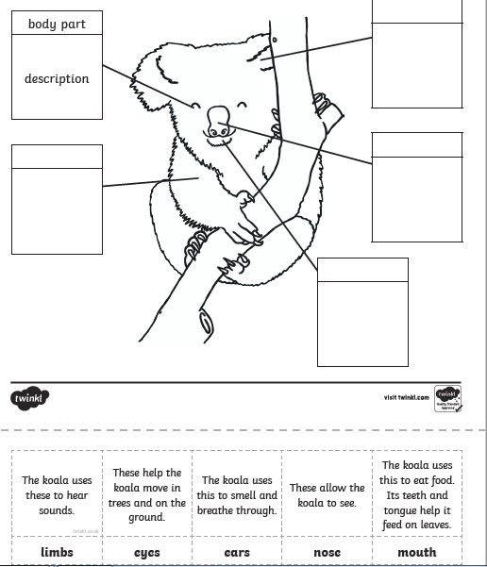

Well done for all your hard work today!

Wednesday 10th June
English
- ‘Jasper Saves the Day’ read p18 and 19
- Oral Language: looking at the picture on page 18, think of 3 words to describe Jasper.
- Spelling workbook: Unit 9 exercise 4 and 5
- Spelling list 30: Put one word from today’s spellings into a sentence.
Maths
- Mental Maths: Week 34 Wednesday and the problem
- Tables: -11
- Planet Maths: p132
Art: The Sydney Opera House is a famous landmark in Australia. Follow the steps below to draw your own.
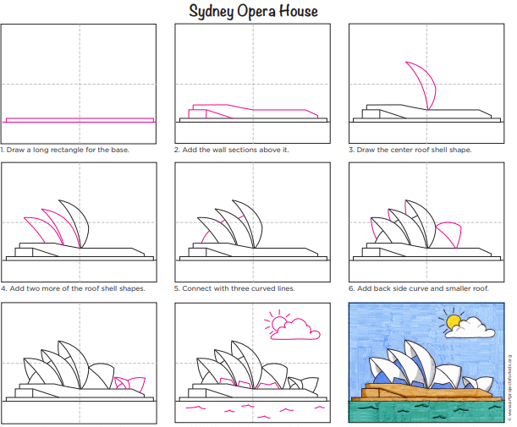

Thursday 11th June
English
- ‘Jasper Saves the Day’ read page 19 and 20
- Oral Language: What do you think Katie and the shop keeper were talking about? Create the conversation they might have had. No need to write it out!
- Spelling list 30: Put one word from today’s spelling list into a sentence.
- Spelling workbook: Unit 9 exercise 6
Maths
- Mental Maths: Week 34 Thursday and the problem.
- Tables: -11
- Complete the following subtractions sums into your copy.
SESE:
Complete the fact file on Australia. You can print it out or write it into your SESE copy.

Well done today! That’s Thursday’s work done which means tomorrow is Friday!

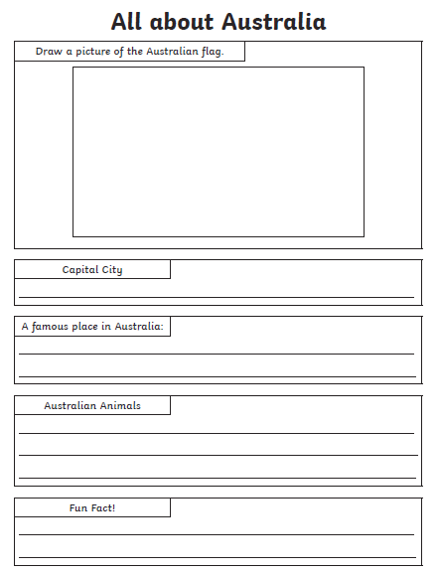

Friday 12 ^{th} June
Happy Friday!
English:
- ‘Jasper Saves the Day’ revise reading some of chapter 2.
- Spelling workbook: Unit 9 exercise 7
- Spelling test: spelling list 30
Maths
- Mental Maths: Friday Review
- Table test -11
PE: Complete 30 minutes of exercise.
Well done on all your hard work this week.

