Monday May 18th 2020
3rd Class Ms Hughes
English (My Read at Home and Get Set are available online see webpage)
- My Spelling Workbook pg 62 Unit 16
Today’s spellings: happily-angrily (LCWC) Write spelling 3 times.
Write 4 sentences with each spelling word.
Answer Q1 Missing Letters pg 62 My Spelling Workbook
Answer Q2 Base Words pg 62 My Spelling Workbook
- Get Set –Read pages pgs 224-228 The Giant’s Wife
- Answer QA+ B orally. Answer QC Seek and search 1-5.
- My Read at home- Read the next page and answer questions orally.
- Library Book- Read your library book or listen to a story on www.storylineonline.net/library/ or Elevenses with David Walliams
Maths
- Mental Maths Book- Week 32 pg 86 complete Monday
- Tables Champion- Week 31 pg 40 complete Monday
- Warm Up- Word Problem
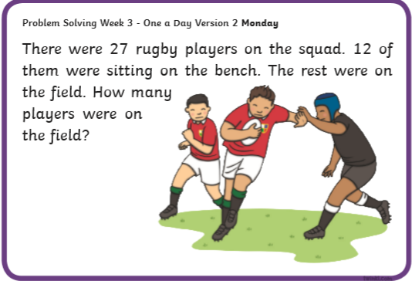
Planet Maths- Topic 25: 3D Shapes pg 152
Explore, describe and classify 3D shapes including cube, cuboid, cylinder, cone and sphere.
- Access Folens online and play the 3D shape warm-up game.
https://content.folensonline.ie/programmes/PlanetMaths/PM3/resources/activitya/pm_3c_152/index.html
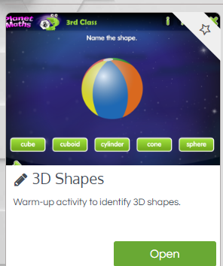

- In the book answer QB 1+2 and QC 1-16 page 152.

Gaeilge
- Téama: Caitheamh Aimsire (Past Times)
- Litriú: haca(hockey) + gleachaíocht (gymnastics). Write 3 times in copy like spellings.
- Log in to Folens online and do the digital activities for the dán Iscaireacht (fishing). The dán is also on lch 147 in Abair Liom.
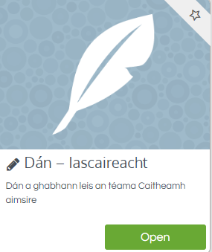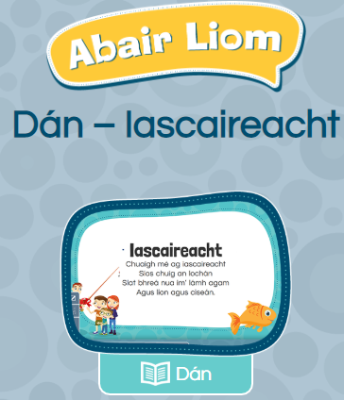
- Listen to the dán. Try and read it yourself. Draw a picture about it with the title Iscaireacht.

Religion
- Log in to ‘Grow in Love’ https://www.growinlove.ie/en/ and access the 3rd class materials.
- Email: trial@growinlove.ie Password: growinlove
- Select Third Class. Click into Theme 9: Celtic Christianity
Lesson 2: Christian Pilgrimage
- In resource section, watch the song Celtic Blessing video.
- Read pages 76+77 of the ebook and chat about it.

Well-being
- Talk about Rainbow Moments. Complete the journal activity page.
- Choose a Well-being activity from padlet that you haven’t yet done.

