Monday May 11th 2020
3rd Class Ms Hughes
English (My Read at Home and Get Set are available online see webpage)
- My Spelling Workbook pg 58 Unit 15
Today’s spellings: difficult-loft (LCWC) Write spelling 3 times.
Write 4 sentences with each spelling word.
Answer Q4 Shape Sorter pg 59 My Spelling Workbook
Answer Q5 Homophones pg 60 My Spelling Workbook
- Get Set –Read pages pgs 212-216 Spy Dog
- Answer QA+ B orally. Answer QC Seek and search 1-5.
- My Read at home- Read the next page and answer questions orally.
- Library Book- Read your library book or listen to a story on www.storylineonline.net/library/ or Elevenses with David Walliams
Maths
- Mental Maths Book- Week 31 pg 85 complete Monday
- Tables Champion- Week 30 pg 39 complete Monday
- Warm Up- Word Problem
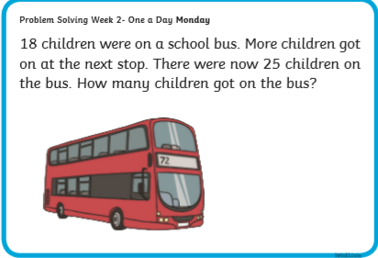
- Topic 24:Division 3 pg 143
Develop and/ or recall division facts within 100
We need to use our table knowledge to help us solve division.
Look at tables if you need to on page 176 to help.
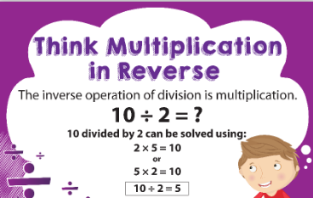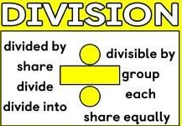
Division is a difficult concept for some children to grasp. Students who know their x facts/tables and understand the relationship between x and ÷ will find division easier. If students need more time learning x facts focus on these first. Remember division will be revised and covered again in 4th Class.
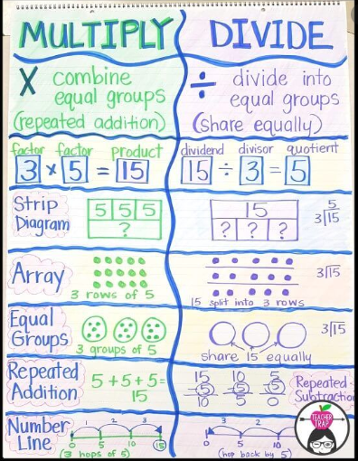

- Planet Maths- Topic 24:Division 3 pg 143
Develop and/ or recall division facts within 100
Watch this https://youtu.be/i31rRt5m1-4
Answer QD 1-4 Total number of objects shared into groups = answer
Answer QB 1-16 Look at x3, x6, x9, x7 tables to help
Optional QE Make up word problems for each number sentence (orally) and
solve the problems if you like.

Gaeilge
- Téama: Caitheamh Aimsire (Past Times)
- Litriú: peil(football) + sacar (soccer). Write 3 times in copy like spellings.
- Log in to Folens online and do the digital activities about the póstaer.
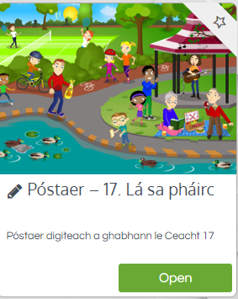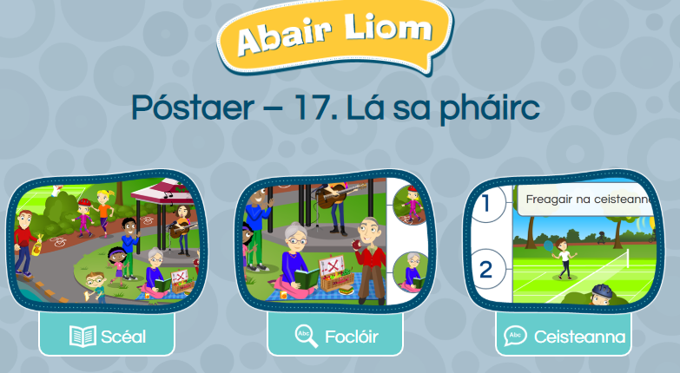

Religion
- Log in to ‘Grow in Love’ https://www.growinlove.ie/en/ and access the 3rd class materials.
- Email: trial@growinlove.ie Password: growinlove
- Select Third Class. Click into Theme 9: Celtic Christianity
Lesson 1: Early Christian Ireland
- In resource section, watch one of the Celtic Blessing videos.
- Read pages 73-75 of the ebook and chat about it.

Well-being
- Talk about feeling positive emotions and complete the journal activity page.
- Choose a Well-being activity from padlet that you have not completed yet https://padlet.com/thirdclassmshughes/7nelhuv6lglw4ti6

Optional Choiceboard
- Choose a different activity to do each day.

