Monday April 27th 2020
3rd Class Ms Hughes
English (My Read at Home and Get Set are available online see webpage)
- My Spelling Workbook pg 56 Unit 14 Suffixes (-less, ness, ly) Today’s spellings: wisely-quickly (LCWC) Write spelling 3 times.
Write 4 sentences with each spelling word.
Answer Q5+6 pg 56 My Spelling Workbook
- Get Set – Talk About some very fast animals that you know. Read pages pgs 206-209 Superfast Animals
- Answer Q B 1-5 pg 210 in copy using full sentences. Answer Mixed-up sentences pg211
- My Read at home- Read the next page and answer questions orally.
- Library Book- Read your library book or listen to a story on www.storylineonline.net/library/ or Elevenses with David Walliams
Maths
- Mental Maths Book- Week 29 pg 83 complete Monday
- Tables Champion- Week 28 pg 37 complete Monday
- Warm Up- What is symmetry? Click on this link to find out more.
https://youtu.be/YFzktJNmnPU
- Planet Maths- Topic 22:Symmetry pg 133
Identify and draw lines of symmetry in 2D Shapes
Answer QB 1-8 and QC pg133

Gaeilge
- Seanfhocail: Ní neart go cur le chéile (There is strength in unity)
- Téama: An Aimsir (The Weather) Continued
- Litriú: scamall(cloud) + báisteach (rain). Write 3 times in copy like spellings.
- Log in to Folens online and do the digital activities about the póstaer.
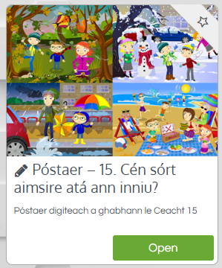

Religion
- Log in to ‘Grow in Love’ https://www.growinlove.ie/en/ and access the 3rd class materials.
- Email: trial@growinlove.ie Password: growinlove
- Select Third Class. Click into Theme 8: The Church is a Community of Believers Lesson 2 : Life in the Parish
- In resource section, look at poster and chat about it.

Well-being
- Talk about what well-being means. Complete the journal activity page.
- Choose a Well-being activity
https://padlet.com/thirdclassmshughes/7nelhuv6lglw4ti6

Active Schools Week
Monday: “Marathon Monday”
- See how many laps of your garden you can do in the day!
- Challenge other members of your family.

