Happy Monday 25th May! : )
English
1. Write your news from the weekend and draw a picture.
2. Read P. 1-2 of Jasper Saves the day.
3. Spelling Workbook: Unit 8– exercise 1 and 2
4. Spelling list 28: put one word from the spelling list into a sentence

Maths
- Mental Maths: Week 32 Monday and the problem
- Tables: -9
- Planet Maths: p148 (attached below)
Gaeilge: Bua naCainte –Siopadóireacht- Ceacht 4
- Click the Yellow speech bubble and listen to comhra.
Religion Theme 10: Lesson 1 - Sign up to ‘Grow in Love’ and access the 1st class materials. (Email address: trial@growinlove.ie Password: growinlove)
- Look at the pictures of how people show love. Discuss with your family how you can show love. From looking at the pictures discuss how Jesus showed love towards other people.

P.E Take part in 30 minutes of exercise; play in the garden, go for a walk or take part in one of Joe Wick’s PE lessons on YouTube.

Tuesday 26th May
English
- Read 3-4
- Spelling Workbook: Unit 8 exercise 3
- Spelling list 28: Put one word from today’s spellings into a sentence.
Maths
- Mental Maths: Week 32 Tuesday and the problem
- Tables: -9

Gaeilge: Siopadoireacht-ceacht 4
- Click the yellow bubble and listen to comhra again.
- Complete ‘Bí ag scriobh’ on p. 79
Religion: Theme 10 Lesson 1
- Watch the videos: ‘Love one another’.
- Complete following worksheet.
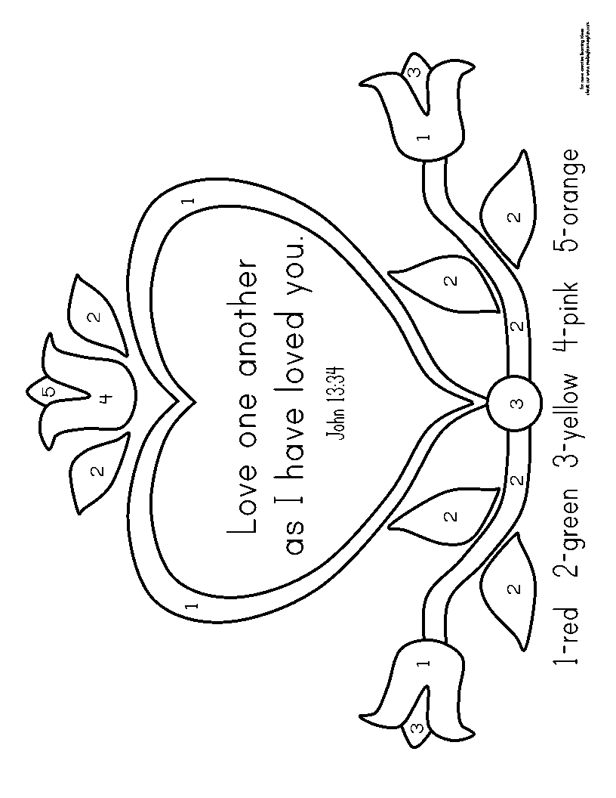

SESE:
Watch the powerpoint on Mother Thersa and answer the following questions.
- Where is Mother Teresa from?
- What did she want to become?
- Where did she work?
- What did she become in 2016?

Well done for all your hard work today!
Wednesday 27th May

English
- Spelling workbook: Unit 8 exercise 4 and 5
- Spelling list 28: Put one word from today’s spellings into a sentence.
- Questions: Practice writing your question mark on a blank sheet of paper. Then complete the following worksheet where you have to decide if the sentence is a question or not.

Well-Being
This week we are going to think of different things we are grateful for in our lives. Please find word document attached for this exercise.
Maths
- Mental Maths: Week 32 Wednesday and the problem
- Tables: -9
- Planet maths: P.149

Gaeilge: Siopadoireacht- Ceacht 5
- Click the yellow speech bubble and listen to comhra
- Complete Bua na cainte p.80
Art: https://www.youtube.com/watch?v=wc_6xXdj2r8
Use this link to guide you through this week’s art. If you do not have coloured sheets available you can simply just colour in blank white sheets.

Thursday 28th May
English
- Spelling list 28 Put one word from today’s spelling list into a sentence.
- Spelling workbook: Unit 8 exercise 6
- Read p.5-6

Maths
- Mental Maths: Week 32 Thursday and the problem.
- Tables: -9

Gaeilge: Ceacht 6
- Click the music note and listen to the song for this lesson.
- Click the yellow speech bubble and listen to comhrá.

SESE:
- Discuss with your family different objects that you push or pull around the house. Think of as many for each as possible.
- Complete the following worksheet.

Well done today! That’s Thursday’s work done which means tomorrow is Friday!

Friday 29th May
Happy Friday!
English:
- Spelling workbook: Unit 8 exercise 7
- Spelling test: spelling list 28
Maths
- Mental Maths: Friday Review
- Table test
17-9= 13-9= 11-9=
9-9= 10-9= 15-9=
19-9= 12-9= 16-9=
14-9= 20-9= 18-9=
Gaeilge: Ceacht 3
- Click the yellow speech bubble and listen to comhra again
- Complete Bua na Cainte p. 81. Read the page and the complete the colouring.
PE: Complete 30 minutes of exercise.
Well done on all your hard work this week.

