Monday 11th May

English
1. Write your news from the weekend and draw a picture.
2. Read P. 56 the story ‘Who invested LEGO’.
3. Spelling Workbook: Unit 7 – exercise 1 and 2
4. Spelling list 26: put one word from the spelling list into a sentence

Maths
- Mental Maths: Monday p. 58 and the problem
- Tables: -7
- Complete the following worksheet:
Gaeilge
- Bua naCainte – An Teilifís Ceacht 48 - Click on the yellow speech bubble and select Comhrá. Press play and listen to the lesson.
- Complete Tasc Éisteachta
The video game controller icon at the bottom will lead you games that you can play also.
Religion Theme 9: Lesson 1- Sign up to ‘Grow in Love’ and access the 1st class materials. (Email address: trial@growinlove.ie Password: growinlove)
- Watch the video ‘What is your favourite animal’ and then chat about your favourite animal with your family.

Tuesday 28th April
English
- Read the story ‘Who invented LEGO’ P.57
- Spelling Workbook: Unit 7 exercise 3 and 4
- Spelling list 26: Put one word from today’s spellings into a sentence.
Maths
- Mental Maths:Tuesday p.58 and the problem
- Tables: -7
- Planet Maths: p.151
.

Gaeilge: Teílifís Cleacht 8
- An Teilifís Ceacht 8: Click on the yellow speech bubble and listen to the lesson again.
- Complete P.74 in Bua na Cáínte
Religion: Theme 9 Lesson 1
- Listen to the ‘Creation story’
- Complete p.50 in G.I.L workbook. (access ebook on grow in love website for this page)
SESE: Complete the following reading:
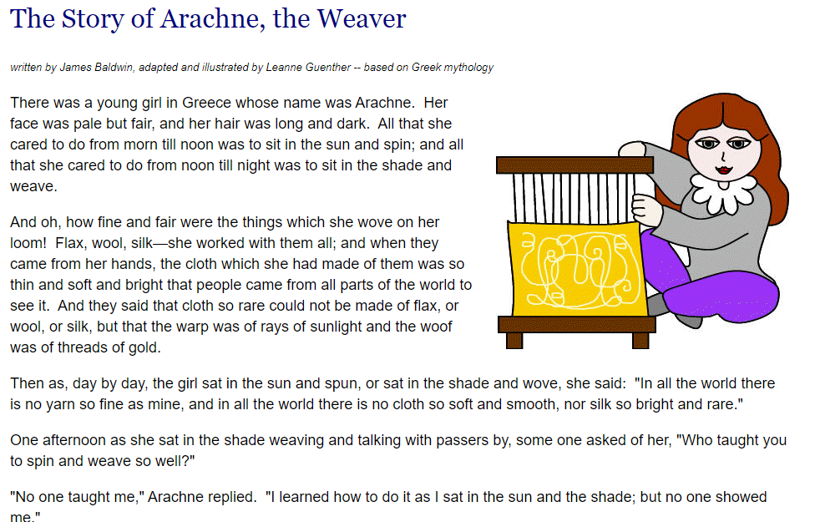

Wednesday 28th April
English
- Spelling workbook: Unit 7 exercise 5
- Spelling list 26: Put one word from today’s spellings into a sentence.
- Alphabetical order: Revise the alphabet by saying it outloud. Complete the following exercise

Maths
- Mental Maths: Wednesday and the problem p.58
- Tables: -7
- Planet maths: P.152 - Here we will be finding out how much change we get when we buy something. For this we will be counting on or taking away. You can use your number line or hundred squares to help you with this.

Gaeilge:
- Listen to the ‘scéal’. This is in the bottom left corner.
Religion: Theme 9 Lesson 1
- Complete p.51 in G.I.L workbook
P.E.
Complete a Joe Wicks you tube P.E. lesson
Art: This week we are going to make out own instruments. See attached document for instructions.

Thursday 29th April
English
- Spelling list 26: Put one word from today’s spellings into a sentence.
- Skills Book: Complete following worksheet. It can be printed out or done onto a blank page.

Maths
- Mental Maths: Thursday p.59 and the problem.
- Tables: -7
- Complete following worksheets:

Gaeilge:
- Listen to the scéal again.
- Complete P.75 in Bua na cainnte.

SESE:
- Revise the reading on Anarche from Wednesday:
- Read the next page of the story
- Answer the following questions:
- Where was Arachne from?
- What did she like to do?
- Who is Athena?
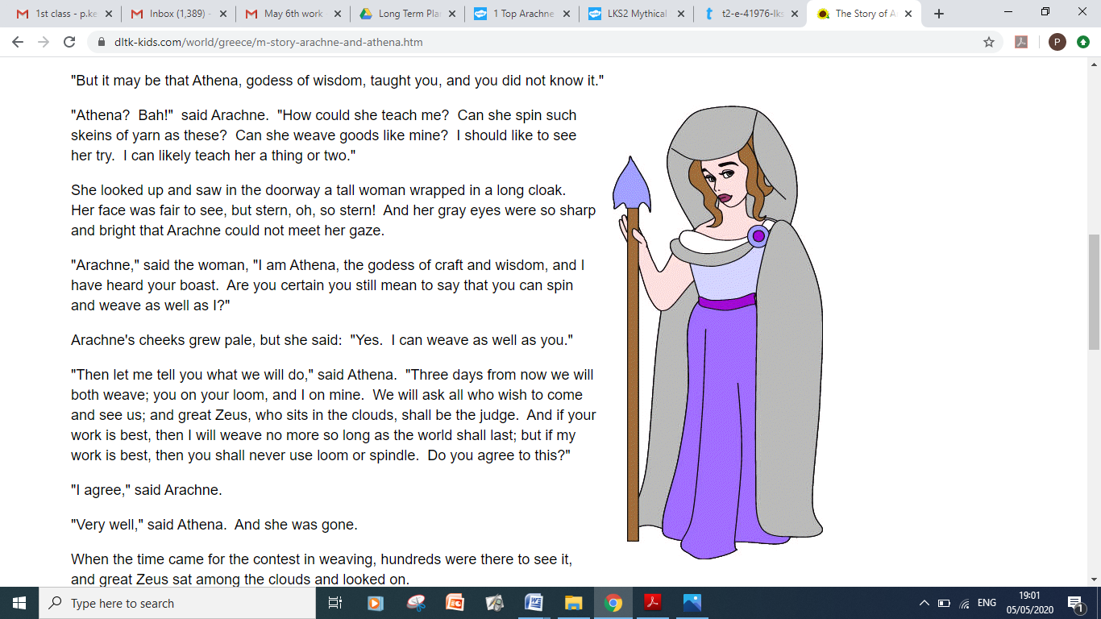

Friday 29th
English:
- Spelling workbook: Unit 7 exercise 6 and 7
- Spelling test: spelling list 26
- Skills book: Complete following worksheet. It can be printed out or done onto a blank page.

Maths
- Mental Maths: Friday Review p.59
- Table test
17-7= 13-7=
9-7= 10-7= 15-7=
7-7= 12-7= 16-7=
19-7=
14-7= 8-7=
18-7= 11-7=
SESE:
- Complete the reading of our story
- Retell the story using pictures in the boxes provides. This exercise can be done onto a blank piece of paper also.
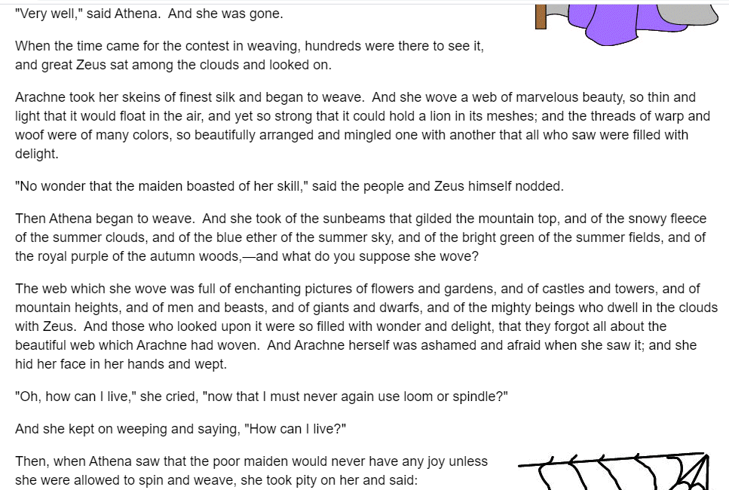
1 | 2 | 3 | 4 | 5
6 | 7 | 8 | 9 | 10

P.E.
Complete 30 mins of exercise.

