Work for Tuesday 28th April
PE :
As this is Active School’s Week, we’re going to do lots of activity today. You could do a Joe Wicks PE class on YouTube, a cosmic kids yoga lesson, jump on the trampoline or go for a walk/cycle/scoot with your family. There is also a website ‘gonoodle’ that we use regularly in class. I always go on to guided dance or kidzbop dance and let your child copy the moves.
English :
- Wordlist for ‘What a Box’. Read and learn the next 3 words –
- computer
- think
- like
What do these words mean? Find rhyming words. Find other words that start with the same sound. Write a sentence if possible.
- Handwriting : Capital Letter K. Continue practising the letter K by writing words beginning with this letter-Kerry, Kildare, Kilkenny, Kyle, Kayce, Katie, Kelly, Kevin, Keith.
- Sight words reading: Please find attached below a reading piece. There are three sight words at the top. They can then read the piece and draw a little picture at the end based on what happened in the story.

Gaeilge :
Bua na Cainte – Teilifís Ceacht 6
- Click on the yellow speech bubble. Press play and listen to the lesson. Pause between sentences and repeat, again play 2/3 times if possible.
- Practise retelling the story with the sound off. Maybe re-tell it with family members instead – Is mise Doireann. Tá nuacht agam. Fuair mé rothar nua inné. Fuair Caoimhe babóg nua. Slán go foill.
- The children could play some of the games for this ‘ceacht’. Just click the Gameboy symbol and they can complete the activities.
Maths :
- Counting practise: count forwards and backwards to 20. Do actions for your numbers – stand up for 1, sit for 2, etc. Practise saying the days of the week, months of the year and seasons.
- Revise your 3D shapes. Find a cube, cuboid, sphere and cylinder in your house.
- Watch the video from yesterday of Ms. Doyle working out all the ways to make the number 10. Complete Pg 94 – again, use household items to move around the apple on the top of the page.
Religion :
Find accompanying colouring page. If you can’t print it, children could draw their own version of a catholic church or of our local church, The Church of our Lady’s Nativity in Leixlip.
SPHE :
Continuing on from last week – we are still discussing our theme ‘Caring for New Life’.
This week we are going to look at baby animals that are born around this type of year in the Spring.
Please find PowerPoint attached.
Try to think of as many animals as possible and their young.
- Cow – calf
- Horse – foal
- Sheep – lamb
- Pig – piglet
- Dog – puppy
- Cat – kitten
- Duck – duckling
- Swan – cygnet
- Deer – fawn
- Goose – gosling
- Lion – cub
- Elephant – calf
- Kangaroo - joey
I’ve attached a colouring activity of a sheep and lamb below.
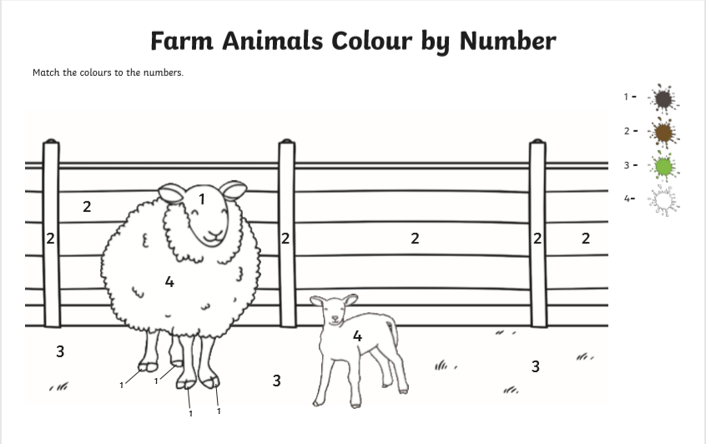

Sight Reading
