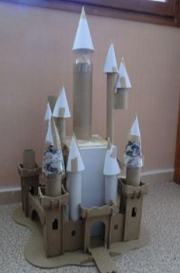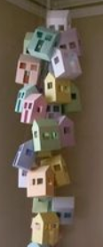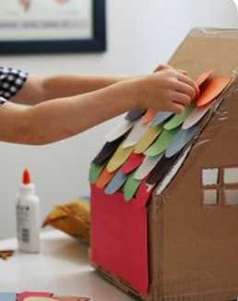
Junk Art Town – This should keep everyone busy for weeks!! Here are some pictures of junk art buildings and towns.....
We are going to make our own over the next few weeks, and send in pictures to show our progress. Then when we finally get back to school, maybe we could bring them in and make a city together!!
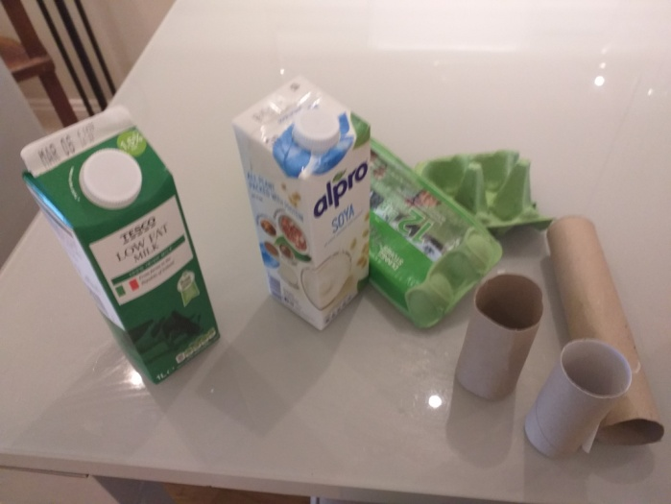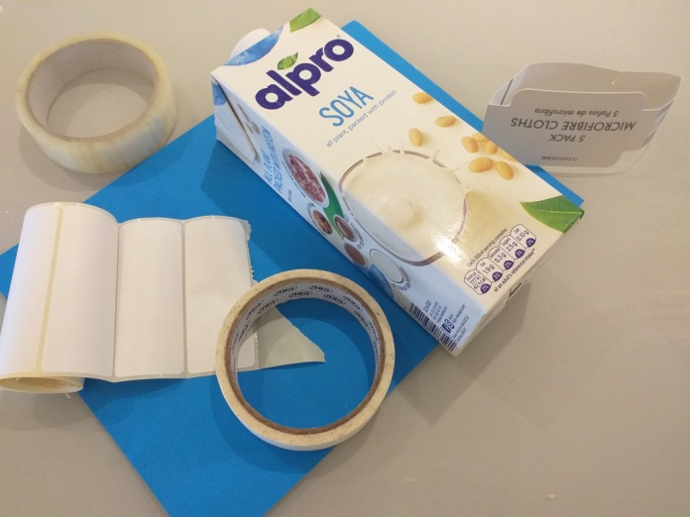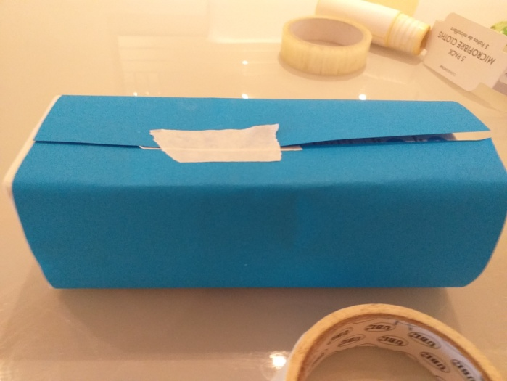
Start collecting junk cardboard items. For our first building you’ll need cover your carton with paper
A carton, tape, coloured paper
And stickers or white paper
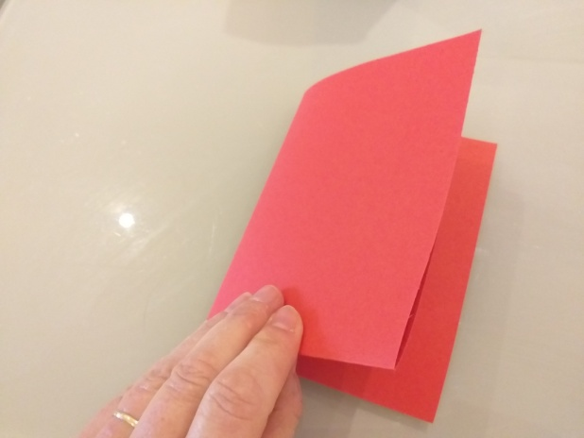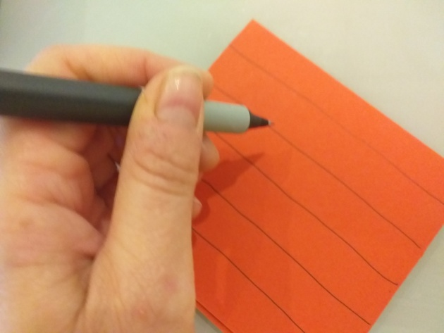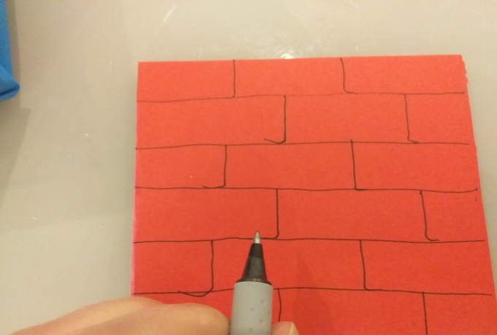
Make you roof by folding some add lines with marker..... ...and more lines to look like tiles
Coloured paper
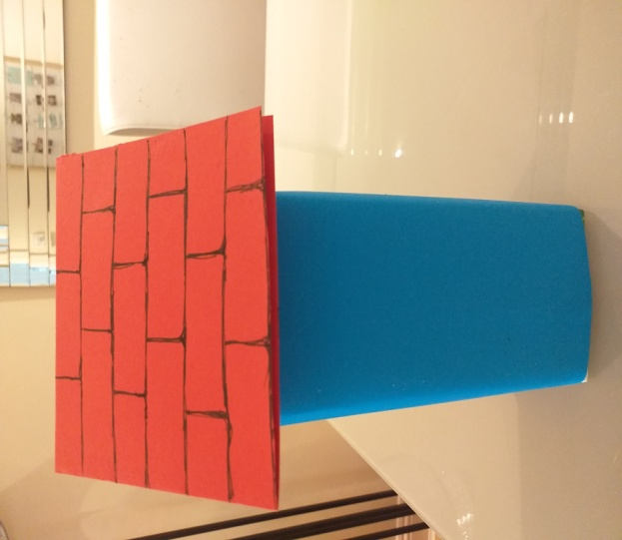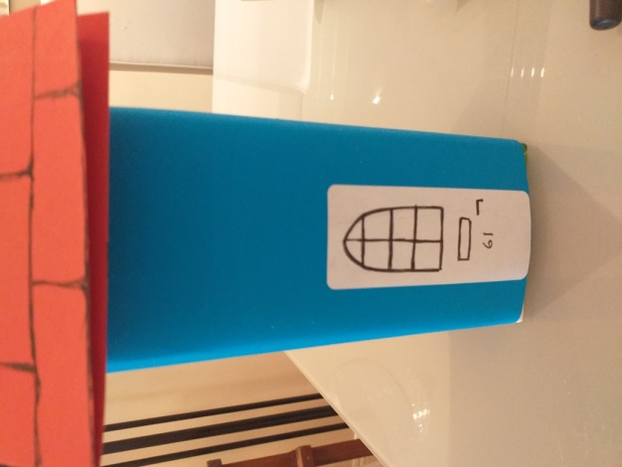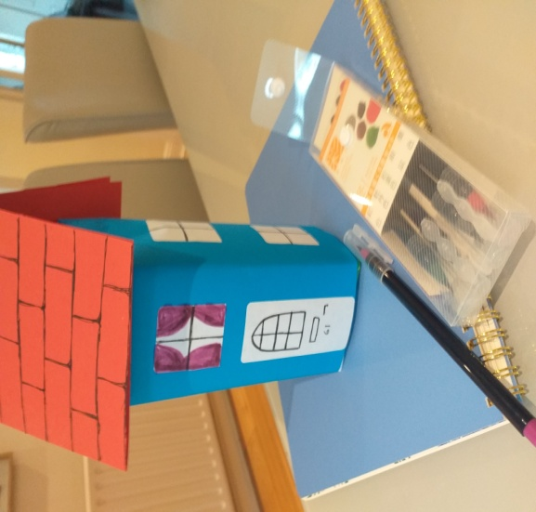
Pop your roof on top Now start adding details with Maybe even some curtains?
Stickers or white paper

