Friday May 9th 2020
3rd Class Ms Hughes

English (My Read at Home and Get Set are available online see webpage)
- My Spelling Workbook pg 58 Unit 15
Today’s spellings: built-revolt (LCWC) Write spelling 3 times.
Write 4 sentences with each spelling word.
Answer Q3 Down Clues pg 59 My Spelling Workbook
- Handwriting- complete pages 68+69
- Complete the activities on Alphabetical Order worksheet
- My Read at home OR Library Book
Read your library book or listen to a story on www.storylineonline.net/library/ or Elevenses with David Walliams

Maths (Planet Maths available online see webpage)
- Mental Maths Book- Week 30 pg 84 complete Wednesday
- Tables Champion- Week 29 pg 38 complete Wednesday
- Warm Up-Word Problem
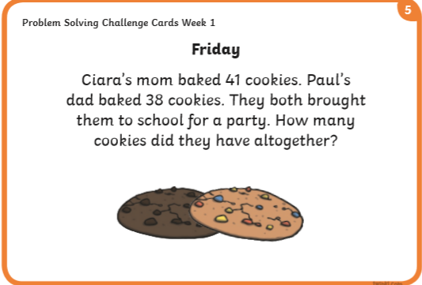

- Counting in 2, 5, 10../Singing Table songs/Making up word problems/Choose an area warm-up on padlet https://padlet.com/thirdclassmshughes/7nelhuv6lglw4ti6
Explain what area is and how you calculate it. Why do we need to know the area of something? Give an example
- Planet Maths- Topic 23:Area pg 141
Estimate, compare and measure the area of regular and irregular shapes
Answer QA+B pg 141.
Do some Q’s on Check-Up pg 142 if you’ve time.

Gaeilge
- Seanfhocail: Ní neart go cur le chéile (There is strength in unity)
- Téama: An Aimsir (The Weather) Continued
- Log into Folens and listen to the Dán: Ní maith liom an Bháisteach

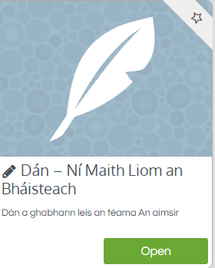
- Léigh (read) an dán ar lch 129
- Do an aimsir wordsearch

Religion
- Log in to ‘Grow in Love’ https://www.growinlove.ie/en/ and access the 3rd class materials. Email: trial@growinlove.ie Password: growinlove
- Select Third Class. Click into Theme 8: The Church is a Community of Believers Lesson 3: Baptism
- Read about reflecting on Baptism on page 71 and chose an activity to complete

Art
- Watch the story The Dot by Peter H Renyolds https://youtu.be/Clpw7PG7m1Q
- Create your own masterpiece starting from a dot. This can be done on any paper or on template provided.

