Friday May 29th 2020
3rd Class Ms Hughes
For additional support see https://padlet.com/thirdclassmshughes/7nelhuv6lglw4ti6
English (My Read at Home and Get Set are available online see webpage)
- Spelling Test- do your spelling test and get someone to correct it!
- Reading Comprehension- Read the text and answer the questions.
The text should be read at least 3 times. Student should be able to answer the Q’s independently.
- Read text
- Read questions
- Read text
- Answer questions
- Check questions

- My Read at home OR Library Book
Read your library book or listen to a story on www.storylineonline.net/library/ or Elevenses with David Walliams

Maths (Planet Maths available online see webpage)
- Mental Maths Book- Week 33 pg 87 complete Friday
- Tables Champion- Week 32 pg 41 complete Friday

- Warm Up- Word Problem
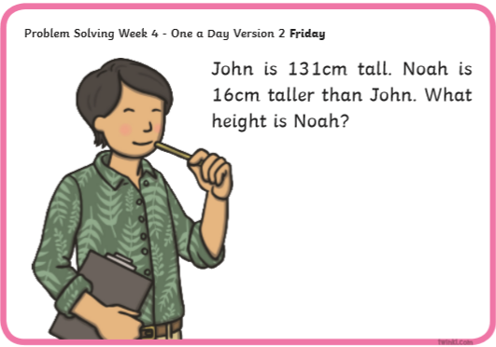

- Planet Maths- Topic 26: Capacity pg 161
- Revise what we were working on this week. Go back and work on something you found tricky this week.
- Check Up! Pg 161 Answer QB+D and one other question of your choice or more if you like!

Gaeilge
- Téama: Caitheamh Aimsire (Past Times)
- Litriú Bingo: Draw a grid with 6 boxes. Choose 6 of your litriú words this week and write one word in each box. Ask someone to call out a word from the 8 litriú words this week. Remember if you get bingo ‘Tá Bingo agam!’
- Déan 10 as 10 https://rtejr.rte.ie/10at10/ as gaeilge
- Féach ar https://youtu.be/jNTt0oAcoEQ. Listen to the children talking about Caitheamh Aimsire.

Music
- Take out your recorder and review songs we played with Mr. Gaskin by yourself (15mins approx.)
- Perform one of the songs for a member of your family.

Optional Choiceboard
- Choose a different activity to do each day.

Well done for all your hard work!
Have a great weekend!

