Friday May 22nd 2020
3rd Class Ms Hughes

English (My Read at Home and Get Set are available online see webpage)
- Spelling Test- do your spelling test and get someone to correct it!
- Reading Comprehension- Read the text and answer the questions.
The text should be read at least 3 times. Student should be able to answer the Q’s independently.
- Read text
- Read questions
- Read text
- Answer questions
- Check questions

- My Read at home OR Library Book
Read your library book or listen to a story on www.storylineonline.net/library/ or Elevenses with David Walliams

Maths (Planet Maths available online see webpage)
- Mental Maths Book- Week 32 pg 86 complete Friday
- Tables Champion- Week 31 pg 40 complete Friday

- Warm Up- Word Problem
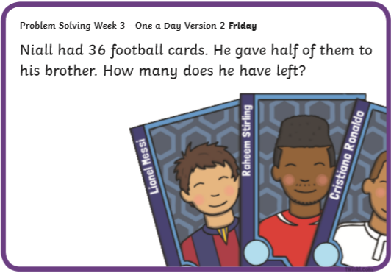

- Planet Maths- Topic 25: 3D Shapes pg 156
- Revise what we were working on this week. Go back and work on something you found tricky this week.
- Take a 3D Shape quiz https://www.turtlediary.com/quiz/identify-3d-shapes.html
- Check Up! Pg 156 Answer QB+C and one other question of your choice or more if you like!

Gaeilge
- Téama: Caitheamh Aimsire (Past Times)
- Litriú Bingo: Draw a grid with 6 boxes. Choose 6 of your litriú words this week and write one word in each box. Ask someone to call out a word from the 8 litriú words this week. Remember if you get bingo ‘Tá Bingo agam!’
- Phrasaí Nua: Taitníonn _________ go mór liom.
Tá suim mhór agam sa _______.
- Léigh lch 154 Abair Liom. Finish scéal Niamh.
- Choose Caitheamh Aimsire you are interested in and write 4 sentences using the 2 phrasaí nua.
- Taitníonn _________ go mór liom.
- Tá suim mhór agam sa _______.

Music
Close your eyes and listen to this piece of music from John Williams. Imagine you are an astronaut in Space!
https://youtu.be/_D0ZQPqeJkk
Or listen while you make your own Solar System.
Art
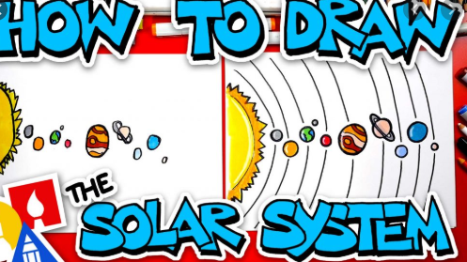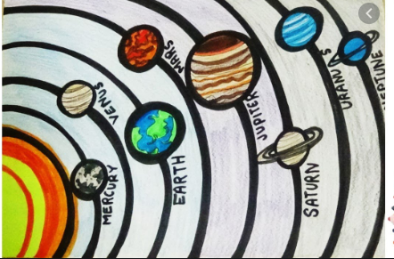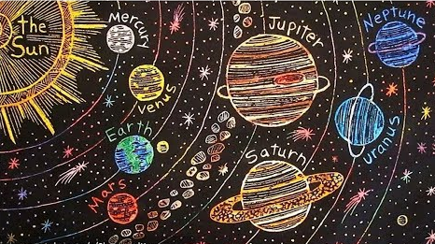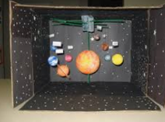

Make your own Solar System. There are lots of different ways to do this and it might depend on what things you have at home.
- Use the planet worksheet from Geography. Cut out the planets and arrange in order and stick onto a background.
Make a drawing. Learn how to draw a solar system. Watch this to help! https://youtu.be/wAJg6aKqLBk
- Use the planet cut outs, stick them onto card and attach with string onto a hanger or piece of wood to make a mobile. (See instructions below)
- If you’d like to get more creative you could paint a solar system or with help you could make a 3D model.
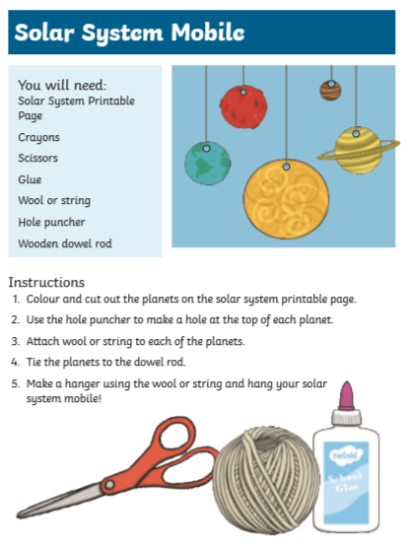
Optional Choiceboard
- Choose a different activity to do each day.

Well done for all your hard work!
Have a great weekend!

