Friday June 5th 2020
3rd Class Ms Hughes
For additional support see https://padlet.com/thirdclassmshughes/7nelhuv6lglw4ti6
English (My Read at Home and Get Set are available online see webpage)
- My Spelling Workbook pg 66 Unit 17
Today’s spellings: door-poor (LCWC) Write spelling 3 times.
Write 4 sentences with each spelling word.
Answer Q3 Crossword Across Clues pg 67 My Spelling Workbook
- My Read at home- Read the next page and answer questions orally.
- Library Book- Read your library book or listen to a story on www.storylineonline.net/library/ or Elevenses with David Walliams
Maths (Planet Maths available online see webpage)
- Mental Maths Book- Week 34 pg 88 complete Friday
- Tables Champion- Week 33 pg 42 complete Thursday
- Warm Up- Word Problem
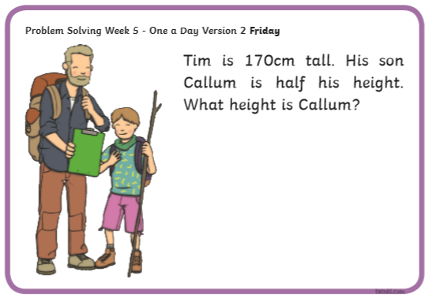
- Planet Maths
Page 151 Mental Maths 6 Answer QC1-10

Gaeilge
- Téama: Ócaidí Speisialta (Special Occasions)
- Déan 10 as 10 https://rtejr.rte.ie/10at10/ as gaeilge
- See padlet Ceisteanna video
- Éist leis na ceisteanna ar folens online and try and answer them
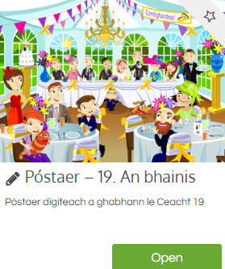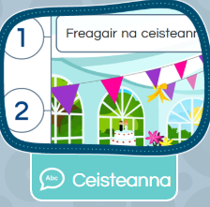

Religion
- Log in to ‘Grow in Love’ https://www.growinlove.ie/en/ and access the 3rd class materials.
- Email: trial@growinlove.ie Password: growinlove
- Select Third Class. Click into Theme 10: The Mass
Lesson 2: At Mass We Remember and Give Thanks
- Read page 84 of the ebook and chat about it.
- In the resource section listen to some of the songs.

Geog/English (Intercultural Project)
These tasks can be used as a foundation for the project or as part of it.
- Look at the powerpoint World Flags and test yourself- see how many world flags you know already or learn some new ones.
- Fantastic Flags worksheet- colour in different European flags. Use an atlas or other research method to find out the correct colours for each flag.

Optional Choiceboard
- Choose a different activity to do each day.

