Lines of Symmetry
twinkl.co.uk
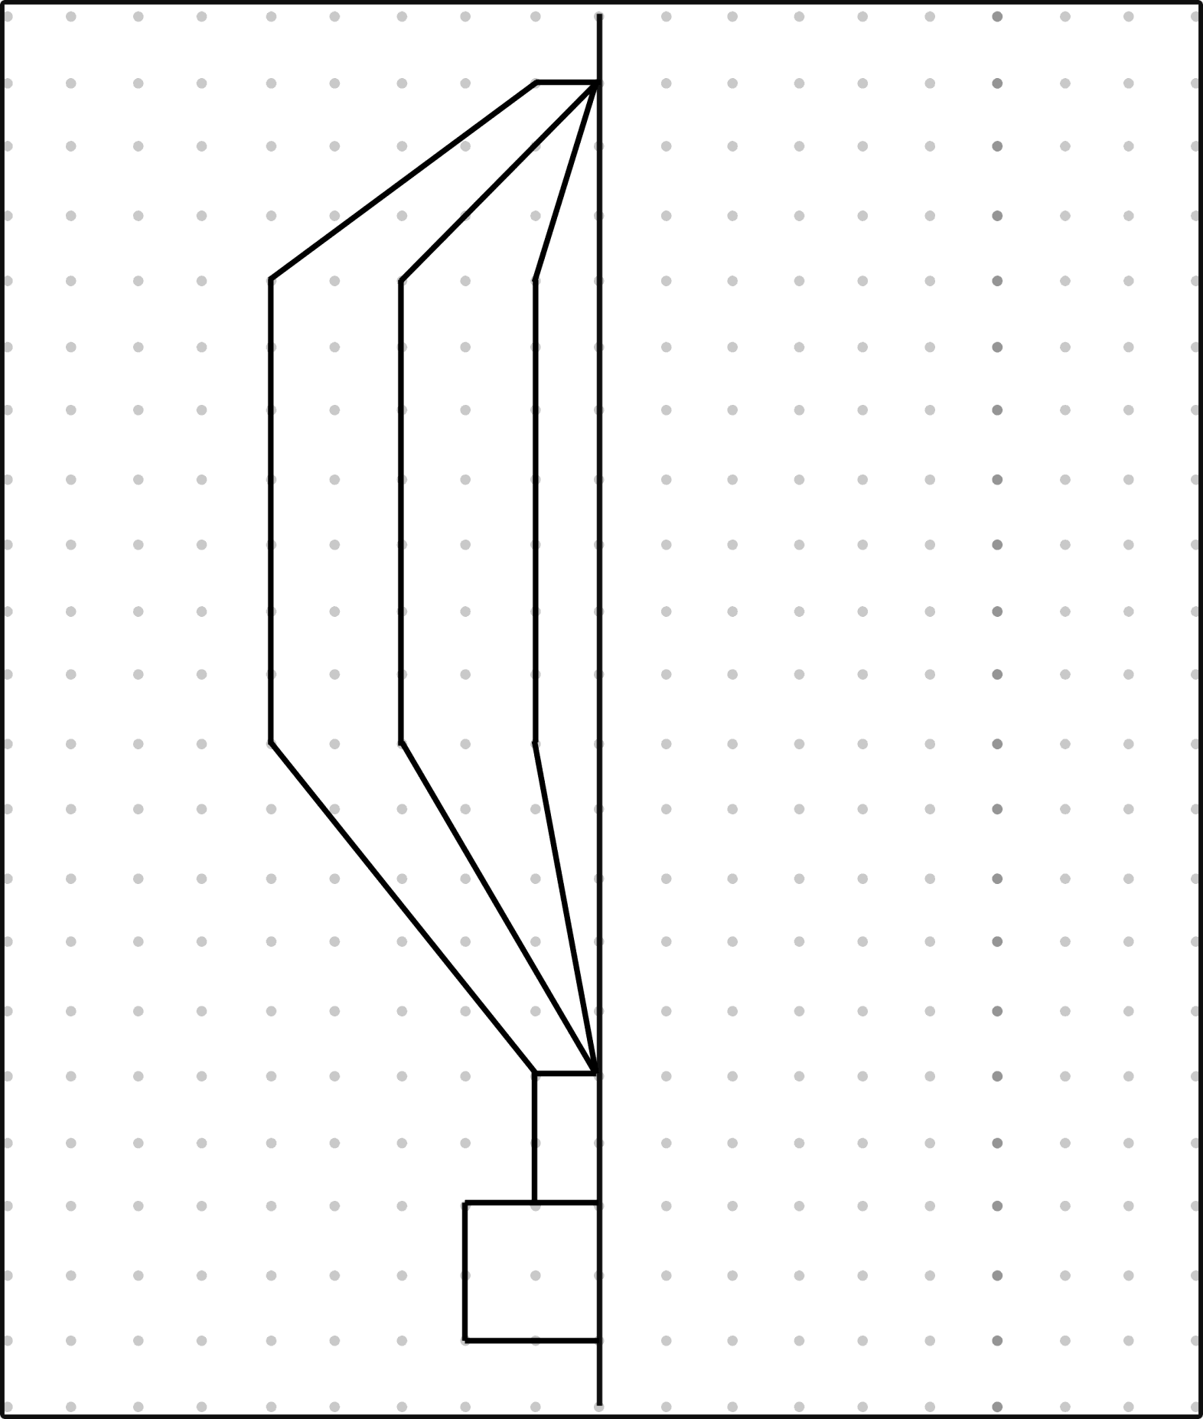

I have drawn

Lines o/ Spmmetrp
twink(.co.uk
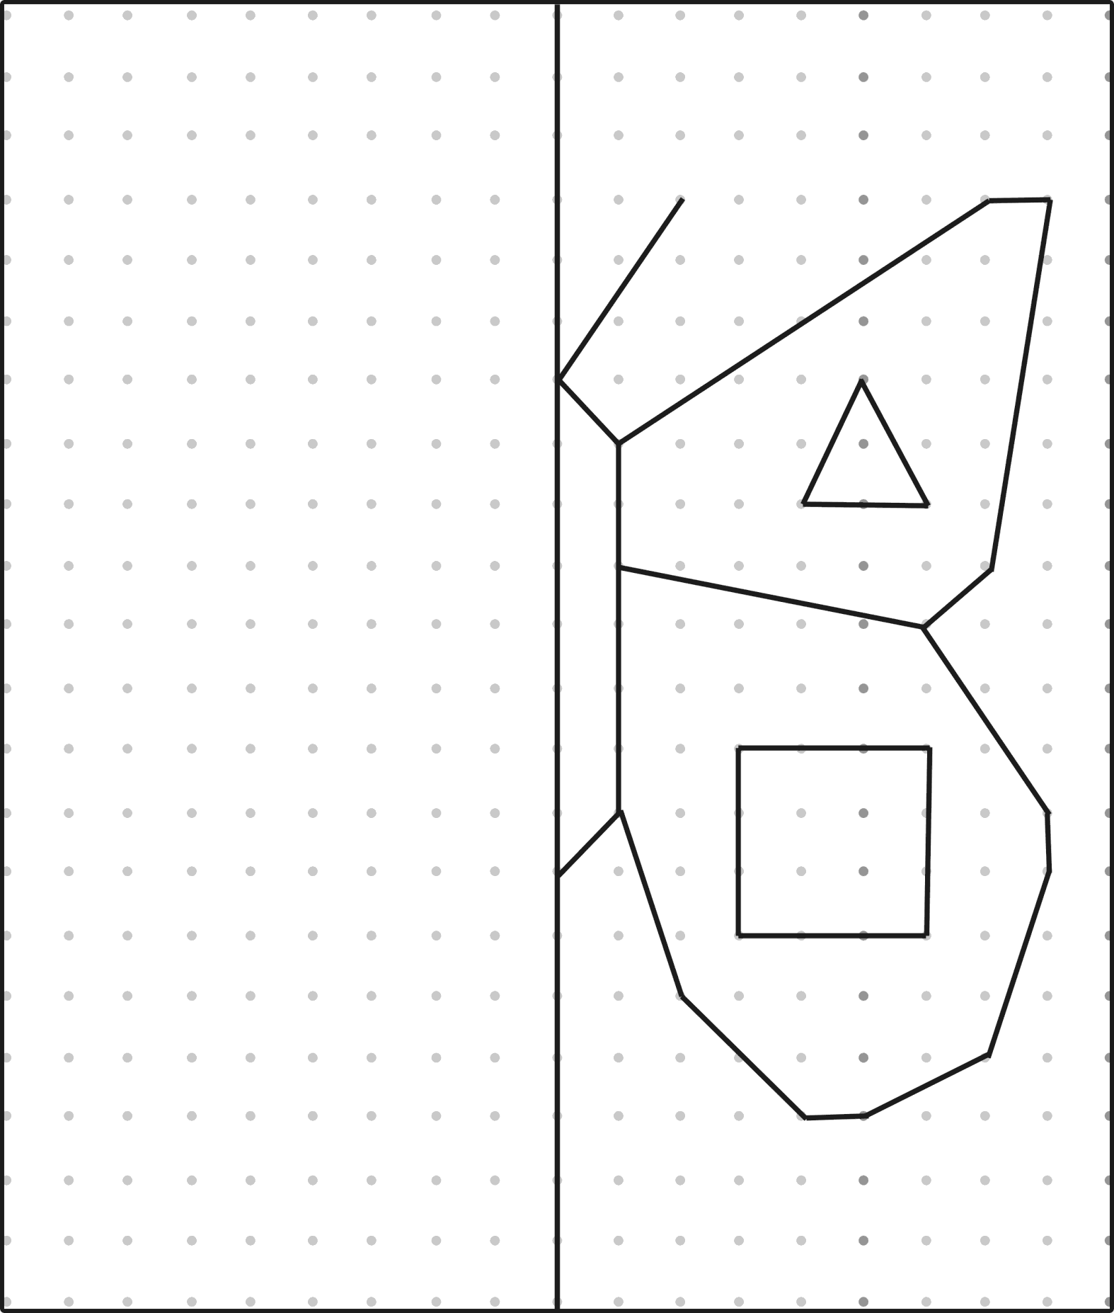

I have drawn

Thank you for using www.freepdfconvert.com service!

Only two pages are converted. Please Sign Up to convert all pages. https://www.freepdfconvert.com/membership

