Day One
Week of June 22nd 2020
3rd Class Ms Hughes
For additional support see https://padlet.com/thirdclassmshughes/7nelhuv6lglw4ti6
English (My Read at Home and Get Set are available online see webpage)
- My Spelling Workbook pg 72 Unit 18
Today’s spellings: castle-umbrella (LCWC) Write spelling 3 times.
Write 4 sentences with each spelling word.
Answer Q5 Picture Story pg 72 My Spelling Workbook
- My Read at home- Read the next page & answer questions orally.
- Library Book- Read your library book or listen to a story on www.storylineonline.net/library/ or Elevenses with David Walliams
Maths
- Mental Maths Book- Week 38 pg 110-112 complete Monday
Complete Monday for the next week that you are on. Some people are on different weeks. Complete any remaining weeks during the holidays if you can.
- Warm Up- Word Problem:
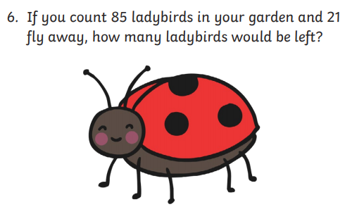
Summer Multiplication Activity Booklet
- Complete page 1 Summer Multiplication
- Read each word problem and write a number sentences that matches it

Gaeilge
- Téama: An Samhradh (Summer)
- Déan 10 as 10 https://rtejr.rte.ie/10at10/ as gaeilge
- Féach ar na pictúirí
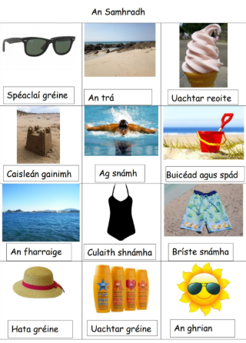

- Tarraing pictúir leis an teideal An Samhradh. Draw a picture titled Summer. Use some of the items above. Label them in your picture.

Well-being
- Change is part of life. Read page 16 and complete the activity.
- Try Ocean Breathing
