Day Three
Week of June 22nd 2020
3rd Class Ms Hughes
For additional support see https://padlet.com/thirdclassmshughes/7nelhuv6lglw4ti6
English (My Read at Home and Get Set are available online see webpage)
- My Spelling Workbook pg 72 Unit 18
Today’s spellings: passport-boat (LCWC) Write spelling 3 times.
Write 4 sentences with each spelling word.
Answer Q8 Secret Code pg 73 My Spelling Workbook
Answer Q9 Word Search any 16 words pg 73 My Spelling Workbook
- My Read at home- Read the next page & answer questions orally.
- Library Book- Read your library book or listen to a story on www.storylineonline.net/library/ or Elevenses with David Walliams
Maths (Planet Maths available online see webpage)
- Mental Maths Book- Week 38 pg 110-112 complete Wednesday
Complete Wednesday for the next week that you are on. Some people are on different weeks. Complete any remaining weeks during the holidays if you can.
- Warm Up- Word Problem
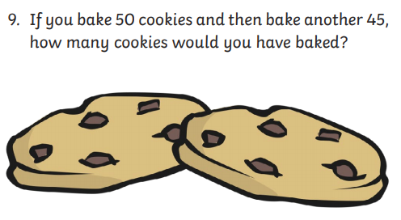
Summer Multiplication Activity Booklet
- Complete page 3 Summer Multiplication Riddle
- Solve the multiplications first
- Check the key at the bottom of the page to see what letter you need to complete the riddle.

Gaeilge
- Téama: An Samhradh (Summer)
- Déan 10 as 10 https://rtejr.rte.ie/10at10/ as gaeilge
- Complete Éadaí Samhraidh. Follow the instructions.
2.
-Put a swimsuit on her.
-Put goggles on her.
-Put sandals on her.
-Put a skirt on her.
-Put a t-shirt on her.

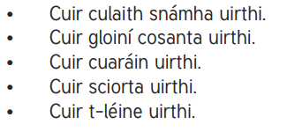

SPHE Water Safety Primary Aquatics Water Safety
- During the summer holidays, when the weather is nice, lots of people visit the beach and go for a swim. This can be lots of fun when you know how to keep safe near water.
- Water Safety Ireland designed a programme called PAWS to help us keep safe around water. There is a special section for third/fourth class.
- Look through presentation https://online.flowpaper.com/7efd0784/PAWS3ENGLISHWEB/#page=1
- Complete the interactive activities http://paws.edco.ie/third-and-fourth-classes/

Optional Choiceboard
- Choose a different activity to do each day.

