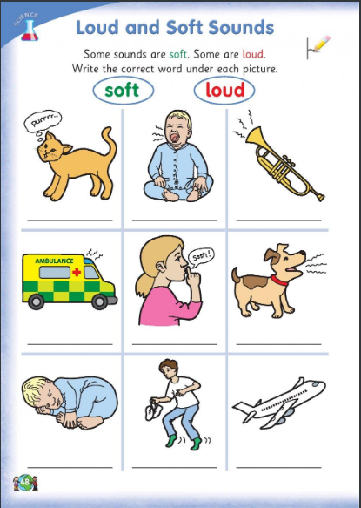

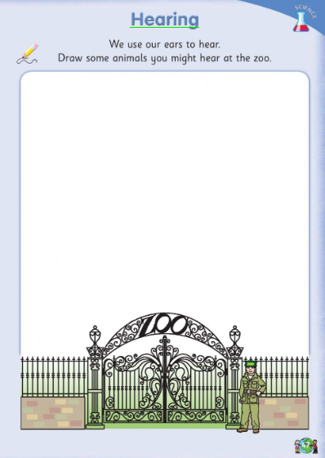

Why not make your own instrument at home?
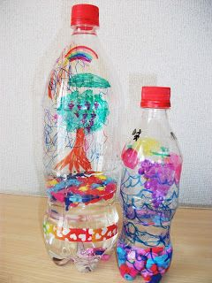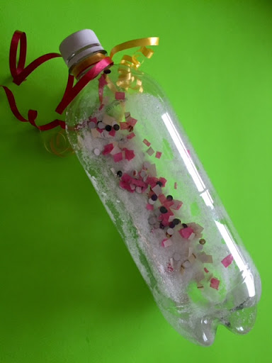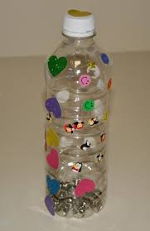
What you need?
- Plastic bottle
- Paint, stickers, ribbon, markers, glitter, paper ..etc (Anything you have at home to design your bottle)
- Stones, pasta, beads, nuts or small household items.
How to make your shaker:
- Design your bottle- Be creative!
- Add in stones, pasta, nuts, beads or small household items to bottle. You only need to fill it a small bit.
- Put lid on and make sure it is closed tightly.(You might need to ask an adult to help you)
- SHAKE SHAKE SHAKE!
Below are some other instruments you might like to try and make.
