Room 4 Monday 27th April 2020:

Your art, SESE and SPHE work for the week is found by clicking on the the individual ‘Buttons’. Do as much as you can, but don’t feel pressured to complete everything. Your fine and gross motor activities are here. Your literacy and Maths will be sent to you by email. Try to do reading, fine motor, gross motor and life skills every day if you can.
Keep a record of your work and send it to us by email if you like.

27/04/2020 | Monday | Tuesday | Wednesday | Thursday | Friday
Literacy:
Reading

Writing

Oral work

Maths
Life skills
Gross Motor and PE
Fine Motor
Extra activity
(Art, SESE, Baking, playdoh etc)

Life Skills: Please use the board below to choose 3 activities every day this week

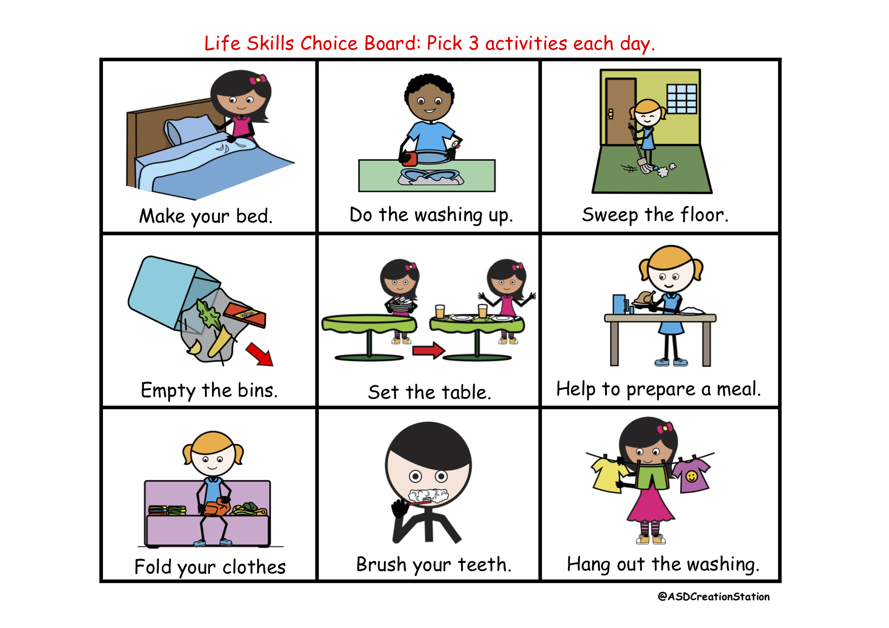

Gross Motor Skills: Please use the Board below to choose 3 activities every day this week
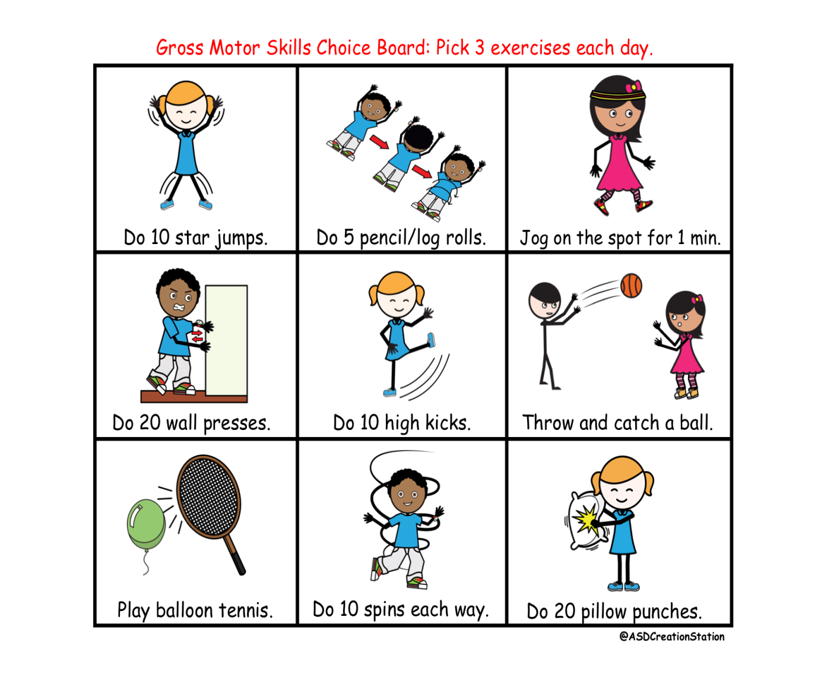

P.E.

- Use the gross Motor activity choice board every day.
- On Tuesday complete 5 gonoodle activities (see class website for suggestions) https://www.gonoodle.com/good-energy-at-home-kids-games-and-videos/
- On Thursday complete 2 activities from the ‘screen free’ task set on April 1st
- Try to go for a walk every day and look for signs of spring and new baby animals.
or
- Complete one ‘Cosmic kids’ yoga activity daily.

