Do what you can, don’t worry if you cannot complete everything.

You can find all the resources on the school website under our class page “5th Ms. Munroe”.
There is a word document on our webpage with images from each of the books you will need.

But if you want to look at the online book, follow the links below.

English
Up & Running | https://www.cjfallon.ie/
My Read at Home 5 | https://www.cjfallon.ie/
Maths
Planet Maths | https://www.folensonline.ie/
Gaeilge
Abair Liom | https://www.folensonline.ie/
Religion
Grow in Love | https://www.growinlove.ie/en/
History
Window on the World 5 History | https://www.edcolearning.ie/
Science
Window on the World 5 Science | https://www.edcolearning.ie/

Monday
English | Reading:  - My Read at home: pg. 112 + answer questions orally  - Up and Running: wordlist “Stations and Train Journeys” (on class page)  - Up and Running: pg. 240 + 241 of the text “Stations and Train Journeys”.  Writing:  - Wordlist: 3 x WL sentences  - Begin your poem for Declan O’Toole Memorial Competition. See school website homepage for details. But please email me your entry! I have set aside time on Friday for you to finish your poem.  - My Spelling Workbook: Unit 16, LSCWC x4 spellings  - My Spelling Workbook: Exercise 1
Mindfulness | Read Page 6 of your Weaving Wellbeing Work Pack and fill in your first daily record on page 7.  You started this workbook last week. It can be downloaded on our class web page.  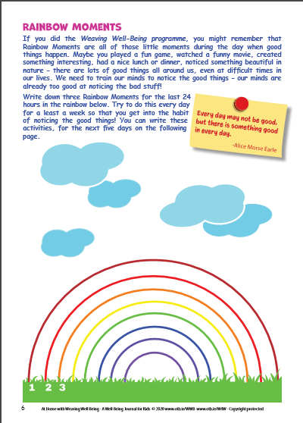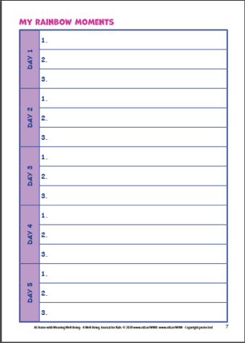  If you can, listen to calming music while you do these activities every day to help you relax.
P.E | Complete the “Full Speed” full body work out on go noodle  https://www.youtube.com/watch?v=g3L556EpRuo  Get as many people in the family to join in as you can!  It’s only 4 minutes long!
Maths | Planet Maths: Pg. 162 – Topic: 3-D Shapes  - Watch the warm up video on folens.ie :  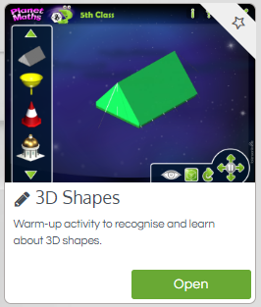  - Complete the table: Exercise B  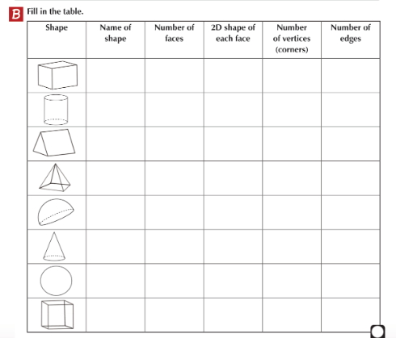  - Tables Champion: Monday  - Mental Maths: Monday
Religion | - Read: Theme 9 Lesson 1 pg. 98  - Answer the questions orally.  - Journal Exercise: List the Catholic diocese found in each church province in Ireland.  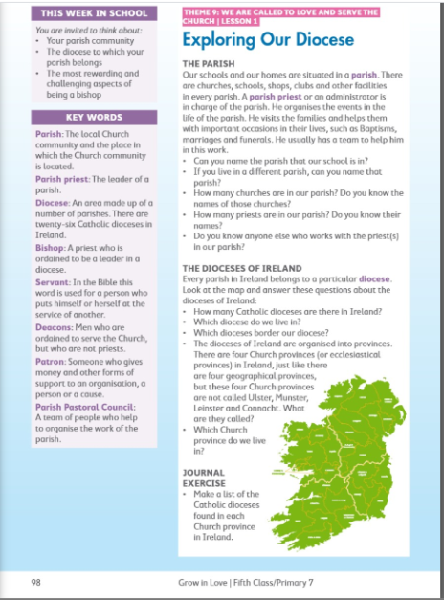  Visit: Grow in Love online with the help of a parent (only of you can) and under 5th class, Theme 9 Lesson 1, you will have access to the songs for the lesson this week, along with other resources.
Gaeilge | Téama: Caitheamh Aimsire (Hobbies)  Use folens online.ie to access the online resources.  - Féach ar an foclóir nua. (Look at the new vocabularly, there is a word document on the class page).  - Play the matching online game avaible on folens.ie as seen in the picture below. Click the button “Foclóir”  - Éist leis an scéal “Páirc an Chrócaigh” (Listen to the story about Croke Park).  - Léigh an póstaer ar lch. 121 agus na eiseamláirí (Read the poster and the new phrases)  When you sign into the folens account for Abair Liom 5th Class. Click on Lesson 17. Here you will see the option below to open and view the following three files. This will help you throughout the week.  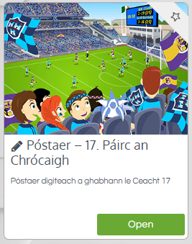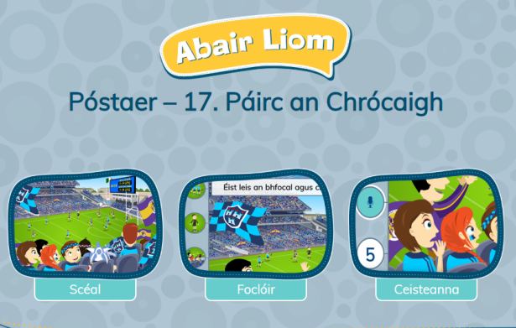
History | Topic: Rosa Parks (Very interesting topic!!)  - Do you know about any women who have changed history?  - Read about Rosa Parks on page 85 of your History book.  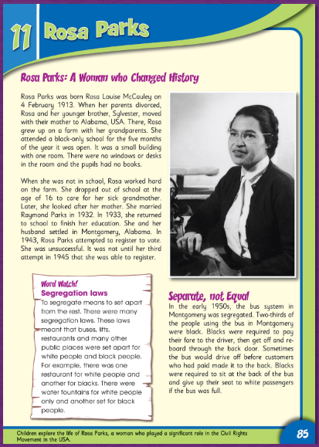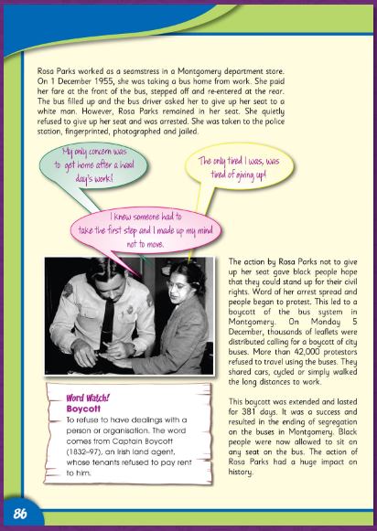

Tuesday
English | Reading:  - My Read at home: pg. 113 + answer questions orally  - Up and Running: wordlist  - Up and Running: pg. 242 + 243 of the story “Stations and Train Journeys”.  - DEAR: 10 mins  Writing:  - My Spelling Workbook: Unit 16, LSCWC x4 spellings  - My Spelling Workbook: Exercise 2  - Up & Running, pg. 245 Ex. H Finish the story (write in copy, try and aim for 1 – 2 pages)
P.E  Mindfulness | Do the “Wake Up” exercise on Go Noodle  https://www.youtube.com/watch?v=ALrdpsWYoJs  Read page 8 of your Well-being journal and complete page 9.  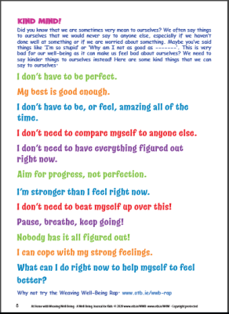  Listen to the Well-being Rap: It is available through this link https://vimeo.com/211667515  Don’t forget to fill in Page 7 (Daily journal: Rainbow moments day 2) of your Wellbeing Work Pack.
Maths | Planet Maths: Pg. 163  Topic: 3-D Shapes  To Learn:  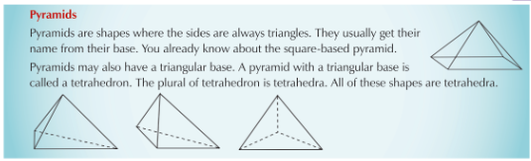  - Answer Orally: Ex. A pg. 163 (don’t worry about q6. If you haven’t got the resources)  - Write the answers to: Ex. B pg. 163  To Learn:  - Answer orally: Ex. D pg. 163  - Tables Champion: Tuesday  - Mental Maths: Tuesday
Religion | - Read about the role of the Bishop pg. 99  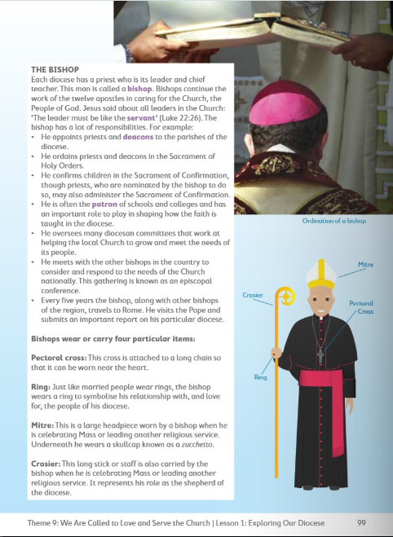
Gaeilge | - Léigh an ticéad ar lch. 125  - Freagair ceacht B (1-5) lch. 125 (Answer 1-5 in your copy).  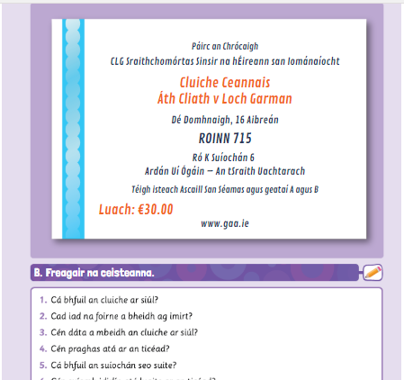
Music | - Listen to this famous piece of music from “The Wizard of Oz”  https://www.youtube.com/watch?v=6KSiyaqnZYs  - Name any of the instruments you can hear (orally)  - Can you describe the tempo of the music?
Science | Topic: Flowers  - What is the purpose of a flower? Answer orally  - Read pg. 77  - Draw a labelled diagram of a flower  - Answer the questions orally about pollination pg. 78  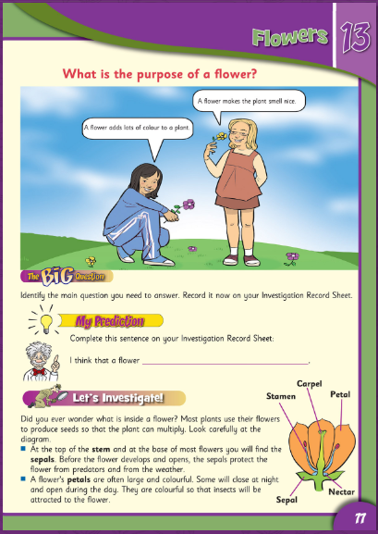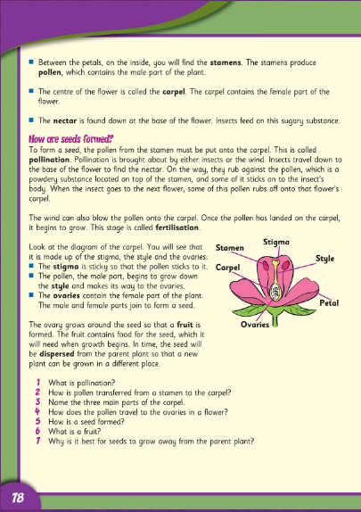

Wednesday
English | Reading:  - My Read at home: pg. 114 and answer questions orally  - Up and Running: wordlist “Stations and Train Journeys”  - DEAR: 10 mins  Writing:  - Up & Running: Write 6 facts about Train Stations and/or Journeys and draw a picture. You can use your textbook to help you! (Maybe you could display it on an A4 page, if you had one).  - My Spelling Workbook: Unit 16, LSCWC x4 spellings  - My Spelling Workbook: Exercise 3
P.E  Mindfulness | Do 15 minutes of any exercise of your choice  Complete page 10 of your wellbeing work pack.  Don’t forget to fill in Page 7 (Daily journal: Rainbow moments day 3) of your Wellbeing Work Pack.  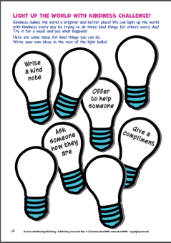
Maths | Planet Maths: Pg. 164  Topic: 3-D Shapes  - Sing your multiplication counting songs  - Answer: Ex. A pg. 164 into your copy/page  To Learn:  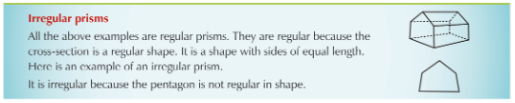  - Answer Orally: Ex. B & C  - Tables Champion: Wednesday  - Mental Maths: Wednesday
Religion | - Read about Bishop John Fleming pg. 100  - To learn: For memorisation  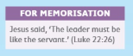  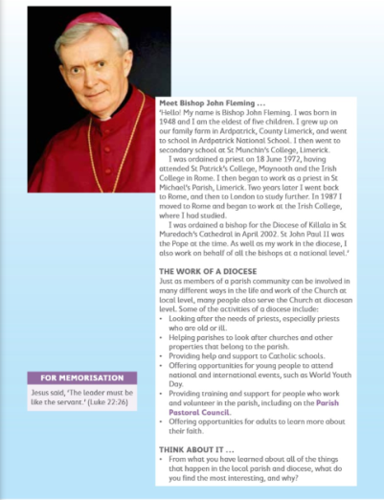
Gaeilge | - Léigh na focail nua arís agus an póstaer  - Éist agus freagair na ceisteanna (listen + answer the qs)  - Log onto Folens.ie  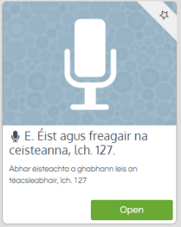  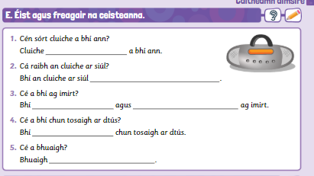
History | Topic: Rosa Parks  - Read page 87 and 88  - Answer the questions orally on pg. 87  - Design a poster. Creative time q3 pg. 89  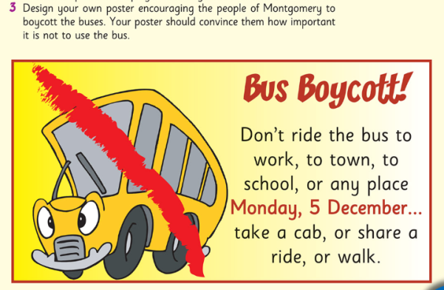  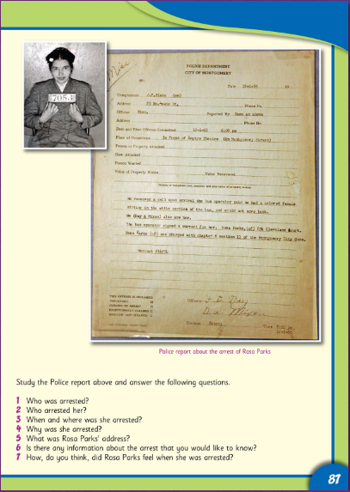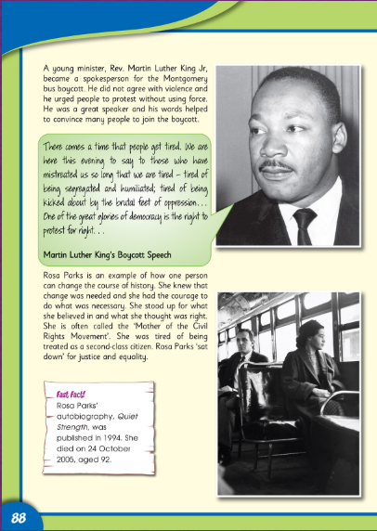
Thursday
English | Reading:  - My Read at home: pg. 115  - Up and Running: wordlist “Stations and Train Journeys”  - Look at the Power Point on Persuasive Letter Writing. (It can be found on our class page on the website)  - Use the Persuasive Letter Poster as a guide to structure your writing. (It can be found on our class web page)  - DEAR: 10 mins  Writing:  - Persuasive Letter: Write a persuasive letter to Mrs. Mescal. I have given you some ideas at the end of the power point if you cannot think of your own! (This poster is also available to view on our class page on the website, if you are having difficulty reading it) 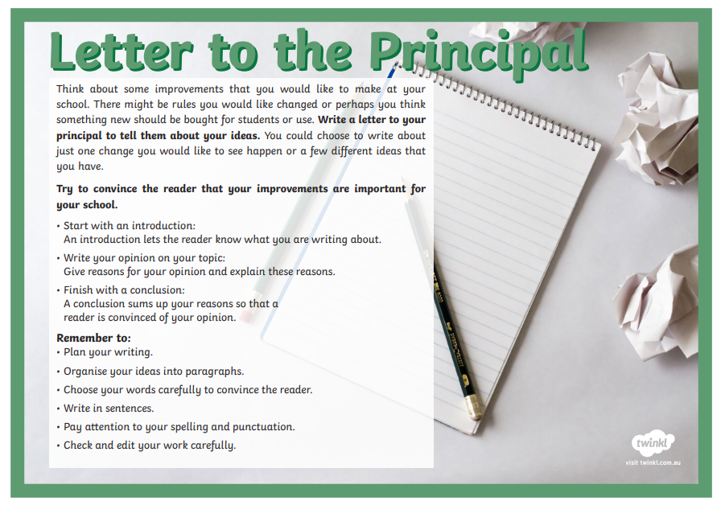  - My Spelling Workbook: Unit 16, LSCWC x4 spellings  - My Spelling Workbook: Exercise 4
P.E  Mindfulness | Complete the “Pump Up” workout from Go Noodle  https://www.youtube.com/watch?v=etYhiq9hM8A  Read and begin page 11 of your wellbeing work pack. Use some of your ideas from yesterday to get you started!  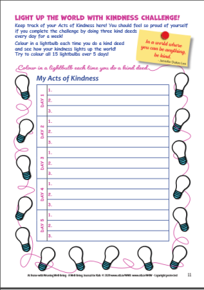  Don’t forget to fill in Page 7 (Daily journal: Rainbow moments day 4) of your Wellbeing Work Pack.
Maths | Planet Maths: Pg. 165  Topic: 3-D Shapes  To Learn:  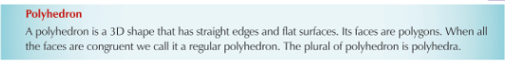  - Write the answers to: Ex. A pg. 165 into your copy.  - Answer orally: Ex. B, C, D Use the Nets of 3D shapes on our class website to help you.  - Tables Champion: Thursday  - Mental Maths: Thursday
Religion | - Read the “At Home” page 102 with a parent or family members.  - Chat together about Bishops  - Say the prayer together  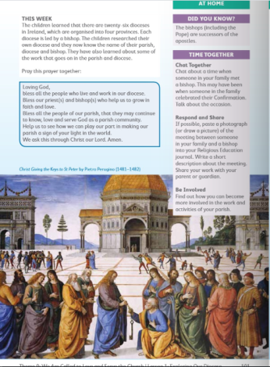
Gaeilge | Briathra: An aimsir fháisteanach – briathra neamhrialta (The Future Tense – irregular verbs)  1. Scríóbh amach na briathra seo i do chóipleabhar. (Write out these verbs in your copy this will help you to learn them.) Pg. 128  Déanfaidh mé = I will do Gheobhaidh mé = I will get  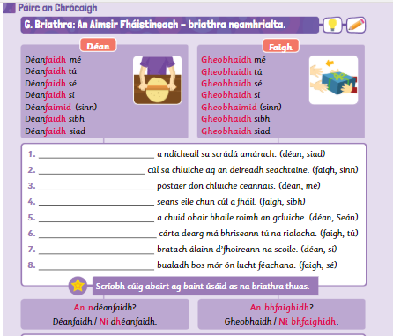  2. Scríobh na habairtí (1-8). (Write the sentences, putting in the correct verb) p.g 128
Art | Topic: Vincent Van Gough - Flowers  - Look at the PowerPoint on Vincent Van Gough  - Choose one of his flower paintings as inspiration to paint/draw/colour  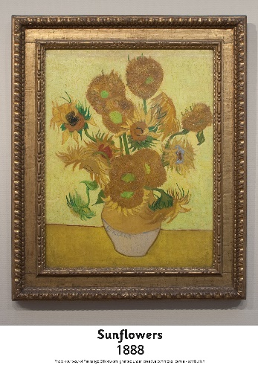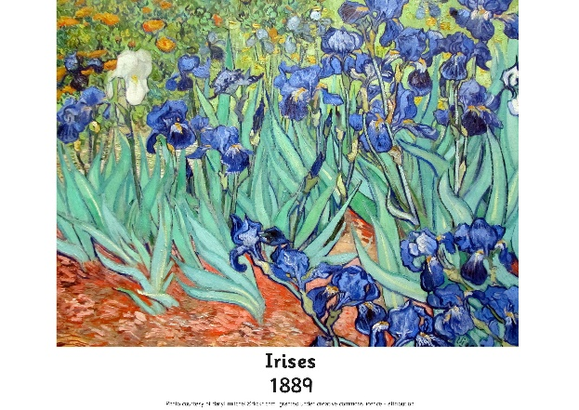
Science | - Read about daffodils.  - Find a flower in your garden (Make sure to ask first!!!!!! Don’t pick one of your mammy’s precious flowers!) See if you can identify the different parts of the flower.  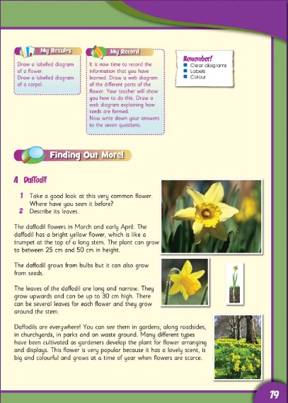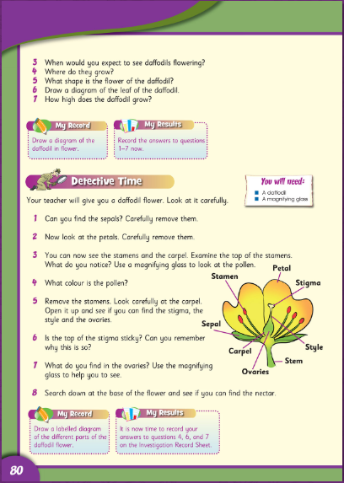

Friday
English | Reading:  - My Read at home: pg. 116  - Up and Running: wordlist “Stations and Train Journeys”  - DEAR: 10 mins  Writing:  - Finish your poem for the poetry competition  - My Spelling Workbook: Unit 16, LSCWC x4  - My Spelling Workbook: Exercise 5
P.E  Mindfulness | Do 15 minutes of any exercise of your choice  Complete page 12 of your wellbeing work pack. I can’t wait to see what animals you come up with! Send them in and I’ll display them in a dedicated photo gallery for “Mindfulness Creativity”.  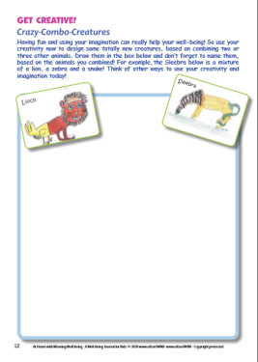  Don’t forget to fill in Page 7 (Daily journal: Rainbow moments day 5) of your Wellbeing Work Pack.
Maths | Planet Maths: Topic: 3D shapes  - Counting, skip counting (10 mins)  - Mental Maths: Friday Test  - Find as many 3D shapes in your house/garden that you can and take a picture (you could label each of them too).  - Create a 3D shape (you can use paper, it doesn’t need to be cardboard) you can use the nets supplied on our class webpage if you wish.
Gaeilge | - Léigh an póstaer arís ar lch.124 agus na eiseamláirí  - Le foghlaim:  - Freagair na ceisteanna ar lch. 128  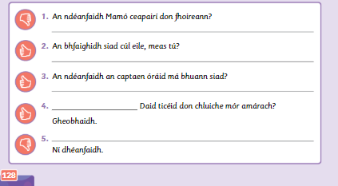
Religion | - Say the Angeles at 12:00 noon or 6:00pm  - Take 5 mins of quite time to pray or have a conversation with God.  - Record an entry into your religion Journal if you wish. What are you thankful for?
History | Topic: Rosa Parks  - Look at the PowerPoint on Rosa Parks as a recap of the chapter.  - Complete the Rosa Parks Fact Sheet (On the class web page)  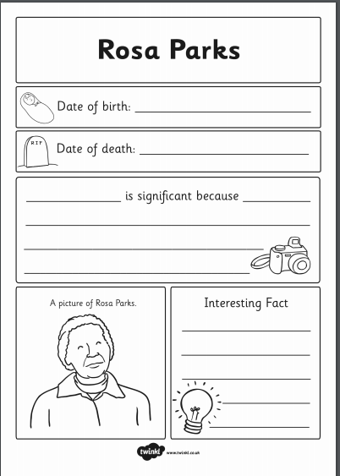
Science | Topic: Flowers  - Read the last page 87  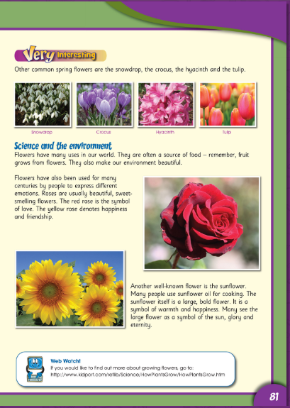  - Using the flower poster, see how many flowers you can identify in your garden, local neighbourhood.  