Do what you can, don’t worry if you cannot complete everything.

You can find all the resources on the school website under our class page “5th Ms. Munroe”.
There is a word document on our webpage with images from your History and Science books.

If you need to look at the online book, follow the links below.

English
Up & Running | https://www.cjfallon.ie/
My Read at Home 5 | https://www.cjfallon.ie/
Maths
Planet Maths | https://www.folensonline.ie/
Gaeilge
Abair Liom | https://www.folensonline.ie/
Religion
Grow in Love | https://www.growinlove.ie/en/
History
Window on the World 5 History | https://www.edcolearning.ie/
Science
Window on the World 5 Science | https://www.edcolearning.ie/

Monday

English | Reading:  - Up and Running: wordlist “An Unsung Hero” (Last wordlist!!!) :)  - Up and Running: pg. 270 + 271 of the text “An Unsung Hero” (Final story!!)  - DEAR: 15 mins  Writing:  - Wordlist: 3 x WL sentences  - My Spelling Workbook: Unit 17, LSCWC x4 spellings  - My Spelling Workbook: Exercise 4
Maths | Planet Maths: Pg. 169 – Topic: Data 2  You will need a compass and a protractor to complete the maths work this week.  Reminder: To get a fraction of a number you divide by the bottom, and then multiply by the top.  - Watch the video that I have created on our class page, which goes through and explains Exercise A on page 169. Fill in the box with the video or once you understand it. Then construct a pie chart using the information.  - Now do Ex. B pg. 169 by yourself, following the method I used in exercise A. (This question is actually easier because they’ve given you the number of children for all the hair types, so you can get the fractions simply by expressing the number of children who have one hair colour out of the total number of children surveyed.  - Answer ex. C orally  - Tables Champion: Monday  - Mental Maths: Monday
Religion | - Read: Theme 10 Lesson 2 pg. 110  - Complete the journal exercise in your copy.  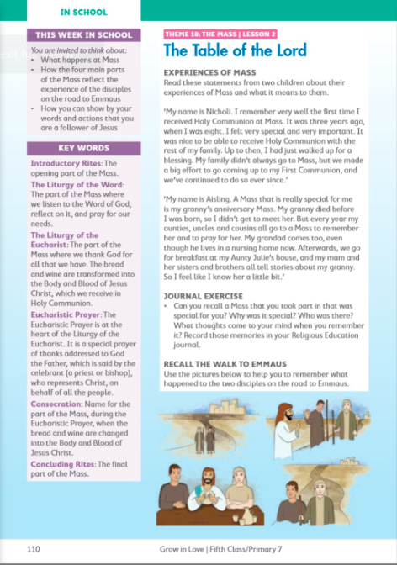  Visit: Grow in Love online with the help of a parent (only of you can) and under 5th class, Theme 10 Lesson 2, you will have access to the songs for the lesson this week, along with other resources.
Gaeilge | Téama: Caitheamh Aimsire (Hobbies)  Use folens online.ie to access the online resources.  - Féach ar an foclóir nua arís. (Look at the new vocabularly again)  - Éist leis an cómhra “Clann Lir” (Listen to the conversation about Clann Lir being read aloud).  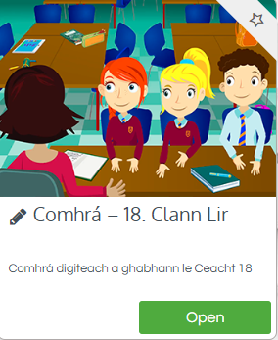  - Anois léigh an cómhrá ar lch 132. (Now read the conversation out loud).  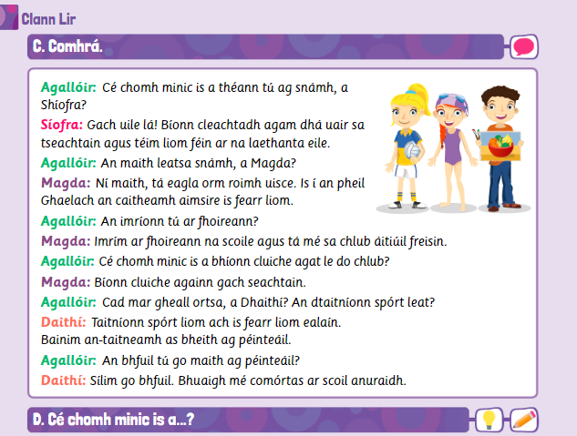
History | Topic: Women who Dare  Can you name any famous, important women who have helped changed the role of women in the world today? (Orally)  - Watch this short video as an introduction to learning about famous women who shaped history: https://www.youtube.com/watch?v=yzhlp8T9s5c  - Read about the remarkable women who have shaped history on pages 100 + 101 of your History book.
Art | Work on your Art Appreciation project as part of the competition on the home page of the website! I have left a few ideas below. I can’t wait to see how creative you all get!  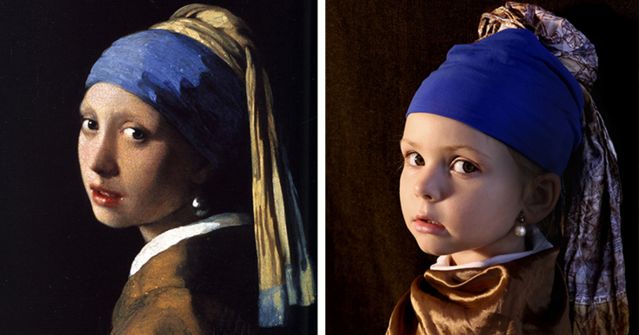  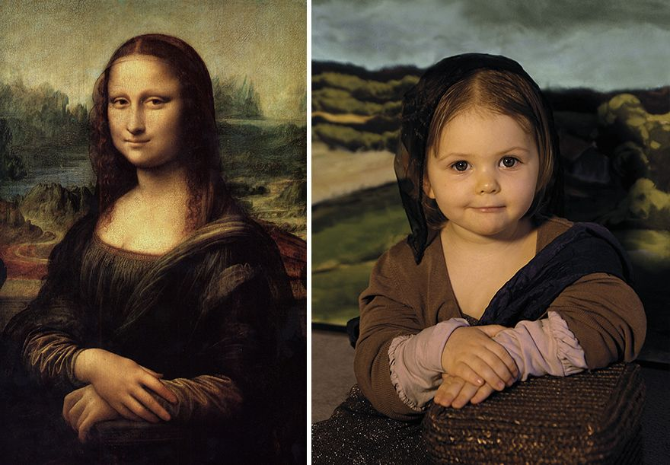  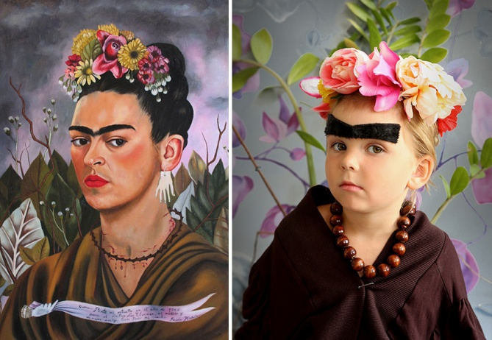  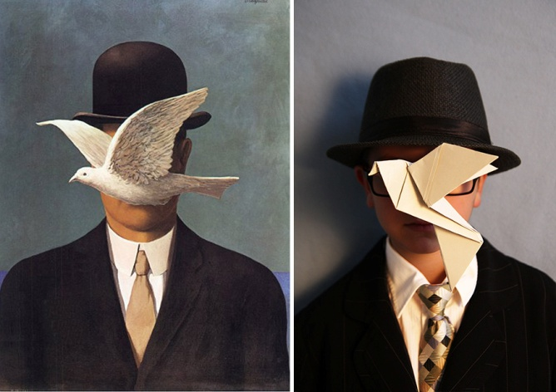

Tuesday
English | Reading:  - Up and Running: wordlist  - Up and Running: pg. 172 + 173 of the story “An Unsung Hero”.  - DEAR: 15 mins  Writing:  - My Spelling Workbook: Unit 17, LSCWC x4 spellings  - My Spelling Workbook: Exercise 5  - Up & Running, pg. 275 Ex. G Finish the Story in copy/word doc
Maths | Planet Maths: Pg. 170  Topic: Data 2  - Before you complete Exercise B, watch the second video I have created on our class page to help you get started.  - Now complete Ex. B (1 + 2) pg. 170. ** I would like you to construct your own pie chart as you’ve been doing in previous questions and ignore the pie chart they have drawn in the book.  - Tables Champion: Tuesday  - Mental Maths: Tuesday
Religion | - Read about the 4 main parts of Mass on pg. 111 + 112  - Learn the For Memorisation box.  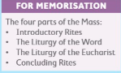  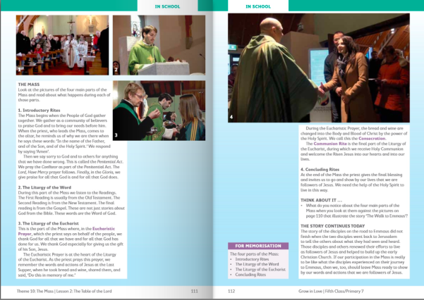
Gaeilge | - Freagair Ceacht D (1-6) lch. 132 (Answer D in your copy).  Cé chomh minic = How often  You have to pick a phrase from under the ‘Cad’ box, and then pair it with a phrase from the ‘cé chomh minic’ box  e.g. Téim ag snámh gach uile lá  gach uile lá = every single day  dhá uair sa tseachtain = twice in the week  gach deireadh seachtaine = every weekend  uair nó dhó sa tseachtain = once or twice in the week  uair nó dhó sa mhí = once or twice in the month  ó am go ham = From time to time  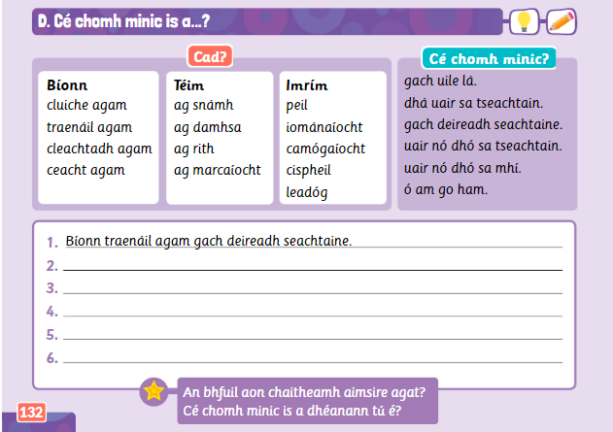
Geography | Topic: Intercultural Day Projects  - Work on your Intercultural Day Project which is due this Friday!  - You could focus on your country’s traditional foods and delicacies today.
Music | Research and listen to some traditional folk music that originates from your country of choice. Do you notice any unusual instruments? Is it similar or different to Irish traditional music?

Wednesday
English | Reading:  - Up and Running: pg. 270 - 273 of the text “An Unsung Hero”.  - Up and Running: wordlist “An Unsung Hero”  - DEAR: 10 mins  Writing:  - Up & Running: Answer the questions Ex. B (4 - 10) pg. 274  - My Spelling Workbook: Unit 17, LSCWC x4 spellings (2 list, 2 revision)  - My Spelling Workbook: Exercise 6
P.E | Use the Circuit Recording sheet (on class page) to test yourself and see how many of each exercise you can do in one minute! Try and get your family members involved!  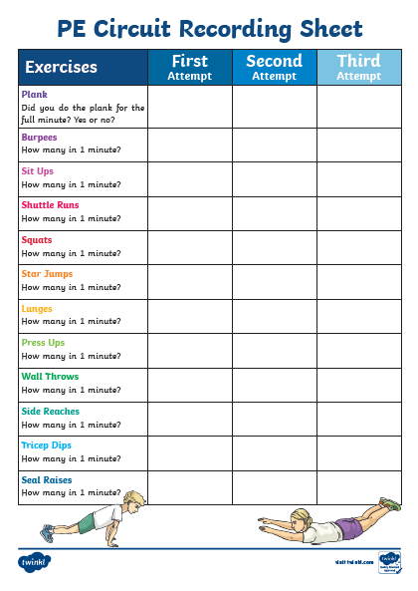
Maths | Planet Maths: Pg. 170  Topic: Data 2  - Sing your multiplication counting songs  - Complete ex. A pg. 170 in your copy. You will have to do a bit problem solving and thinking to figure out some of these answers – but they’re not hard!  - Construct the pie chart ex. C pg. 170  - Tables Champion: Wednesday  - Mental Maths: Wednesday
Gaeilge | - Léigh an cómhrá arís (Practise reading the cómhrá)  - Déan ceacht F ar lch. 133 (Do activity F on page 133)  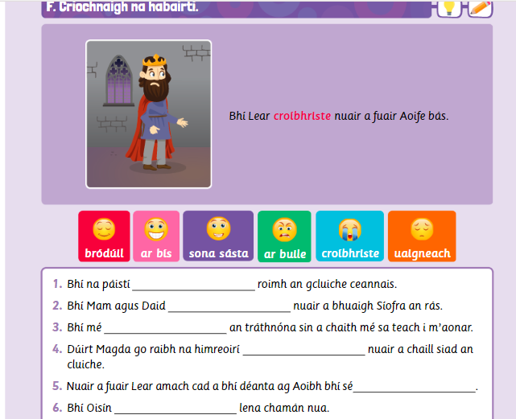  Bródúil = Proud  Ar bís = Excited  Sona sásta = Very Happy  Ar buille = Furious  Croíbhriste = Heartbroken  Uaigneach = Lonely
History | Topic: Women Who Dare  - Read pages 102 + 103 of your book about Women who made a difference and about Women and voting.  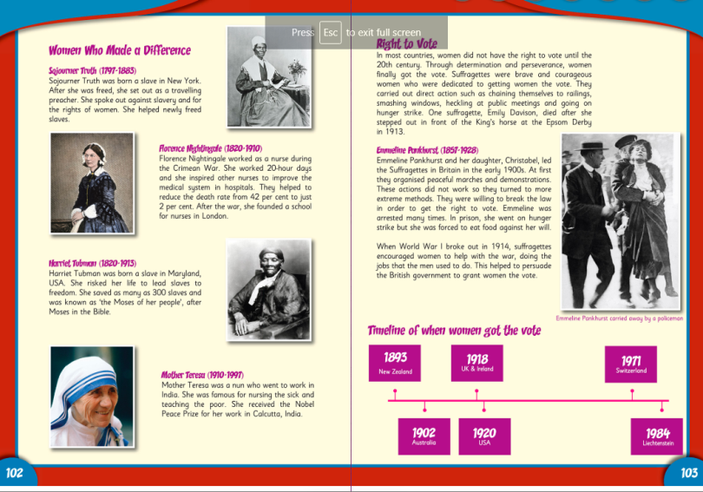  - Answer the ‘Question Time’ questions on page 104 in your copy.

Thursday
English | Reading:  - Up and Running: wordlist “An Unsung Hero”  Writing:  - “All Primary School Children should Repeat their Current Year in School”  - Write a speech or presentation to tackle the statement above. Consider the pros and cons and come to a conclusion.  - Think about the current global pandemic, as a result of Coronavirus and the impact it has had on children and their education.  - Pretend you have to present to the class.  Don’t forget to include as many persuasive phrases as you can and use persuasive language throughout your work.  - My Spelling Workbook: Exercise 7  - My Spelling Workbook: Unit 17, LSCWC x4 spellings (Revision Words)
Maths | Planet Maths: Pg. 171  Topic: Data 2  - Answer ex. B pg. 171 in your copy. You will have to do a bit problem solving and thinking to figure out some of these answers – but they’re not hard!  - Complete this activity on a page or in your copy:  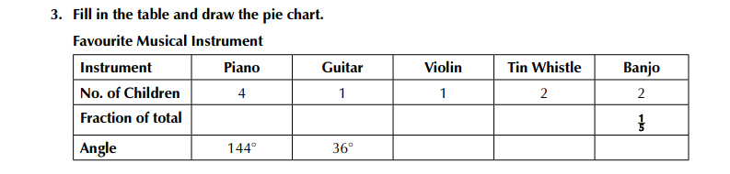  - Tables Champion: Thursday  - Mental Maths: Thursday
Religion | - Read the “At Home” page 114 with a parent or family members.  - Chat together about how you can live as a follower of Jesus.  - Say the prayer together  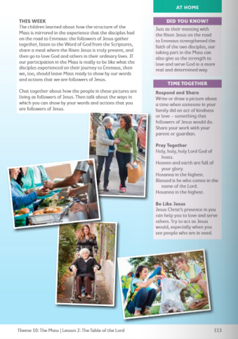
SPHE | Positivity Jar: Follow the instructions in the document (on class page) to create a positivity Jar. This jar can be filled with positive words, comments or affirmations. The purpose of the jar is to use it whenever you are feeling sad and need to remember all the positive things about yourself! :)  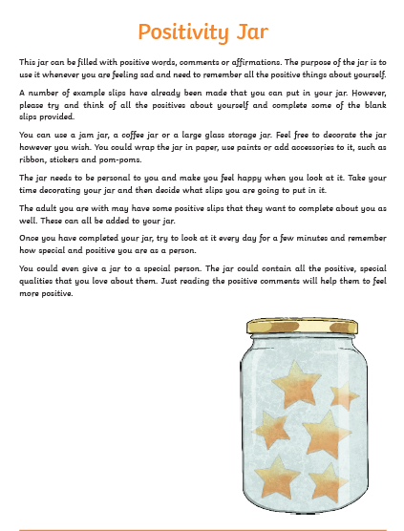
Gaeilge | Gramadach : ‘Roimh’ lch 135  1. Déan an ceacht gramadach H (1-8) ar lch 135 i do chóipleabhar. (Write the sentences in your copy).  2. Déan cleachtadh ar an gcómhrá (Practise the cómhrá)  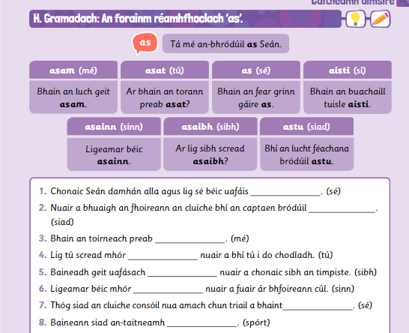
Geography | Finish your Intercultural Day Projects which are due tomorrow!  Make sure you have included a wide range of different information and facts about your country e.g. traditional food, clothes, music, where it is located in the world, a map of the country, the country’s flag, its population, some of the country’s traditions and practices etc. I can’t wait to see everyone’s excellent work! :)

Friday
English | Reading:  - Up and Running: wordlist “An Unsung Hero”  - DEAR: 10 mins  Writing:  - My Spelling Workbook: Exercise 8  - My Spelling Workbook: Unit 17, LSCWC x4 spellings (Revision Words)
Maths | Planet Maths: Page 171 Topic: Data 2  - Counting, skip counting (10 mins)  - Answer ex. C (1+2) on pg. 171 in your copy. You only have to write 5 statements or facts.  - Try and figure out these puzzles! Go to the website, and find the puzzles, to see if your answer is correct :) https://www.solvemoji.com/Puzzle/MostPopular/  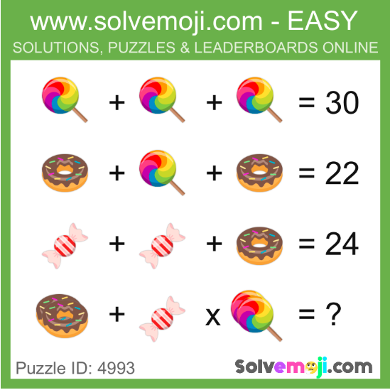  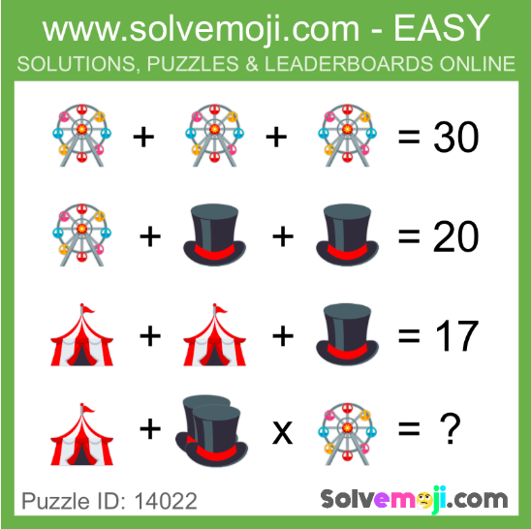  Mental Maths: Friday Test
Gaeilge | - Léigh an t-alt faoi chaitheamh aimsire Magda ar lch 136 (Read the paragraph about Magda’s hobbies)  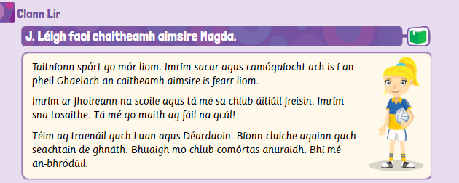  - Anois scríobh alt faoi do chaitheamh aimsire (Now write a paragraph about your hobbies, using the vocabulary and Magda’s paragraph  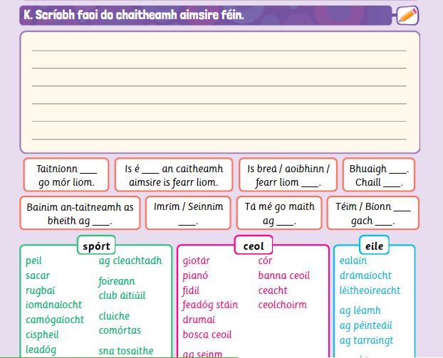
Religion | - Say the Angelus at 12:00 noon or 6:00pm  - Take 5 minutes of quiet time to pray or have a conversation with God.
History | Topic: Women Who Dare  Task:  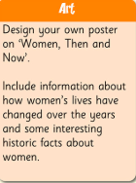  You can use an A4 sheet or do it in your copy!

