Intercultural Day was due to be held on June 5th and whilst we’re not in school, we are still going to celebrate it.
We want you to do the following: Pick a Country - Do a project on that country. Learn all about the country you have chosen e.g. location, history, famous landmarks, food etc and then put together a presentation on it.
It could be on an A4 page with facts and pictures, a PowerPoint presentation with slides, a video listing a number of facts. You make the decision!
If you have a brother or sister in the school, you could team up with them and make the project together.
If you have a connection to a particular country, why not do your project on it? The project is due by Friday 12th June.
You will see it included in your weekly work below and we will allocate time for it next week also. We would like to share the projects on the school webpage but it’s no problem if you do not want it to appear there, just let me know.
Also, keep an eye on the school home page this week as Ms. Dowling will be posting further information to celebrate Intercultural Day. Ms. Dowling will also be asking children with a connection to a certain country to send in photos of themselves dressed in traditional clothes or with the flag of the country or beside traditional food they’ve cooked.
It would be wonderful to see performances of a song/ dance/ poem relating to the country too!
Happy Intercultural Day!

Wednesday
English | Reading:  - Up and Running: wordlist “The Boy in the Striped Pyjamas”  - Up & Running: The Boy in the Striped Pyjamas pg. 260, 261, 261, 263  - Library book: 15 mins  Writing:  - Up & Running: Grammar Ex. F, pg. 269  - My Spelling Workbook: Unit 17, LSCWC x4 spellings  - My Spelling Workbook: Exercise 1
P.E  SPHE: Mindfulness | 10 x Burpees  10 x Jumping Jacks  10 x squats  10 x press ups  10 x high knees  10 x leap frogs  Finish with 1-minute of spiriting on the spot (or up and down the garden if you have one)  Following on from last week. Think about someone you admire for their bravery! Complete page 18 of your wellbeing work pack by drawing a picture of them and write why you admire them!  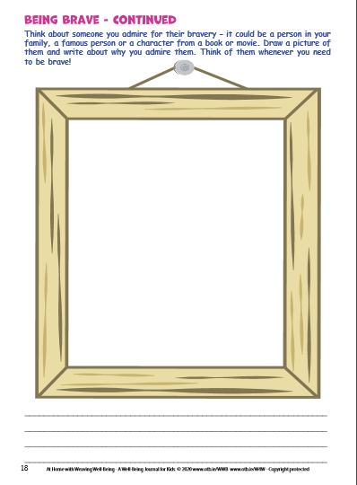
Maths | Planet Maths: Pg. 167  Topic: Data  Remember: To find the average of a set of numbers, you add all of the numbers and divide the answer by the amount of numbers.  - Sing your multiplication counting songs  - Answer exercise A pg. 167 orally.  - In your copy answer Ex. C q1 & q2 and Ex. D q1 & q2  When you are answering Ex. D See example 3(b) below:  Say to yourself “What ÷ 5 = 12”. The answer I got was 60.  Place 60 in a circle above the brackets to remember it. Add the numbers inside the brackets (12 + 13 + 11 + 3 = 39).  Take 39 away from 60. 60 – 39 = 21.  Our answer is 21.  - Tables Champion: Wednesday  - Mental Maths: Wednesday
Religion | Theme 10: Lesson 1  - Read pg. 106  - Journal Exercise: Pick two scripture references and look them up in a Bible (you may have a bible from your first holy communion).  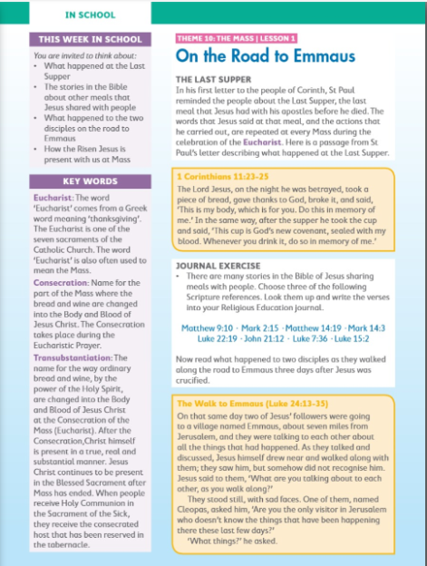
Gaeilge | Scéal: Clann Lir  Téama: Caitheamh aimsire  - Feach ar na liosta focail nua (Look at the new list of words, on the school website)  - Éist leis an scéal : Clann Lir (Listen to the story Clann Lir)  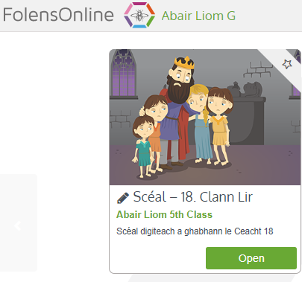  - Léigh an scéál Clann Lir ar lch. 130 (Read the story)  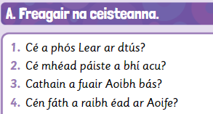  - Freagair na céisteanna Ceacht A 1-4 ar lch. 131  A phós = marry  Cathain = when  éad = jealous
Geography | Topic: Intercultural Day Project  Work on your Intercultural Day project based on the country of your choice.  - Decision: Which country are you going to choose? How are you going to record the information? Are you doing the project on your own or as part of a family?  - Check out World Atlas.com https://www.worldatlas.com/aatlas/world.htm to view all the countries in the world.  - Location: In what continent is your country of choice located? What other countries are located near your country? What oceans / seas are near your country or bordering it?  - Physical Geography: Does your country have mountains / rivers / lakes? How high are the mountains? How long are the rivers?  - Map: It would be nice to include a map with your project. You could have a map of the world to show where your country is located. You could also have a map of your country showing the important cities, towns, rivers, mountains and bordering countries.  Check out the World Population Density Website: http://luminocity3d.org/WorldPopDen/#3/47.46/10.55  You can find the population of your country here.  When you have chosen your country, check out this website to see if you can research some facts. https://www.sciencekids.co.nz/sciencefacts/countries.html  There is a selection of PowerPoint presentations on the class web page if you are having trouble deciding on a country.
Science | Topic: Mixing  - Predict: What will happen when you mix salt into warm water and freeze it.  - Using the ingredients and equipment listed; follow the method to complete the experiment.  - What happens????  - You can find the reasoning/explanation on the class web page.  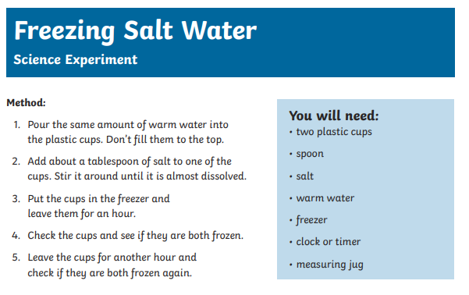

Thursday
English | Reading:  - Up and Running: wordlist “The Boy in the Striped Pyjamas”  - Up and Running: Read pg. 264, 265, 266, 267 “The Boy in the Striped Pyjamas”  - DEAR: 15 mins  Writing:  - Up & Running: Answer Quest & Query Ex. D pg. 268 into your copy/type.  - Unit 17, LSCWC x4 spellings  - My Spelling Workbook: Exercise 2.
P.E  S.P.H.E: Mindfulness | 15-minute walk/ cycle / scoot / run around your estate with permission from an adult.  Read page 19 of your well-being pack. Mood Boost!  Complete the activity by writing down all of the things that help to boost your mood!  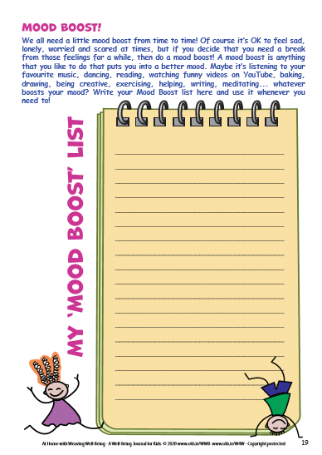
Maths | Planet Maths: Pg. 168  Topic: Data  - Answer the warm up question on Folens online.  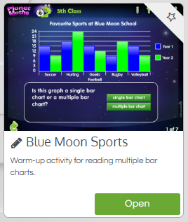  - Read the blue box on pg. 168 explaining Pie charts.  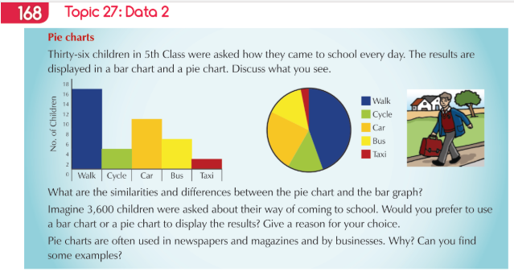  - Answer Ex. A orally pg. 168.  - Answer Ex. B q 1-4, pg. 168 into your copy  Remember to look carefully at the Pie chart (it is the shape of a circle or a pizza). When you are asked about fractions think about ½’s, ¼’s, 1/8’s for this question.  - Tables Champion: Thursday  - Mental Maths: Thursday
Religion | - Read pages 107 & 108 and answer the questions orally.  - For memorisation:  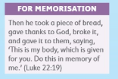
Gaeilge | - Léigh & éist leis an scéal Clann Lir arís.  - Freagai na céisteanna ar lch. 131, A 5 – 8  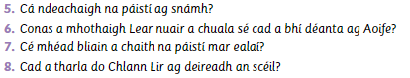  Cá ndeachaigh = where did they go (answer: Chuaigh)  ag snámh = swimming  a mhothaigh = feel  nuair = when  a chuala sé = he heard  cad a bhí déanta = what Aoife did  bliain = years  a chaith = spend  mar ealaí = as swans  cad a tharla = what happened
Art | Topic: Rangoli Artwork  - Look at the PowerPoint All about Rangoli  - Create your own Rangoli artwork using paper, paint, markers, paper plates, chalk outside, you decide!  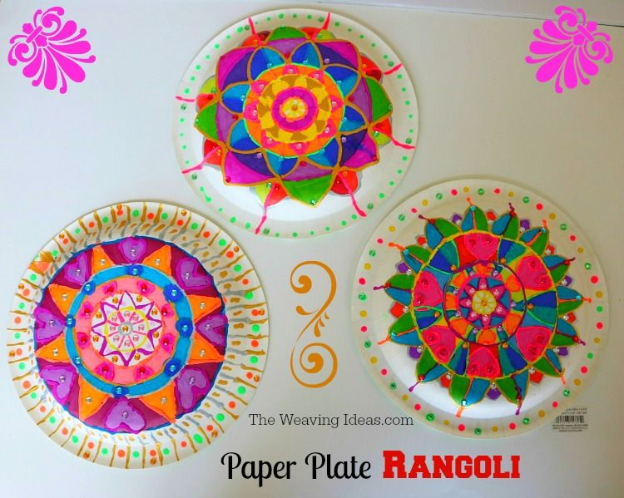  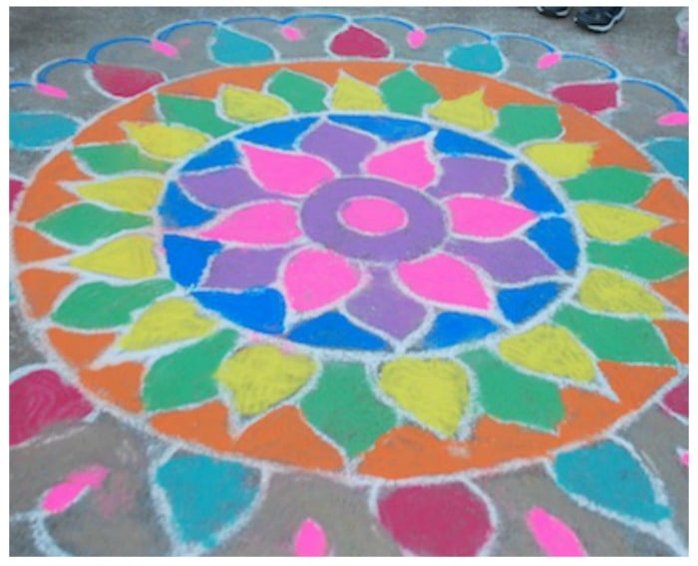  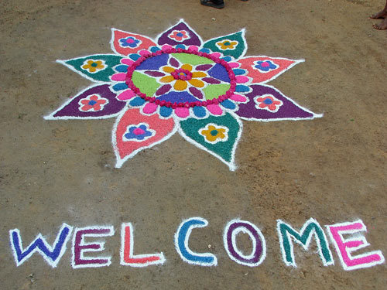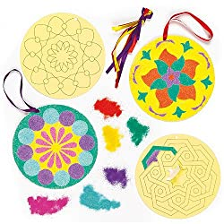  Or if you wish, you could create a piece of artwork to represent the country you have chosen for your project.
Geography | Topic: Intercultural Day Project  - Look at the PowerPoint presentation on Families around the World.  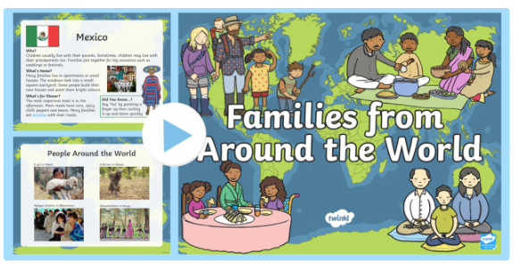  - You recently learned about festivals around the world on pg. 77 of your geography book.  - Today write about any festivals or celebrations that your select country celebrates.
Science | Topic: Mix and seperate  - Read pg. 83 from your science book  - Following the method from the recipe (on the school website) you can make your own bread!  - Predict: What will happen when you mix all the ingredients together and you leave the mixture to rest in a bowl covered for cling film for about an hour?  (Do you know what this part of the method is call?)  - You can watch the method on the video (on school website)  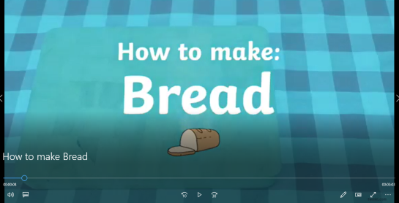  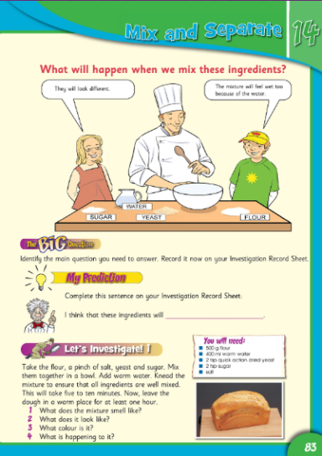

Friday
English | Reading:  - Up and Running: wordlist “The Boy in the Striped Pyjamas”  - Read through and listen to the PowerPoint on “Zoos”, you can find it on the class web page under English. I have added a voiceover to it.  - DEAR: 10 mins  Writing:  - “Zoos Are Cruel and All the Animals Should Be Released into the Wild”  Write a speech or presentation to tackle the statement above. Consider the pros and cons and come to a conclusion  (Pretend you have to present to the class).  Don’t forget to include as many persuasive phrases as you can and use persuasive language throughout your work.  - My Spelling Workbook: Exercise 3  - Unit 17, LSCWC x4 spellings
P.E  S.P.H.E: Mindfulness | Do 15 minutes of any exercise of your choice  This is the final page of your Well-being Pack! Page 20  Good to me: This is a wonderful activity. You may recall we did something similar during the year. Write your name and get as many people in your family to write down positive words or ways to describe you. Why not give your Granny or your grandad a call! You can tell them I was asking for them!  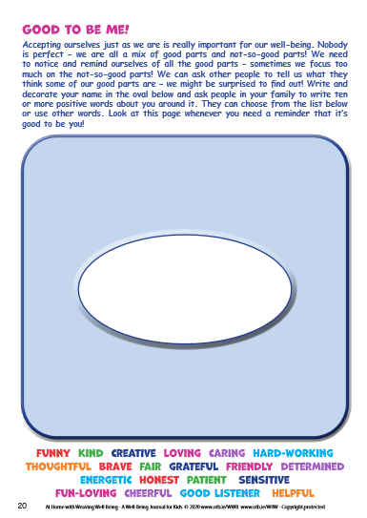
Maths | Planet Maths: Page 169  - Counting, skip counting (10 mins)  - Watch the video I have created on the website.  - Play it for a second time, and then try to complete the question by yourself, or pause the video after each step, in order to complete the question. It is looking at the example on page 169.  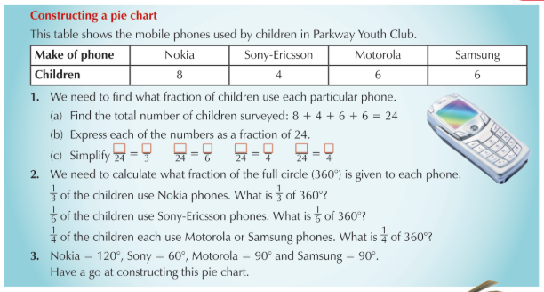  - Then try Ex. A, use the second video on the website to help you fill in the table.  - There are extra worksheets available on the school website if you wish to complete more data charts.  - Mental Maths: Friday Test
Gaeilge | - Léigh na eiseamláirí agus focóir nua.  - Le fhoglaim: An Aimsir Fháistnineach, Feic & Ith (To learn: The future tense of the verbs to see & to eat)  - Déan cúid G sa cóipleabhar ar lch. 134 ( Do Ex.G in your copy)  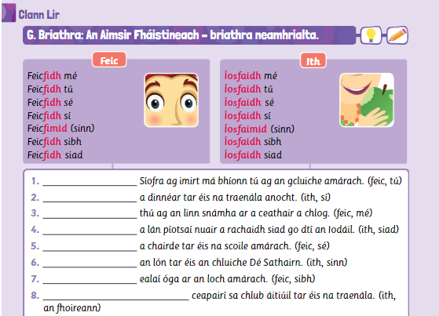
Religion | - Read the “At Home” page together with a parent pg. 109.  - Chat together about how it is difficult to believe that the bread and wine are changed into the Body and Blood of Jesus Christ at Holy Communion.  - Say the prayer together  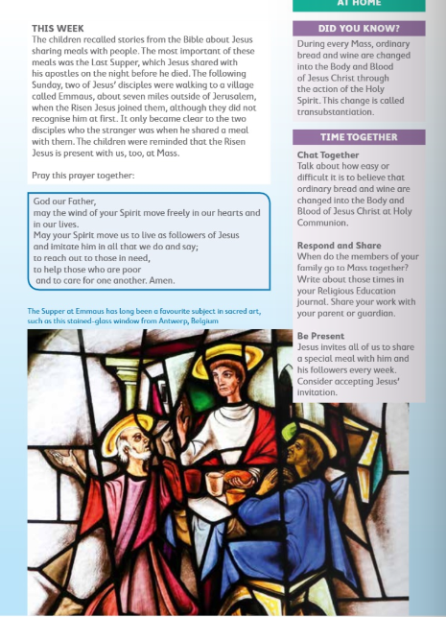
Science: | Topic: Mixing and Separating  - Read and investigate the experiment in pg. 85 of the science book. Window on the World Science, available on Edco.ie, or images on school class webpage.  - Remember to make your prediction first!  