Do what you can, don’t worry if you cannot complete everything.

You can find all the resources on the school website under our class page “5th Ms. Munroe”.

Sports’ Day will take place this week. You will receive information about Sports’ Day before Sunday evening. Similar to last week, you can choose which day suits you best for Sports’ Day. There will be plenty of activities for everyone and guidance on how to do them. We have only given you work for four days this week.

Monday

English | Reading:  - DEAR: 15 mins  Writing:  - My Spelling Workbook: Unit 18, LSCWC x4 spellings  - My Spelling Workbook: Exercise 5
PM | Planet Maths: Pg. 181 & 182 – Topic: Chance  - Exercise B pg. 181 – answer the questions orally  - Exercise A pg. 182 – answer in copy  - Tables Champion: Monday  - Mental Maths: Monday
Gaeilge | Téama: An tSamhraidh  Use folens online.ie to access the online resources.  - Féach ar an foclóir nua arís . (Look at the new vocabularly again)  Damhsóirí ag damhsa = dancers dancing  Aghaidh phéinteáil = face paint  Stallaí ceardaíochta = Craft stalls  An spúinse = sponge  An casúr = hammar  Preabchaisleán = bouncing castle  Ceoltóirí ag seinm = musicians playing  Stallaí bia = food stalls  Lámhchleasaithe = jugglers  Ag spórt is ag spraoi = fun and games  Féile = festival  - Éist leis an cómhra “Féile an tSamhraidh” (Listen to the conversation being read aloud).  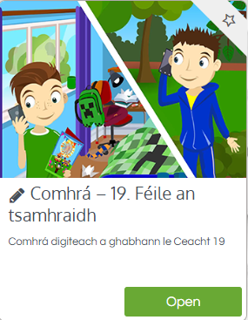  - Anois léigh an cómhrá ar lch 140. (Now read the conversation out loud).  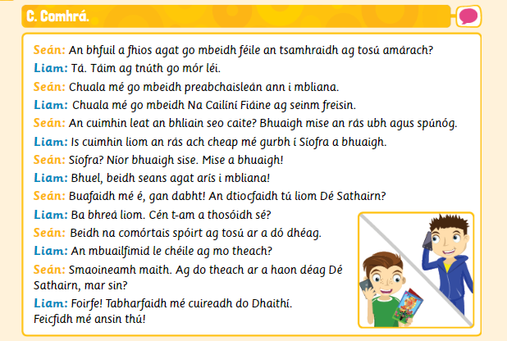

Tuesday
English | Reading:  - DEAR: 15 mins  Writing:  - My Spelling Workbook: Unit 18, LSCWC x4 spellings  - My Spelling Workbook: Exercise 6
Maths | Planet Maths: Pg. 182  Topic: Chance  - Exercise B pg. 182 (ignore question 2c)  - Exercise A pg. 183 (answer orally)  - Tables Champion: Tuesday  - Mental Maths: Tuesday
Gaeilge | - Éist agus leigh an cómhrá arís.  - Freagair ceacht D lch. 126 (Answer D in your copy).  Chuala mé go mbeidh… = I heard that there will be…  Rás ubh agus spúnóg = Egg and Spoon race  Stalla seaodra = Jewellery Stall  Comórtas bácála = Baking competition  An casúr = The hammer  picnic na mbéiríní = Teddy Bear’s Picnic  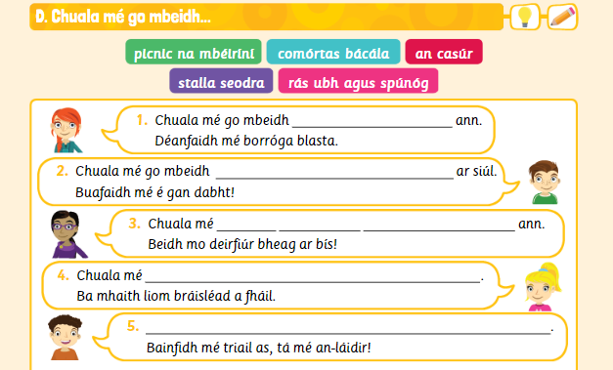

Wednesday
English | Reading:  - DEAR: 10 mins  Writing:  - My Spelling Workbook: Unit 18, LSCWC x4 spellings  - My Spelling Workbook: Exercise 7
Maths | Planet Maths: pg. 183 & 184  Topic: Chance  - Ex. B 1-8 pg. 183 answer orally  - Ex. C 1-9 pg. 183 answer orally  - Ex. B pg 184 in copy  - Tables Champion: Wednesday  - Mental Maths: Wednesday
Gaeilge | - Léigh na eiseamláirí nua (Practise reading the phrases)  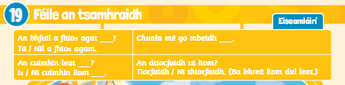  - Éist leis an Dán ‘Bainseó’  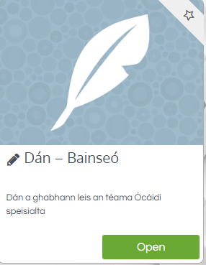  - Anois léigh agus foghlaim na focail ar lch. 141 (Now read and learn the words)  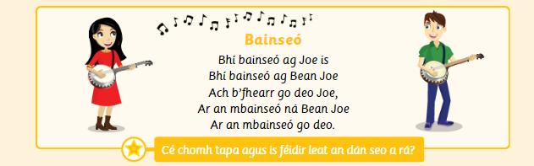

Thursday
English | Reading:  - DEAR: 10 mins  Writing:  - My Spelling Workbook: Exercise 8  - My Spelling Workbook: Unit 18, LSCWC x4 spellings
Maths | Planet Maths: Pg. 185  Topic: Chance  **If you don’t have coloured cubes, use coloured pieces of paper instead!  - Exercise A – record answers in copy. (If you want you could get a sibling or family member to help you with this investigation!)  - Exercise B: 1-5e  - Tables Champion: Thursday  - Mental Maths: Thursday
Gaeilge | - Léigh an cómhrá arís (Practise reading the cómhrá)  - Déan cleachtadh ar an dán (Practise saying the poem)

If you need to look at the online book, follow the links below.

Maths
Planet Maths | https://www.folensonline.ie/
Gaeilge
Abair Liom | https://www.folensonline.ie/

