Do what you can, don’t worry if you cannot complete everything.

You can find all the resources on the school website under our class page “5th Ms. Munroe”.
There is a word document on our webpage with images of the English Story.

This week we are going on our School Tour! We have given you work for four days this week (Monday – Thursday). You can have your School Tour on Friday, or you can pick a different day during the week if you wish! Details about the School Tour are available on our class page “Ms. Munroe” on the website.

Monday

English | Reading:  - “Help! It’s Harriet!” pg. 6, 7 & 8 (Story on class page)  - DEAR: 15 mins  Writing:  - My Spelling Workbook: Unit 18, LSCWC x4 spellings  - My Spelling Workbook: Exercise 1
PM | Planet Maths: Pg. 173 – Topic: School Tour  Reminder: To find the average of a list of numbers, you add the numbers together and divide the answer by the number of numbers in the list.  Reminder: To get a fraction of a number you divide by the bottom, and then multiply by the top.  - School Tour: This is a set of revision questions. Answer Q1 – 4. (If you need to complete this work over two days, that is ok! )  - Tables Champion: Monday  - Mental Maths: Monday
Religion | - Read: Additional Lesson 6 pg. 134  - Read the story of Passover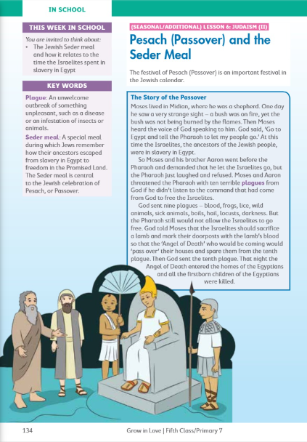  Visit: Grow in Love online with the help of a parent (only of you can) and under 5th class, Theme 10 Lesson 2, you will have access to the songs for the lesson this week, along with other resources.
Gaeilge | Téama: An tSamhraidh  Use folens online.ie to access the online resources.  - Féach ar an foclóir nua . (Look at the new vocabularly)  Damhsóirí ag damhsa = dancers dancing  Aghaidh phéinteáil = face paint  Stallaí ceardaíochta = Craft stalls  An spúinse = sponge  An casúr = hammar  Preabchaisleán = bouncing castle  Ceoltóirí ag seinm = musicians playing  Stallaí bia = food stalls  Lámhchleasaithe = jugglers  Ag spórt is ag spraoi = fun and games  Féile = festival  - Éist leis na foclóir nua (Listen to the the vocabulary online being read aloud).  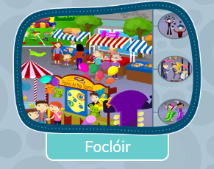  - Anois éist leis an scéal agus ansin léigh an scéal. (Now listen to ther story and then read the story out loud). The story is not in your book this week it is only available online.  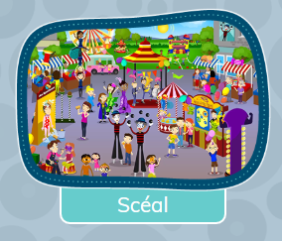  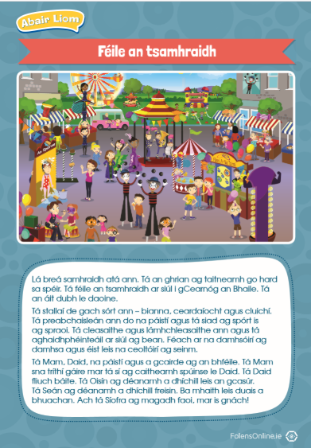
Art | Topic: The Ocean  Activity: Select your favourite or the most interesting sea creature to you and draw, create, paint it.  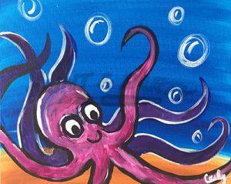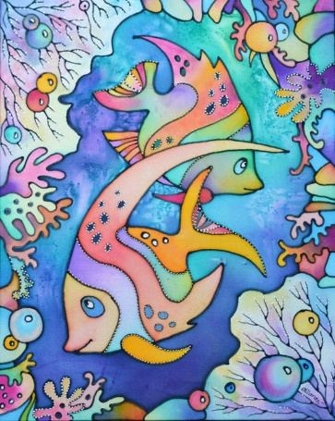  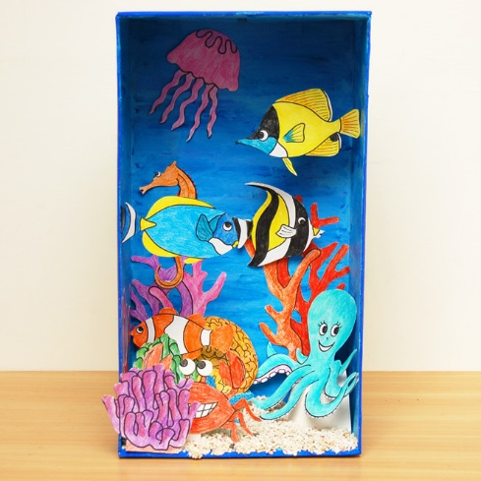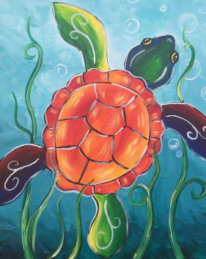

Tuesday
English | Reading:  - “Help! It’s Harriet!” pg. 9, 10 & 11 (Story on class page)  - DEAR: 15 mins  Writing:  - My Spelling Workbook: Unit 18, LSCWC x4 spellings  - My Spelling Workbook: Exercise 2  - ‘Tale and Detail’ 1-7 in copy/word doc (From ‘Help! It’s Harriet!’)
Maths | Planet Maths: Pg. 176  Topic: Capacity  - Choose one of the following options (Some of you may not be able to complete the first exercise)  - Complete exercise A (if you can) 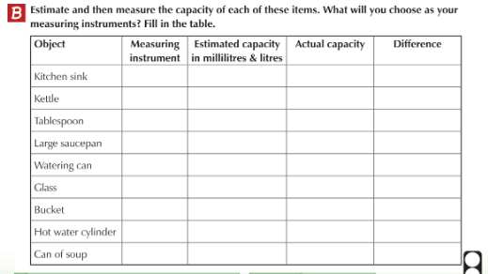  Or  - Complete Ex. A pg. 174 Mental Maths  - Tables Champion: Tuesday  - Mental Maths: Tuesday
Gaeilge | - Éist agus leigh an scéal arís.  - Éist leis na ceisteanna agus dean an cluiche gníomhaíochta  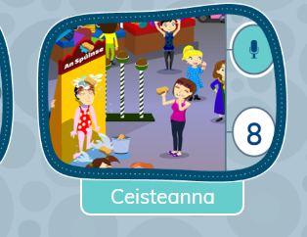  - Leigh an bileoigín ar lch. 139 (read the notice)  - Freagair na ceisteanna (1 – 4) i bhur gcóipleabhar. (answer the questions in your copy).  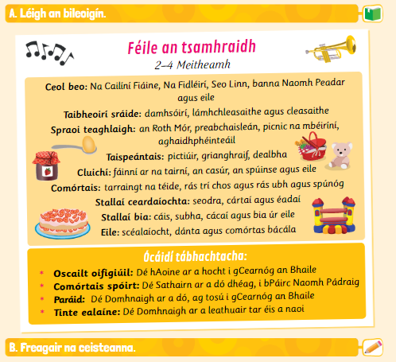
Religion | - Answer the questions orally on pg. 135  - Complete the journal exercise  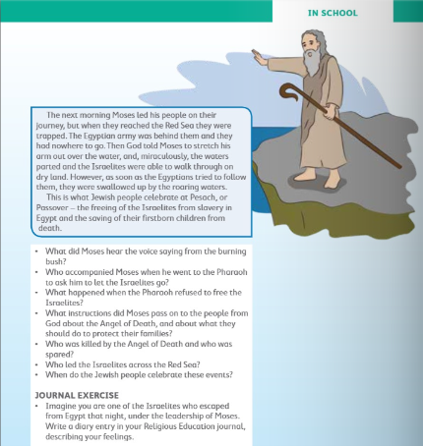
Science | Topic: Bubble Snake  What you will need:  - Small tube or plastic bottle  - Elastic band  - Bubble mix – shop bought or make your own  - Old cloth or sock for the end  - scissors (You will need the help of a parent)  BUBBLE SNAKE INSTRUCTIONS:  - First you need to cut the bottom off your water bottle – ask an adult to help and be careful as the end might be sharp.  - Cover the end of the bottle with a piece of cloth and secure tightly with an elastic band.  - Dip the cloth end into bubble mix.  - Blow carefully down the other end of the bottle and watch as a bubble snake appears!  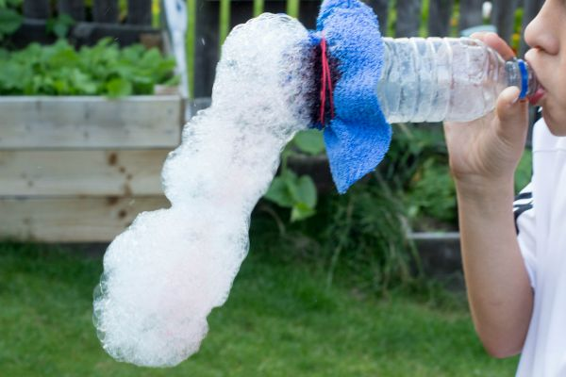  Tip: If you have food colouring for baking, you could add this to the bubble mixture to create a colourful snake!
Music | UNDER THE SEA: Listen to the clip from “The Little Mermaid”.  https://www.youtube.com/watch?v=eVvktGBemME  - What instruments can you hear?  - What is the time signature of the piece?  - How does the piece of music make you feel?  - Did you sing along????? (I did!)

Wednesday
English | Reading:  - “Help! It’s Harriet!” re-read pg. 6 - 11  - DEAR: 10 mins  Writing:  - ‘Undercover work’ q 1-8 pg. 12 (From ‘Help! It’s Harriet!’)  - My Spelling Workbook: Unit 18, LSCWC x4 spellings  - My Spelling Workbook: Exercise 3
P.E | Daily exercise:  15 minute walk  5 minute jog  3 minute sprint  5 minute walk
Maths | Planet Maths: 177  Topic: Capacity  Remember: 1000ml = 1Litre  To find a fraction of a number, you divide by the (denominator) bottom and multiply by the top (numerator).  ¾ of 1000ml  1000 ÷ 4 = 250ml  250ml X 3 = 750ml  - Sing your multiplication counting songs  - Ex. A (1 – 5) Draw the graduated cylinders into you copy and shade in the measurements.  - Ex. B (1 -8) Workout the amount and represent it on the measuring jug.  - Tables Champion: Wednesday  - Mental Maths: Wednesday
Religion | - Read about the Seder meal on pg. 135 + 136. 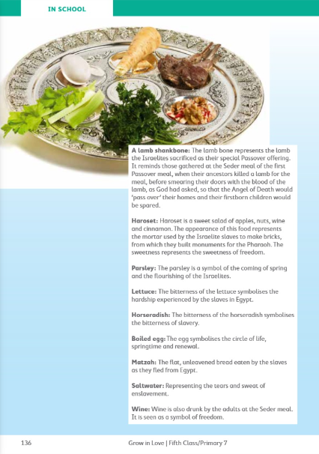
Gaeilge | - Léigh na eiseamláirí nua (Practise reading the phrases)  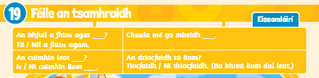  - Críochnaigh na ceisteanna ar lch. 139 (5-9). (Finish the questions on pg. 139)
Geography | Topic: Oceans of the World  - Look at the power point “Oceans of the world” on the school website.  - Using the activity pack on the website as a reference (if you do not have a printer) create a diagram showing the different layers of the sea.

Thursday
English | Reading:  - DEAR: 10 mins  Writing:  - My Spelling Workbook: Exercise 4  - My Spelling Workbook: Unit 18, LSCWC x4 spellings
Maths | Planet Maths: Pg. 178  Topic: Capacity  To learn:  100ml = 1/10 of 1L = 0.1L  10ml = 1/100 of 1L = 0.01L  1ml = 1/1000 of 1L = 0.001L  You may need to refresh your memory of place value using decimals before you begin.  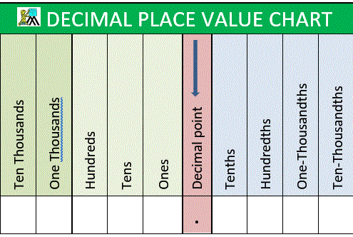  - Answer Ex. A (1-4) pg. 178  - Answer Ex. B (1-4), pg. 178  Remember: To express a number as a fraction, e.g. 450ml as a fraction of 1L. You write is as 450/1000. You can simplify by 10 if you wish. 45/100.  How would we write this as a decimal?  45/100 = 0.045  - Now answer Ex. C (1-4), pg.178  - Tables Champion: Thursday  - Mental Maths: Thursday
Religion | - Read the “At Home” page 137 with a parent or family members.  - Chat together about the special meals your family has.  - Say the prayer together at meal time.  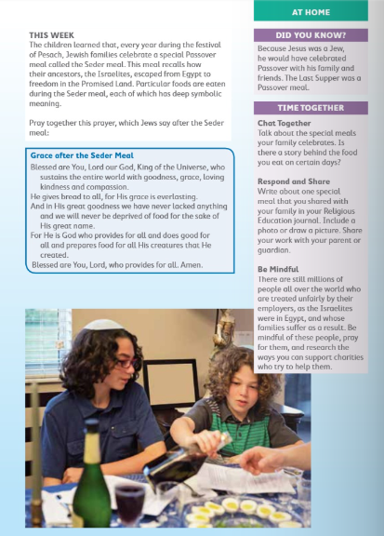
SPHE | Breathing: Bubble breath  - Watch the video on bubble breath.  https://app.gonoodle.com/activities/bubble-breath?s=Discover&t=Wo6/8/20-FP-4A-Featured%20on%20GoNoodle&sid=1789&x=2&y=1&mft=simple%20row  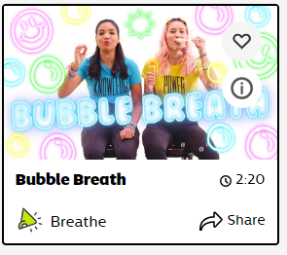
Gaeilge | - Freagair Ceacht G (1-8) lch. 142 (Answer G in your copy).  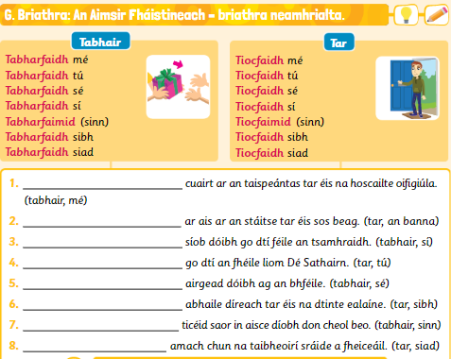
Geography | Topic: Oceans  - Watch the National Geographic video about Oceans  https://www.youtube.com/watch?v=MfWyzrkFkg8  - Visit the National Geographic website exploring oceans of the world: https://www.natgeokids.com/ie/discover/geography/general-geography/ocean-facts/  - Create an A4 page (You can use your copy if you do not have an A4 page) and make a short fact file/project about the oceans of the world.

Friday
School Tour | We are going on a virtual tour to……. THE GREAT BARRIER REEF!!  There is a word document on our class page on the website with instructions you can follow.  This is the link to The Great Barrier Reef:  https://attenboroughsreef.com/

If you need to look at the online book, follow the links below.

English
Up & Running | https://www.cjfallon.ie/
My Read at Home 5 | https://www.cjfallon.ie/
Maths
Planet Maths | https://www.folensonline.ie/
Gaeilge
Abair Liom | https://www.folensonline.ie/
Religion
Grow in Love | https://www.growinlove.ie/en/
History
Window on the World 5 History | https://www.edcolearning.ie/
Science
Window on the World 5 Science | https://www.edcolearning.ie/

