5th Class – Suggested Work
Hi everyone,
We hope you are all keeping safe during this time. We’ve heard some great stories about how you have been getting on working at home. If you can, try to email us with photos of you and your work. We’d love to see how you’re doing.
Below we have included additional work for you to complete next week. Try your best and see what you can get done!
We can’t wait to see you soon!
Ms. Cleary & Ms. Munroe

Maths
- Mental Maths - continue with one per day as usual.
- Tables Champion - continue with one per day as usual.
- Planet Maths “Bright Star Pizza” pgs. 50 - 51 in maths copy.

English
- Handwriting - continue on with your handwriting book.
- Spelling Workbook – continue with the same unit.
- My Read at Home – one page per day. Write full answers in copy.
- Finish the story and email it to msmunroesclass@gmail.com

Story starter!
Flying is supposed to be fun, right?
Poppy often dreamed about what her first flight would be like. She’d imagined it was like being a bird; free and weightlessly drifting through the clouds.
The first part of the journey had been exactly as she’d hoped it would be. Jasper agreed, signalling his enjoyment by barking enthusiastically from the co-pilot’s seat.
Things were about to take a drastic turn for the worse…

Art
- Select one or more of the following pieces of art. Send us a photo of your creation to msmunroesclass@gmail.com
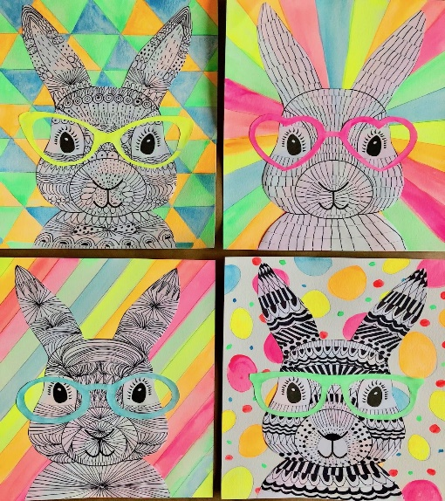
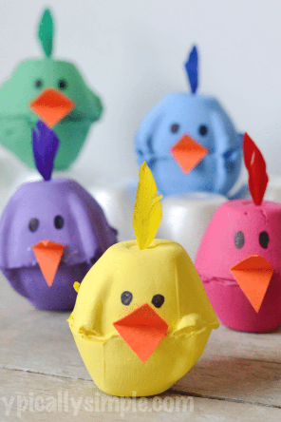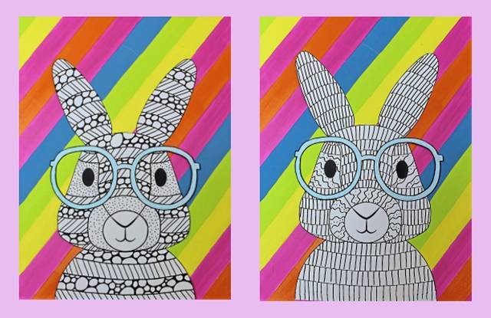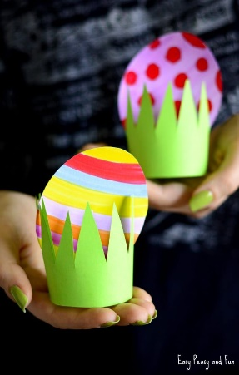
Music
- Revise the songs: Grace and The Fields of Athenry
- Send us in a clip of you playing a musical instrument if you’d like!
- Access our Irish songs through folens online.
Gaeilge
- Complete the exercise below on the Aimsir Láithreach (present tense) – briathra neamhrialta (irregular verbs). Write full sentences in copy.
- Learn the verbs: 1. Tabhair (to give) 2. Tar (to come)
- Revise each of the verbs on the pink page: these are all regular verbs
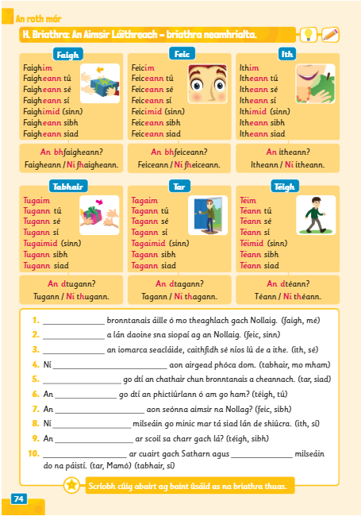
- You can access Abair Liom and all of the songs and poems online. There is a link and instructions on the class page.
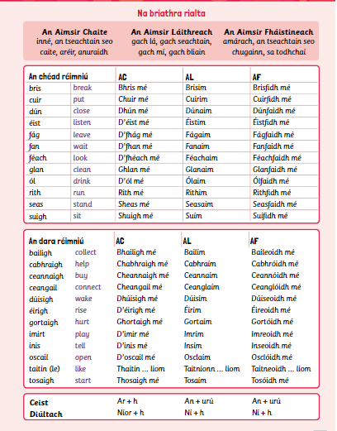

Geography
- Chapter 13: The Earth at work
- Read this chapter and answer the questions (1-10) in your copy.
You can use the images of the book below or you can access the online book by following these instructions:
- Go to www.edcolearning.ie
- Enter the following details
- Click on the book “Window on the world” Geography 5th class
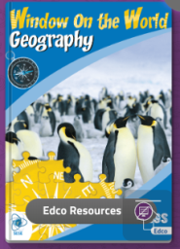

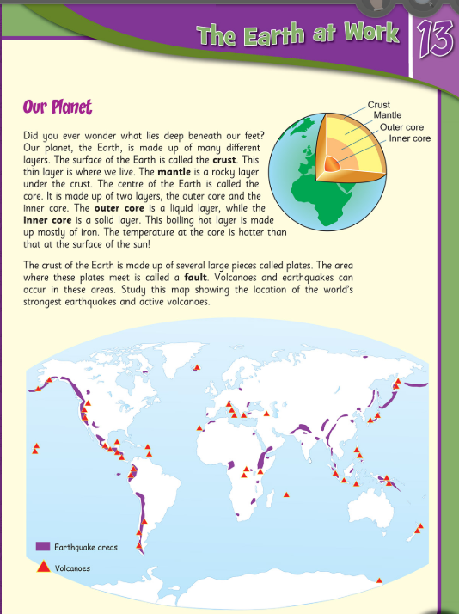
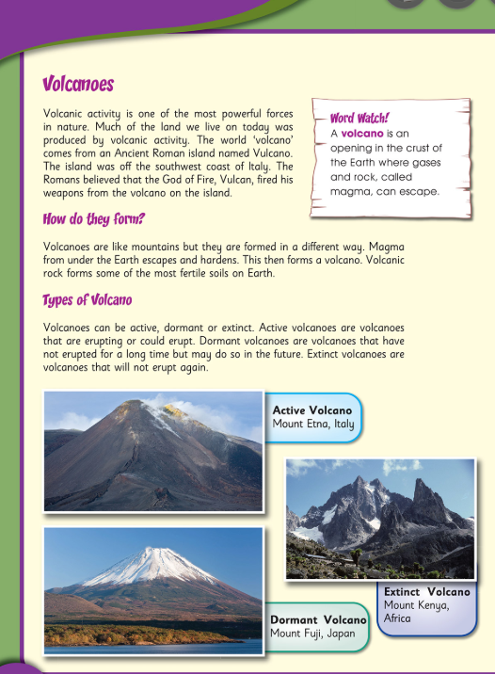

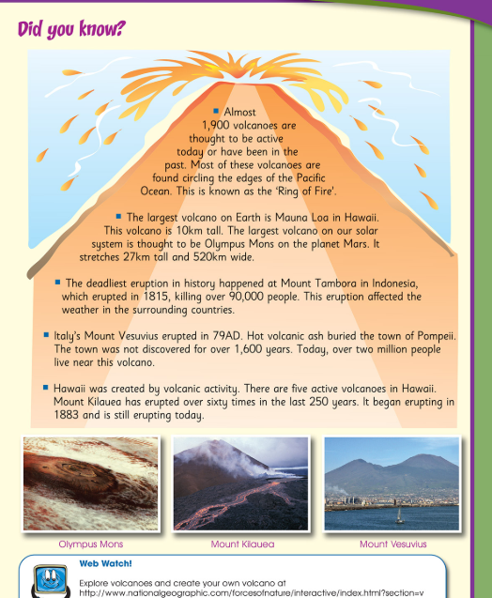

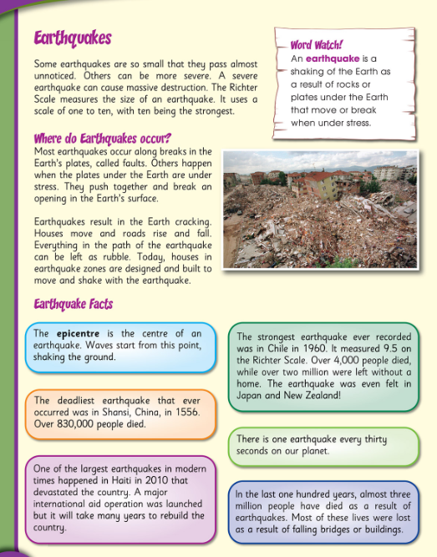

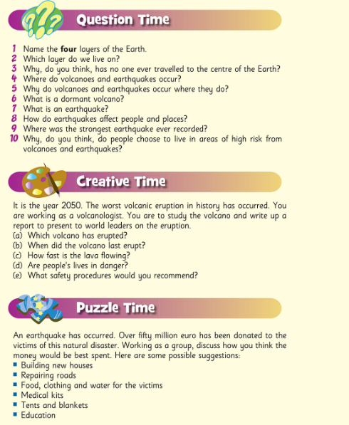

Religion
- Read the reading comprehension about Easter and answer the questions in your copy.
