5th Class – Suggested Work
Hi everyone,
We hope you are all keeping safe during this time. We’ve heard some great stories about how you have been getting on working at home. If you can, try to email us with photos of you and your work. We’d love to see how you’re doing.
Below we have included additional work for you to complete next week. Try your best and see what you can get done!
We can’t wait to see you soon!
Ms. Cleary & Ms. Munroe

Maths
- Mental Maths continue with one per day as usual
- Tables Champion continue with one per day as usual
- Planet Maths Chapter 21 Directed Numbers pgs. 135 - 137 in maths copy

English
- D.E.A.R: 10 – 15 minutes of reading everyday.
- Handwriting - continue on with your handwriting book
- Spelling Workbook – continue with the “Easter Words” Unit
- My Read at Home – one page per day. Write full answers in homework copy.
- Finish the story and email it to 5thclassmscleary@gmail.com or msmunroesclass@gmail.com

Story starter!
Flying is supposed to be fun, right?
Poppy often dreamed about what her first flight would be like. She’d imagined it was like being a bird; free and weightlessly drifting through the clouds.
The first part of the journey had been exactly as she’d hoped it would be. Jasper agreed, signalling his enjoyment by barking enthusiastically from the co-pilot’s seat.
Things were about to take a drastic turn for the worse…

Art
- Select one or more of the following pieces of art. Send us a photo of your creation. 5thclassmscleary@gmail.com or msmunroesclass@gmail.com
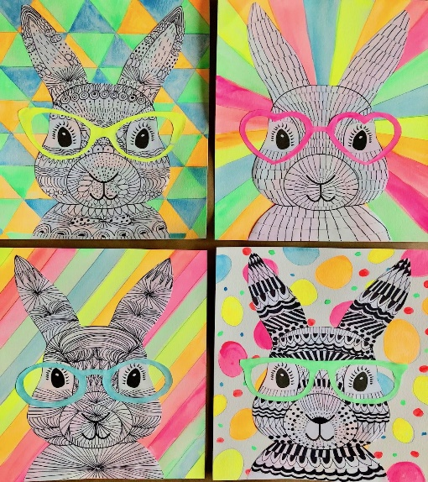
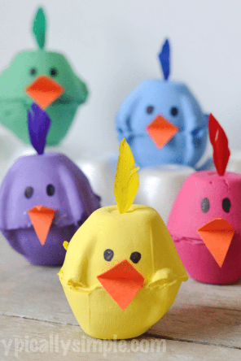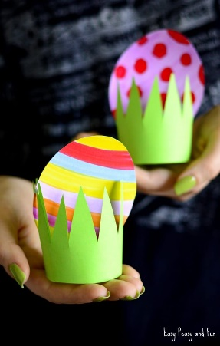
Music
- Revise the songs: Grace and The Fields of Athenry (or learn a song of your choice)
- Send us in a clip of you playing a musical instrument if you’d like!
- Access our Irish songs through Folens online.

Gaeilge
Using the images below
- Complete the exercise below on the (future tense) Aimsir Fhaistineach – an dara réimniú (two syllables)
Oscail: to open
Inis: to tell
- Revise each of the verbs on the pink page: these are all regular verbs
- You can access Abair Liom and all of the songs and poems online. There is a link and instructions on the class page.
- 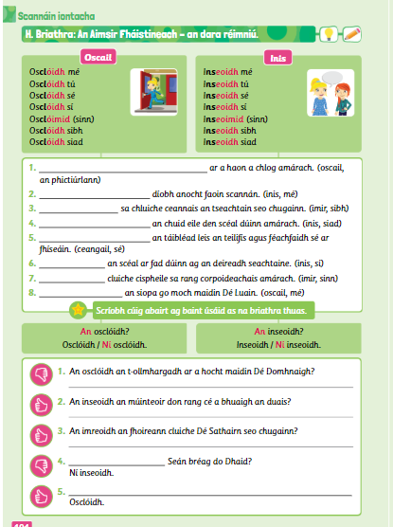
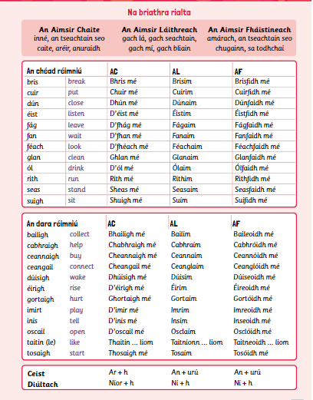

P.E
- At least 20 mins of activity outside (if possible especially when the weather is lovely.)
- Dancing, hurling, football, skipping, burpees, basketball, running etc.
- When not create an obstacle course (I’d love to see how creative you could be)
- Spell your name using the alphabet list on our class page

Geography
- Chapter 13: The Earth at work
- Read this chapter and answer the questions (1-10) in your homework copy.
You can use the images of the book below or you can access the online book by following these instructions:
- Go to www.edcolearning.ie
- Enter the following details
- Click on the book “Window on the world” Geography 5th class
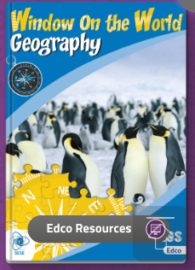

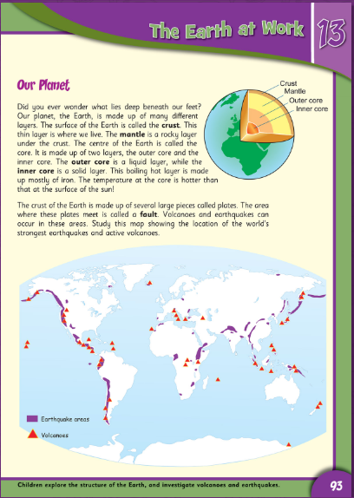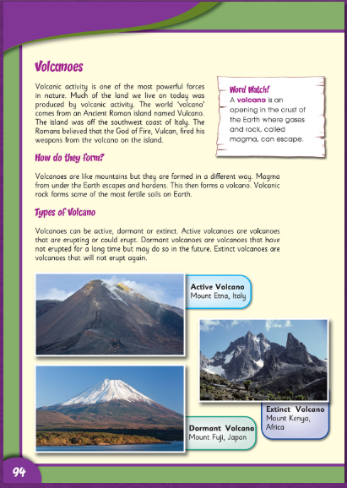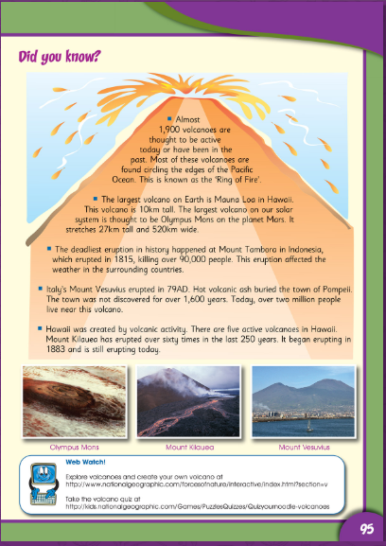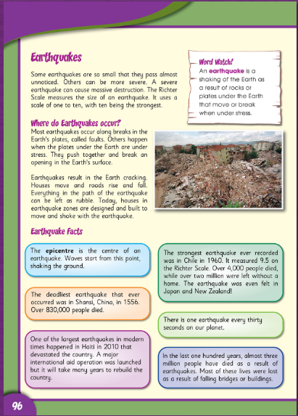
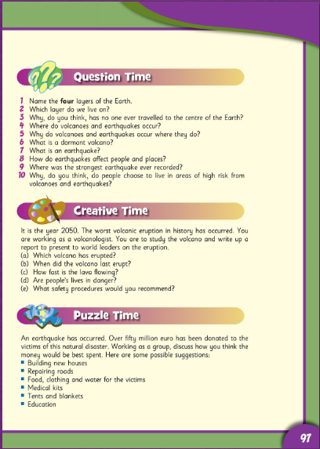
Religion
- Read the reading comprehension about Easter and answer the questions in your copy. 