If there is a device (laptop, tablet, etc.) available to you at home, type any of the below work that you can and send it to me. If not, continue to complete the work in your copy and send me pictures of the work.

These are the links to all of the class books which are available online.
Do what you can, don’t worry if you cannot complete everything.

English
Up & Running | https://www.cjfallon.ie/
My Read at Home 5 | https://www.cjfallon.ie/
Maths
Planet Maths | https://www.folensonline.ie/
Gaeilge
Abair Liom | https://www.folensonline.ie/
Religion
Grow in Love | https://www.growinlove.ie/en/
History
Window on the World 5 History | https://www.edcolearning.ie/
Science
Window on the World 5 Science | https://www.edcolearning.ie/

Active Schools Week 2020

As it is Active Schools Week you can leave out one piece of work every day and replace it with the active work, if you want to!

- Go Noodle Dance: This year our dance will be “Roar“,
https://app.gonoodle.com/activities/roar?s=Search&t=KIDSBOP
- Try and practise it every day. Get all the family involved.

- Wake up Shake up: Why not try this every morning before you start your school work:
- 10 jumping jacks
- 10 frog jumps
- Run on the spot for 30 seconds
- 10 squats
- 10 lunges
- Skipping for 30 seconds
- High knees for 30 seconds
- Stretch up to the sky, to the left side and to the right side
- Stretch those legs and those arms

Monday

English | Reading:  - My Read at home: pg. 99 + answer questions orally  - Up and Running: wordlist 5th Class Wordlist Strange Flying Machines  - Up and Running: pg. 212 + 213 of the story “Strange Flying Machines”.  You can access Up & R here: https://my.cjfallon.ie/preview/student/2694  Writing:  - Wordlist: 3 x WL sentences  - My Spelling Workbook: Unit 14, LSCWC x4 spellings (2 list & 2 revision words)  - My Spelling Workbook: Exercise 6
Active Schools Week  Mindfulness | “Marathon Monday”  - See how many laps of your garden you can do in the day!  - Challenge other members of your family.  Take a few moments to write in your Time capsule Document/Journal about how you are feeling.
Maths | Planet Maths: Pg. 152 – Topic: Weight  Remember the rule: 1000g = 1kg or 1kg = 1000g  - Play the online warm – up game: https://www.folens.ie/login  Click resources, Weight  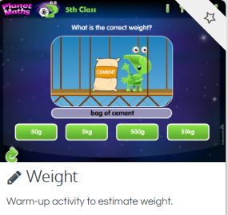  - Write the answers to: Ex. B page 152 into your copy  - Tables Champion: Monday  - Mental Maths: Monday
Religion | Read: Theme 8 Lesson 2  Learn the “For Memorisation box” – The 7 gifts of the Holy spirit  Login details are as follows:  Grow in Love: www.growinlove.ie  Email: trial@growinlove.ie  Password: growinlove  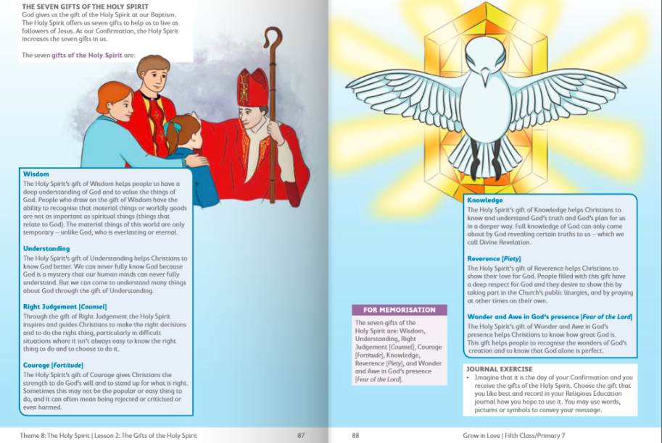  Visit: Grow in Love online with the help of a parent (only if you can) and under 5th class, Theme 8 Lesson 2 you will have access to the songs for the lesson this week, along with other resources.
Gaeilge | Scéal Nua: An rinc scátála oighir  Téama: An Aimsir  You can create a Folens account (with the help of a parent) to check the pronunciations of the words. Details on our class page.  - Léigh na focail nua (Read the new vocabulary again)  Gaeilge Béarla Gaeilge Béarla  bog mild álainn / deas lovely / nice  te hot Drochlá bad day  fuar cold ag taitneamh shining  grianmhar sunny ag spalpadh anuas beating down  scamallach cloudy ag cur báistí / fearthainne raining  fliuch wet ag séideadh blowing  tirim dry ag cur sneachta snowing  gaofar windy ag plúchadh sneachta snowing heavily (blizzard)  ceomhar foggy stoirm storm  grian sun fiáin wild  scamall cloud toirneach thunder  báisteach / fearthainn rain tintreach lightning  gaoth wind tornádó tornado  ceo fog hairicín hurricane  sioc frost crith talún earthquake  sneachta snow súnámaí tsunami  leac oighir ice dóiteán foraoise forest fire  bogha báistí rainbow tonn teasa heatwave  - Léigh an cómhrá: Read the conversation. You can use the interactive account through Folens.ie and listen to the conversation being read aloud first. Pause the video after every line and repeat it. Then try saying the conversation out loud by yourself.  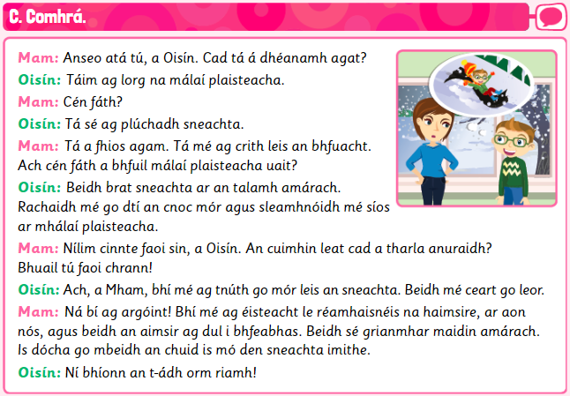
History | Topic: Feasts and Festivals  - Think about the feasts and festivals that we celebrate in Ireland. How do you usually celebrate these special days? What is your favourite feast or festival?  - Now can you think of any feasts and festivals that are celebrated in other parts of the world?  - Read about different festivals around the world and locate them on the map pg. 78 & 79  - Pick 5 of the festivals around the world and write a fact about them.  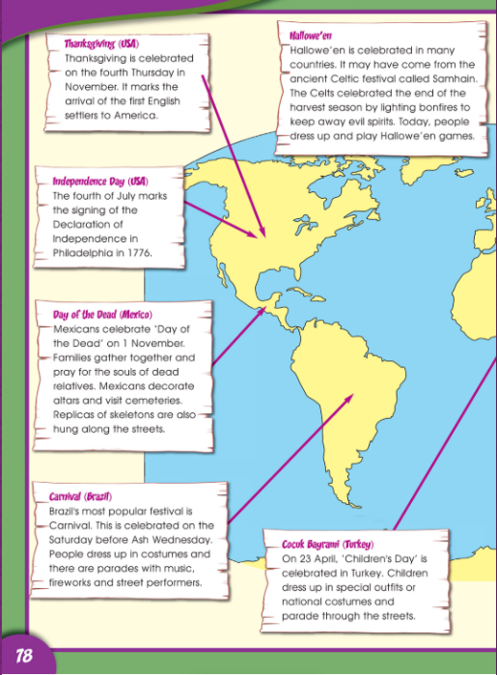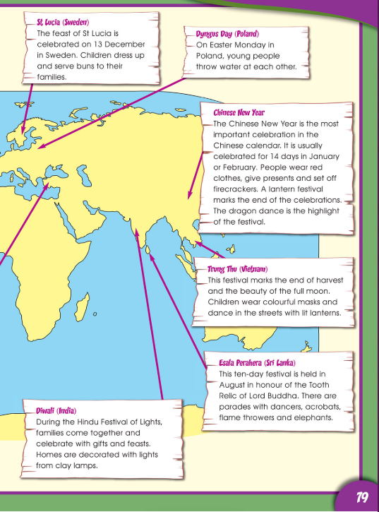

Tuesday
English | Reading:  - My Read at home: pg. 100  - Up and Running: wordlist  - Up and Running: pg. 214 + 215 of the story “Strange Flying Machines”.  - DEAR: 10 mins  You can access Up & R here: https://my.cjfallon.ie/preview/student/2694  Writing:  - My Read at home: Answer questions pg. 100  - My Spelling Workbook: Unit 14, LSCWC x4 spellings (revision words)  - My Spelling Workbook: Exercise 7  - Grammar: Up & Running, pg. 217 Ex. E Mixed up Sentences into your copy/word doc.
Active Schools Week | “Target Tuesday”  - Using whatever equipment you have, set up a target challenge for your family in the garden.  - For example: How many footballs/tennis balls/toilet rolls can you get in to the bucket?
Maths | Planet Maths: Pg. 154 – Weight (Skip Page 153)  - Play the online game: Click resources, Weight  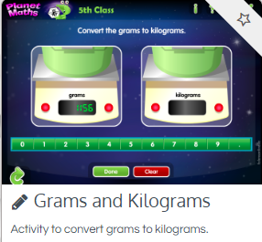  - Answer Orally: Pg. 154 ex. A  - Write the answers to: Ex. B into your copy. You only have to pick 6 of the objects from the list. (Use whatever weighing instruments you have at home).  - Tables Champion: Tuesday  - Mental Maths: Tuesday
Religion | 1. Read about the 7 gifts of the holy spirit and complete the journal exercise on page 88, into your copy. 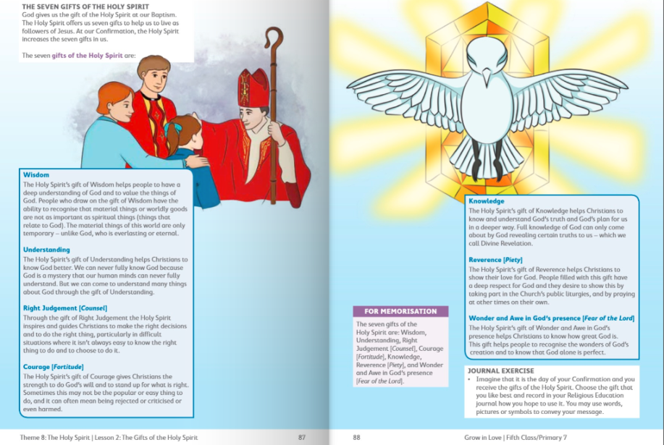
Gaeilge | - Léigh an cómhrá: Listen to the conversation being read aloud. Listen to it for a second time and say the lines with the online reader.  - Now practice reading it aloud by yourself.
Music | - Look at this PowerPoint to learn the Grandma Rap!
Science | Topic: Air  - What do you know about air? What is it made up of and why is it so important?  - Look at the PowerPoint about the Respiratory System  - Read Chapter 8 pages 48 & 49 in Window on the Word Science.  - Draw a labelled diagram of the respiratory system in your copy.  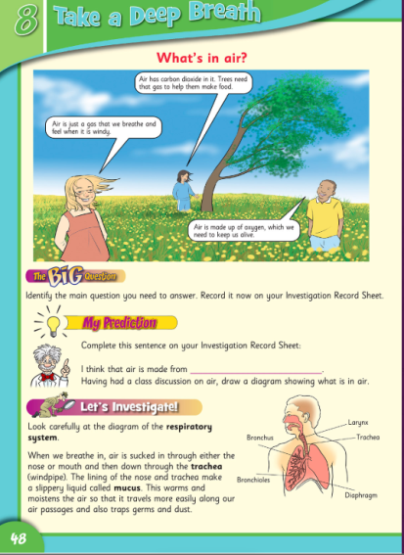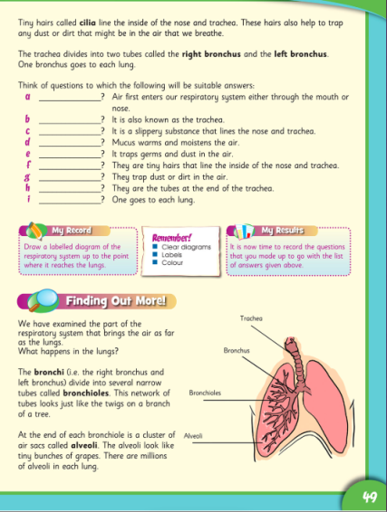

Wednesday
English | Reading:  - My Read at home: pg. 101  - Up and Running: wordlist  - DEAR: 10 mins  You can access Up & R here: https://my.cjfallon.ie/preview/student/2694  Writing:  - Up & Running: Answer activity B questions 1-5 pg. 216  - My Spelling Workbook: Unit 14, LSCWC x4 spellings (revision words)  - My Spelling Workbook: Exercise 8
Active Schools Week | “Walk On Wednesday”  - Be sure to get out for a walk with your family today.  - You could organise the pre walk warm up and cool down for the family.
Maths | Planet Maths: Pg. 155 Weight  1. Watch the online video (Click resources, Weight)  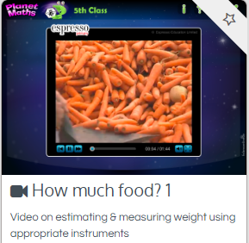  2. Write the answers to: pg. 155 ex. A into your copy. This may look difficult at the start because there is a lot of information, but take your time with it, read it a few times, and break it up into small steps. All you have to do is try your best!  3. Tables Champion: Wednesday  4. Mental Maths: Wednesday
Religion | - Read this “At Home” page and chat with family about what you have learned about the gifts of the Holy Spirit and how they might help you to live a Christian life.  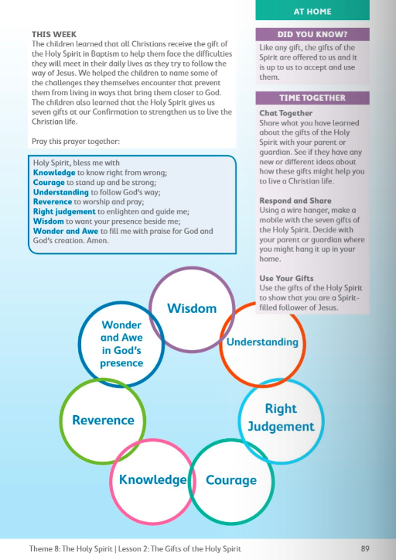
Gaeilge | - Read the new phrases again:  Gaeilge Béarla  Cén sórt aimsire atá ann inniu? What is the weather like today?  Tá an aimsir ____ inniu. / Tá sé ____. The weather is ____ today. / It is ____.  Cén sórt lae atá ann? What sort of day is it?  Lá ____ atá ann. It is a ____ day.  Tá sé ag dul i bhfeabhas / ag dul in olcas. It is getting better / worse.  Tá sé ____ fós. It is still ____.  Beidh / Ní bheidh ____ amárach. It will be / will not be ____ tomorrow.  Tá súil agam go mbeidh sé ____ amárach. I hope it will be ____ tomorrow.  2. Líon na bearnaí: Fill in the blanks, 1-3. You can pick any of the types of weather. Remember: Beidh sé = It will be (future tense). Write out full sentences in copy.  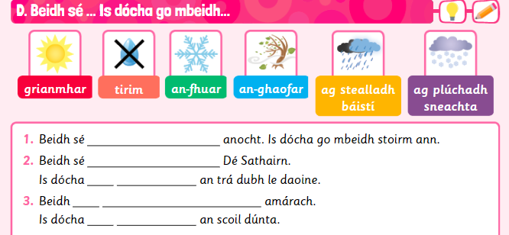
History | - Read pages 80 & 81 in your history book.  - Pick 5 questions from question time (pg 82) to answer in your copy.  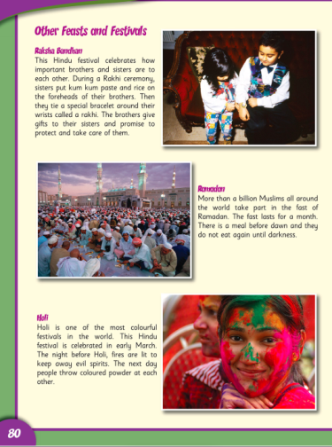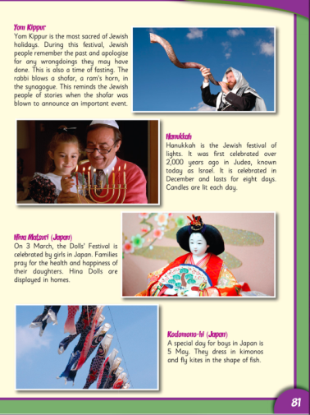
Thursday
English | Reading:  - My Read at home: pg. 102  - Up and Running: wordlist  - Persuasive Writing: Download the power point and read Persuasive Writing Power Point 2  - Read this example of Persuasive Writing and use it as a guide Writing Sample  - Download this Word Mat and look at this and the Poster Page again and use them when you are writing your persuasive piece. They will help you a lot!  - DEAR: 10 mins  Writing:  - ‘Weekends should be three days long.’: Using this topic, state your opinion, give three arguments and write a short conclusion.  - My Spelling Workbook: Exercise 9
Active Schools Week | “Timing Thursday”  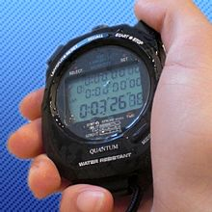  - Get the stopwatch ready: See how many of the following you can do in 1 minute?  - Jumping Jacks  - Frog Jumps  - Squats  - Lunges  - Scissors  - “Keepy uppies”  - Toe taps  - Challenge other members of your family!
Maths | Planet Maths: Pg. 155 – Weight  1. Watch the online video(Click resources, Weight)  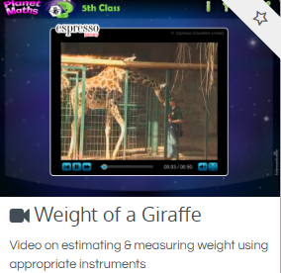  2. Sing your counting songs – you could make your own counting stick and ask somebody in your house to test your skip counting  3. Write the answers to: pg. 155 ex. B (Nenagh, Liverpool and Cairo) into your copy. You will need to look at the Weights Guide at the top of the page to answer this.  4. Tables Champion: Thursday  5. Mental Maths: Thursday
Religion | - Say “The Angelus” at 12:00  - Find a quiet moment to have a conversation with God, you could write a prayer, like you have been doing in your religion Journal.
Gaeilge | 1. Léigh na frásaí nua: Read the new phrases again.  Gaeilge Béarla  Is dócha go mbeidh ____. It will probably be ____.  Conas a bhíonn an aimsir (i rith an ____)? How is the weather (during ____)?  Bíonn an aimsir ____ (i rith an ____). The weather is ____ (during ____).  Cén séasúr is fearr leatsa? Which season do you prefer?  Is fearr liom an ____. I prefer the ____.  Is é ____ an séasúr is fearr liom. ____ is the season that I prefer.  An rud is mó a thaitníonn liom faoi ná ____. The thing that I like best about it is ____.  2. Líon na bearnaí: Fill in the blanks, 4-6. Remember: Beidh sé = It will be (future tense). Write out full sentences in copy.  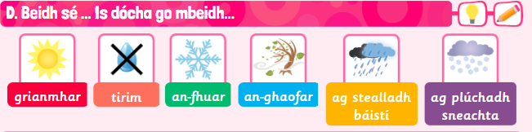  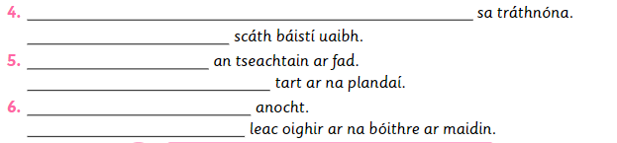
Art | Theme: Day and Night.  Divide your page in half and then draw, paint, colour or sketch, so that one half represents the day and the other represents the night. You can do it any way that you want but here are some examples if you need them:  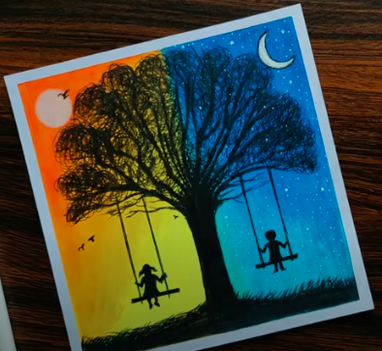  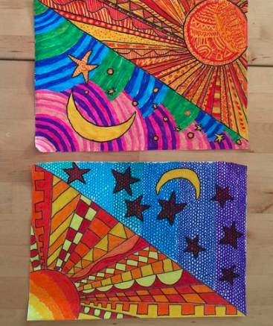
Science | Topic: Air  1. Read Chapter 8 page 50 & 51 in Window on the Word Science  2. Test your knowledge: Answer the true/false worksheet about the lungs orally.

Friday
English | Reading:  - My Read at home: pg. 103  - Up and Running: wordlist  - Revise spellings unit 14  - DEAR: 10 mins  Writing:  - My Spelling Workbook: Exercise 10  - Continue with your persuasive writing piece if you haven’t finished it.
Active Schools Week | “Fun Friday”  - Create an obstacle course for your family in the garden, using household and garden items (kitchen chairs, pots, laundry basket, dustbin, garden pots, buckets, a pillow case as a sack etc.)  Who will be the fastest family member to complete it?  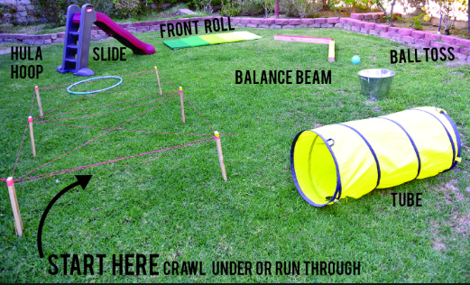
Maths | Planet Maths: Pg. 156 – Weight  - Counting, skip counting (10 mins)  - Write the answers to: Ex. C into your copy  - Mental Maths: Friday Test
Gaeilge | Éist leis an amhrán: Listen to this song online again. Try your best to learn the chorus off by heart.  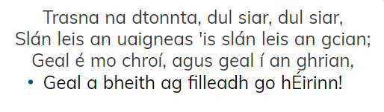  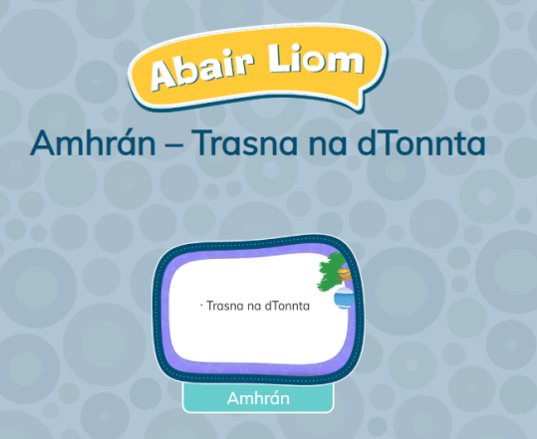  folensonline.ie:  https://content.folensonline.ie/programmes/AbairLiom/5th_class/resources/song/AL_5C_ACT_CH15_007/index.html  Abair Liom, 5th Class: Resources
Geography | - Write a Haiku (instructions on page 82) about your favourite feast or festival. Remember syllables are the amount of claps in a word.  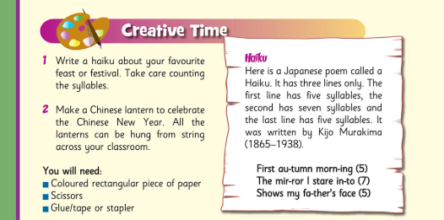  2. Design a kite to celebrate the Japanese festival of Kodomono-hi. Test your design to see if your kite will fly successfully.  OR  2. Design your own wrapping paper for a feast or festival.

