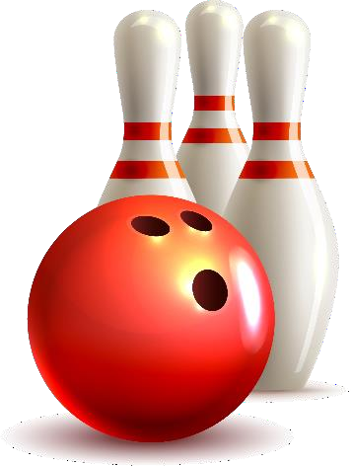
Read the short story. Then answer each question.

Force
Imagine you’re going bowling. You roll the ball down the lane, and it hits a bowling pin. The bowling pin stays up.
Is that what you would expect to happen? Probably not, because the bowling ball exerted force on the bowling pin, so it should have been knocked over! Force is the push or pull upon an object. Since the bowling ball moves and hits the bowling pin, the force causes the bowling pin to move, too.
Is force at work in other sports? Yes, it is! Think about
baseball. The ball could not fly out of the stadium by itself. The pitcher uses the force of his or her arm to make the ball go. The batter uses force to make the bat hit the ball, so the ball will move towards the outfield.
What about football? The same force the pitchers use in baseball works in football, too. The ball cannot move by itself, the quarterback has to use force to throw the ball to another player.
Here’s a different situation: what happens when two football players who have the same strength go to block each other? They have the same strength and so they might have the same force on the other player. What happens if two objects that have the same force try to push from opposite sides? Nothing! They players would stay in the same spot, trying to force the other, until the referee blows the whistle.
Force is not just at work in sports, either. You can experiment with force right now! Get a block. Use one hand to exert force on the block by pushing it along the surface of a table (not too hard, you don’t want to break anything!). What happens? The force makes the block slide. Now try putting one hand on each side of the block and push your hands together. Does the block move? Probably not, since you are probably exerting the same amount of force on each side of the block. If there is more force on one side of an object, it will move. If there is the same amount of force on all sides of the object, it will stay still. Have fun experimenting with force!

Questions:

- What is the short story mostly about?
_____ _

_____ _

- What does the word “force” mean? Highlight the sentence that tells you.
_____ _

_____ _

- What is the main topic of the fifth paragraph?
_____ _ _

_____ _

- Write what happens when force is exerted on one side of an object.
_____ _

_____ _

- How is that different than if force is exerted on both sides of an object?
_____ _

_____ _

- What causes an object to move?
_____ _

_____ _

Answers:

- What is the short story mostly about?
The passage is mostly about how force works.

- What does the word “force” mean? Highlight the sentence that tells you.
Force means strength or power. “Force is the push or pull upon an
object.”

- What is the main topic of the fifth paragraph?
The main topic of the fifth paragraph is about two objects that push from opposite sides stay in the same spot, demonstrated with an example of two football players.

- Write what happens when force is exerted on one side of an object. When force is exerted on one side of an object, it forces that object to move.

- How is that different than if force is exerted on both sides of an object?
If the force is exerted on both sides of an object, it stays in place.

- What causes an object to move? Force causes an object to move.

