Hi First Class,
Well done for all your hard work since we left school. You are doing a great job at home. I miss you all very much. I was in our classroom last week, tidying it up and sorting out your lovely art work. Can you believe we are nearly at the end of First Class! This week, I have a surprise for you! We will be going on a virtual school tour! Unfortunately, we can go on a real school tour so I made a PowerPoint so we can pretend! I hope you enjoy it! I have uploaded the PowerPoint onto the class page on the school website. You can ‘go’ on the pretend tour whatever day you like. I have assigned work for 4 days this week to allow for the tour.
Have a lovely week.
Talk soon, Mr Kennedy
Happy Monday 15th June! : )
English
1. Write your news from the weekend and draw a picture.
2. Read P. 21 and 22. Orally, describe how Jasper might feel in the picture on page 22
3. Spelling Workbook: Unit 9– exercise 8
4. Spelling list 30: put one word from the spelling list into a sentence

Maths
- Mental Maths: Week 35 Monday and the problem
- Tables: -12
- Planet Maths: p 133
Gaeilge: Bua naCainte –Ócáidí Speisialta- Lá Breithe- Ceacht 1
- Listen to the song by clicking the green music note
- Listen to the lesson by clicking the yellow speech bubble and click comhra 1.1
- Click the game controller and play ‘tasc éisteachta 1.1
- ‘Fuair mé... I got’
Answer this sentence into your Gaeilge copy. Use vocabulary on page 77 to help you complete the sentence.
Religion Seasonal Themes: Inter-Religious Education
1. G.I.L page 62
P.E : Take part in 30 minutes of exercise

Tuesday 16th June
English
- Jasper Saves the Day: Read p.23 and 24
- Oral Language: look at the picture of Jasper on page 24. What do you think he might be dreaming about?
- Spelling Workbook: Unit 9 exercise 9
- Spelling list 30: Put one word from today’s spellings into a sentence.
- Handwriting: Complete the next letter in your handwriting book. If you have all the letters completed copy one of the sentences from the book into your handwriting copy.
Maths
- Mental Maths: Week 35 Tuesday and the problem
- Tables: -12
- Planet Maths: p134
Gaeilge: - Ócáidí Speisialta- Lá Breithe- Ceacht 1
- Listen to the lesson by clicking the yellow speech bubble and click comhra 1.2
- Click the game controller and play ‘tasc éisteachta 1.2

Well done for all your hard work today!

Wednesday 17th June
English
- ‘Jasper Saves the Day’ read page 25 and 26
- Create a map: following the instructions on page 26, draw the route that Katie and Jasper walked.
- Spelling workbook: Unit 9 exercise 10
- Spelling list 30: Put one word from today’s spellings into a sentence.
Maths
- Mental Maths: Week 35 Wednesday and the problem
- Tables: -1
- Planet Maths: p135
Gaeilge Ócáidí Speisialta- Lá Breithe- Ceacht 2
- Listen to the song by clicking the green music note
- Listen to the lesson by clicking the yellow speech bubble ‘Comhra 2.1’
- Answer ‘Cén aois thú?’ (what age are you?) in your Gaeilge copy. ‘Tá mé.... d’aois.’
- Click the game controller and play the game
Religion:
- G.I.L page 63
Art: Create your own pirate ship.
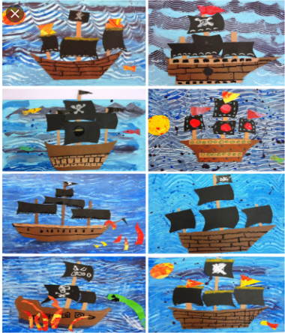

Thursday 18th June
English
- ‘Jasper Saves the Day’ read page 27 and 28
- Oral Language: How do you think Jasper feels waiting for Katie all the time? Think of 3 words to describe his feelings.
- Spelling list 30: Put one word from today’s spelling list into a sentence.
- Handwriting: Complete the next letter in your handwriting book. If you have all the letters completed copy one of the sentences from the book into your handwriting copy.

Maths
- Mental Maths: Week 35 Thursday and the problem.
- Tables: -12
- Planet Maths: p136
Gaeilge: Ócáidí Speisialta- Lá Breithe- Ceacht 2
- Listen to the song by clicking the green music note
- Revise the lesson by listening to the two conversations again
- Bua na Cainte: page 91
Well done for working so hard this week!

