Wednesday May 20th 2020
3rd Class Ms Hughes
For additional support see https://padlet.com/thirdclassmshughes/7nelhuv6lglw4ti6

English (My Read at Home and Get Set are available online see webpage)
- My Spelling Workbook pg 62 Unit 16
Today’s spellings: married-supplied (LCWC) Write spelling 3 times.
Write 4 sentences with each spelling word.
Answer Q3 Crossword Down Clues pg 63 My Spelling Workbook
- Get Set –Review The Giant’s Wife pgs 224-233
- Answer QE Word watch 1-6. (Removing incorrect words)
- My Read at home- Read the next page and answer questions orally.
- Library Book- Read your library book or listen to a story on www.storylineonline.net/library/ or Elevenses with David Walliams

Maths (Planet Maths available online see webpage)
- Mental Maths Book- Week 32 pg 86 complete Wednesday
- Tables Champion- Week 31 pg 40 complete Wednesday

- Warm Up- Word Problem
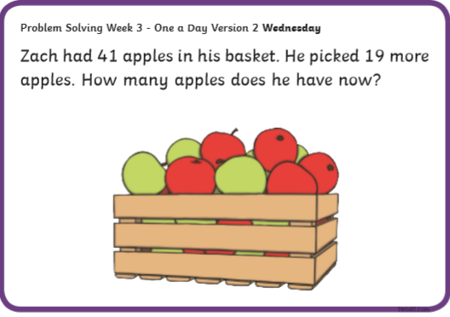

- Planet Maths- Topic 25: 3D Shapes pg 154
Explore, describe the relationship of 3D shapes with constituent 2D shapes.
Construct 3D shapes.
Answer QA 1+2
- What are nets? Watch the video to find out https://youtu.be/SwDjm6Ra1W4
- Look at the powerpoint about Nets
- Answer QB 1-6 Nets or try and make 3D Shapes out of nets yourself!
Gaeilge
- Téama: Caitheamh Aimsire (Past Times)
- Litriú: galf(golf) + traenáil(training). Write 3 times in copy like spellings.
- Scéal: An Bradán Feasa (The Salmon of Knowledge)
- Éist leis an scéal online or see powerpoint. Listen to the scéal being read. Notice some of the foclóir nua words. Try and read the story yourself.
Religion
- Log in to ‘Grow in Love’ https://www.growinlove.ie/en/ and access the 3rd class materials. Email: trial@growinlove.ie Password: growinlove
- Select Third Class. Click into Theme 9: Celtic Christianity
Lesson 2: Christian Pilgrimage
- In the resource section, listen to reflective music and say a prayer.

History
- Who was the first man on the moon?
- Watch this video about the history of Space travel. https://youtu.be/f02BzO1wxb0
- Read Ch 13 The Space Age pages 81-85 History Windows on the World. Access the book on edco online if you don’t have it.
- Answer questions 1-10 orally on page 84.
- Make a History of Space Travel timeline.
- Listen to a story being read from Space https://youtu.be/9wV8yw7iV8w

Optional Choiceboard
- Choose a different activity to do each day.

