Wednesday May 13th 2020
3rd Class Ms Hughes
For additional support see https://padlet.com/thirdclassmshughes/7nelhuv6lglw4ti6
English (My Read at Home and Get Set are available online see webpage)
- My Spelling Workbook pg 60 Unit 15
Today’s spellings: Rome-claw (LCWC) Write spelling 3 times.
Write 4 sentences with each spelling word.
Answer Q7 Word Meanings pg 60 My Spelling Workbook
- Get Set –What is a prefix? Where is it’s position in a word? (start/middle/end) Can you identify the prefix in a word?
- Answer QE Word watch 1-4. (Prefix)
- My Read at home- Read the next page and answer questions orally.
- Library Book- Read your library book or listen to a story on www.storylineonline.net/library/ or Elevenses with David Walliams

Maths (Planet Maths available online see webpage)
- Mental Maths Book- Week 31 pg 85 complete Wednesday
- Tables Champion- Week 30 pg 39 complete Wednesday
- Warm Up- Word Problem
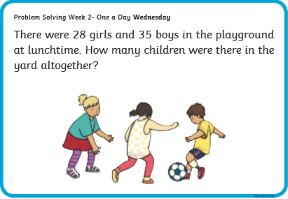

- Planet Maths- Topic 24:Division pg 145
Divide a two-digit number by a one-digit number with remainders
Watch https://youtu.be/KGMf314LUc0
Answer QA1-8 Use household items instead of cubes
Optional B1-6

Gaeilge
- Téama: Caitheamh Aimsire (Past Times)
- Litriú: comógaíocht(camoige) + cispheil (basketball). Write 3 times in copy like spellings.
- Déan Ceist D Scríobh an abairt mar is ceart lch 144
- Déan Ceist E Gramadach lch 144

Religion
- Log in to ‘Grow in Love’ https://www.growinlove.ie/en/ and access the 3rd class materials. Email: trial@growinlove.ie Password: growinlove
- Select Third Class. Click into Theme 9: Celtic Christianity
Lesson 1: Early Christian Ireland
- In the resource section, watch the video about St. Kevin and the Monster.

Science/Engineering Project
This project can be completed over a few days and other members of the family can help. You have a week to work on this. Email photo’s of finished towers (landscape photos are best) on or before Wednesday 18th May.
- Read the design problem
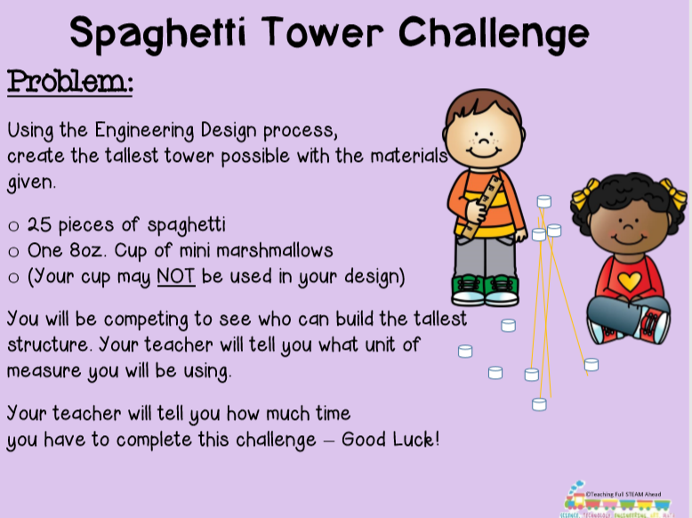

- Gather Materials
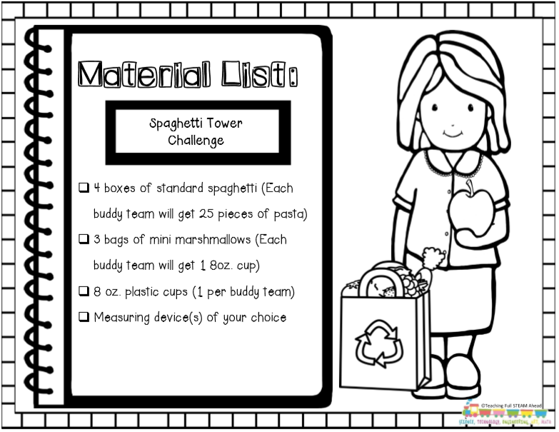

- Follow Design process
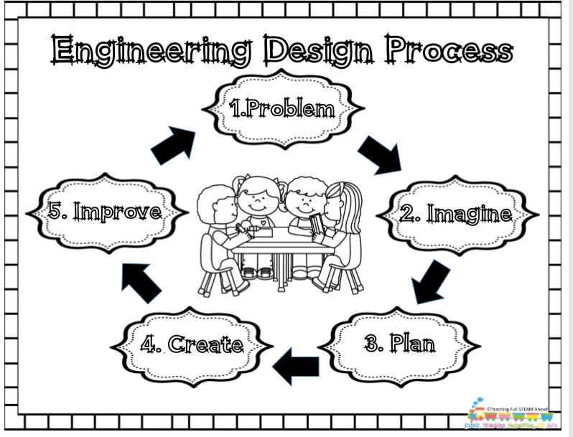

Optional Choiceboard
- Choose a different activity to do each day.

