Tuesday April 28th 2020
3rd Class Ms Hughes
English (My Read at Home and Get Set are available online see webpage)
- My Spelling Workbook pg 56 Unit 14 Suffixes (-less, ness, ly) Today’s spellings: kind-won’t (LCWC) Write spelling 3 times.
Write 4 sentences with each spelling word.
Answer Q7 pg 56 and start Q8 Word Search pg 57 MySpWkBk
- Get Set – Read pages pgs 206-209 Superfast Animals
- Answer Q B 6-10 pg 210 in copy using full sentences. Answer QC True or False orally pg210
- My Read at home- Read the next page and answer questions orally.
- Library Book- Read your library book or listen to a story on www.storylineonline.net/library/ or Elevenses with David Walliams

Maths (Planet Maths available online see webpage)
- Mental Maths Book- Week 29 pg 83 complete Tuesday
- Tables Champion- Week 28 pg 37 complete Tuesday
Warm Up: Counting in 2, 5, 10../Singing Table songs/Making up word problems/Choose a symmetry warm-up on padlet https://padlet.com/thirdclassmshughes/7nelhuv6lglw4ti6
- Planet Maths- Topic 22:Symmetry pg 133
Identify lines symmetry in the environment
Answer QA,B and QC pg134
Gaeilge
- Seanfhocail: Ní neart go cur le chéile (There is strength in unity)
- Téama: An Aimsir (The Weather) Continued
- Litriú: bogha báistí(rainbow) + sioc(frost). Write 3 times in copy like spellings.
- Log in to Folens online and listen to the comhrá. Read along on lch125. Déan ceist C1-6 Cén sort aimsire é?
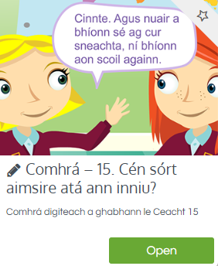
Religion
- Log in to ‘Grow in Love’ https://www.growinlove.ie/en/ and access the 3rd class materials. Email: trial@growinlove.ie Password: growinlove
- Select Third Class. Click into Theme 8: The Church is a Community of Believers Lesson 2 : Life in the Parish
- Listen to the song, read page 68 and do the activity of ebook
PE
- This is Active Schools Week but Tuesday is normally our PE day. Choose an extra activity in the Active Schools or Well-being column
https://padlet.com/thirdclassmshughes/7nelhuv6lglw4ti6
Active Schools Week
Tuesday: “Target Tuesday”
- Using whatever equipment you have, set up a target challenge for your family in the garden.
- For example: How many footballs/tennis balls/toilet rolls can you get in to the bucket?

