Thursday June 11th 2020
3rd Class Ms Hughes
For additional support see https://padlet.com/thirdclassmshughes/7nelhuv6lglw4ti6
English (My Read at Home and Get Set are available online see webpage)
- My Spelling Workbook pg 68 Unit 17
Today’s spellings: honest-write (LCWC) Write spelling 3 times.
Write 4 sentences with each spelling word.
Answer Q9 Word Search any 16 words pg 69 My Spelling Workbook
Answer Q10 Tenses pg 69 My Spelling Workbook
- Work on Intercultural project if not yet completed
- My Read at home- Read the next page and answer questions orally.
- Library Book- Read your library book or listen to a story on www.storylineonline.net/library/ or Elevenses with David Walliams
Maths (Planet Maths available online see webpage)
- Mental Maths Book- Week 35 pg 89 complete Thursday
- Warm Up- Word Problem
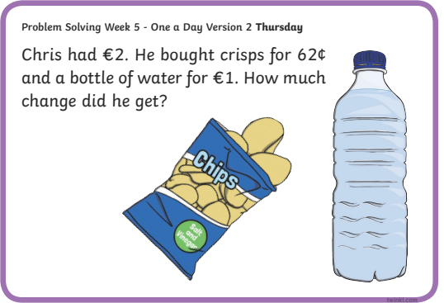

- Planet Maths- Topic 27: Time 2 pg 165 (TV Guide)
Solve and complete practical tasks and problems involving times and dates.
Read and interpret simple timetables.
- Answer QA 1-7 pg 165
- Optional QA 8-10 pg 165
- Answer QB

Gaeilge
- Téama: Caitheamh Aimsire (Past Times)
- Déan 10 as 10 https://rtejr.rte.ie/10at10/ as gaeilge
- Déan Ceist E An t-am (The Time)
- Look at the time on the clock and fill in the answer.
Thosaigh= started
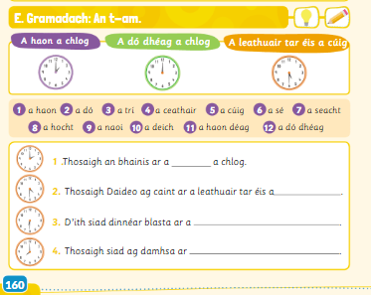

Religion
- Log in to ‘Grow in Love’ https://www.growinlove.ie/en/ and access the 3rd class materials.
- Email: trial@growinlove.ie Password: growinlove
- Select Third Class. Click into Seasonal/Additional Lessons
- Check back or look at an additional lesson of your choice
- Read the pages in your book and chat about it.

Intercultural Project
- Work on country project if not yet completed.
Optional Choiceboard
- Choose a different activity to do each day.

