Work for Thursday 28th May
English :
- ‘What a Box’ Pg 37
- Free Writing : 15-20 minutes of free writing. If you don’t know how to spell a word, try your best to sound it out.
- Handwriting : continue with the next page in Ready to Write.
- Wordbox 17A
- High Frequency Words 41 – 50
Gaeilge :
Bua naCainte – Siopadóireacht Ceacht 4
- Workbook Pg 50 – complete colouring ‘Niamh sa Siopa’
Maths :
- Counting practice : count forwards and backwards to 20. Silent counting for every second number (1 out loud, 2 is silent, etc).
- Practise the shapes that we know : 2D – square, rectangle, triangle, circle, 3D – cube, cuboid, cylinder, sphere. Try to find some around the house.
- Continuing with money – Today we will be looking at adding different money – for example what is 2c + 1c + 1c. The children can use their fingers, or their number lines and coins if available. Or use the cubes – for 2c put out 2 cubes, for 5c put out 5 cubes.
- Small Planet Maths Book p.35
Art :
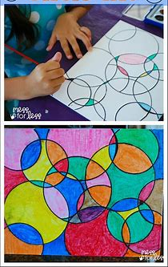
This week we are going to do some ‘Circle Art’. You draw loads of circles on a page, make sure they overlap in places – make them big and small and then you colour in the different spaces. You can draw the circles yourself by tracing around a cup or glass (be careful, or ask an adult for help).

